**MBUYA PARENTS’ SCHOOL**

**P.6 SCIENCE LESSON NOTES 2021**

**TERM ONE**

**THEME: THE WORLD OF LIVING THINGS**

**TOPIC: CLASSIFICATION OF ANIMALS**

Living things are the things which conduct life processes.

All living things are made up of **cells**.

A cell is a basic unit of life.

* Cells form tissues
* Tissues form organs
* Organs form systems
* Systems form an organism

**Characteristics of living things**:

* Living things feed
* Living things respire
* Living things grow
* Living things respond to stimuli
* Living things reproduce
* Living things move
* Living things excrete

**Classification of living things**

* Classification is the arrangement of organisms into groups and sub-groups.
* Living things are classified for easy identification.

**Factors considered when classifying organisms/living things;**

* Mode of feeding
* Body features
* Mode of movement

**The major groups/kingdoms of living things**

* Plant kingdom /plantae
* Animal kingdoms/animalia
* Fungi kingdom
* Monera kingdom – includes bacteria
* Protoctista kingdom– includes protozoa

**Structure of a plant cell Structure of an animal cell**

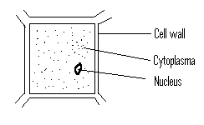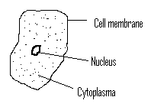

**Differences between plants and animals**

* Green plants make their own food while animals depend on food made by plants.
* Plants have no definite shape while animals have definite shape with fixed body parts.
* The cells of plants have cell wall while the cells of animals have no cell wall.
* Green plants have chlorophyll while animals have no chlorophyll.

**Classification tree of animal kingdom**

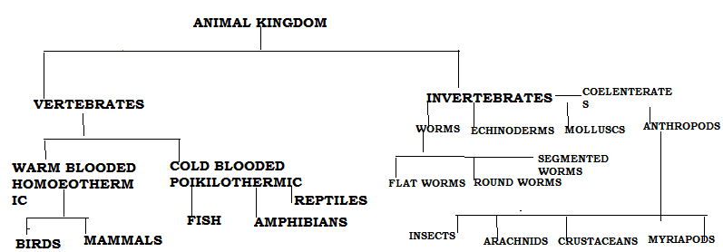

**Vertebrates**

* Vertebrates are animals with backbones or vertebral columns/ spine.

**Vertebrates**

Warm blooded

Cold blooded

Mammals

Birds

Amphibians

Fish

Reptiles

**Sub-groups of vertebrates**

**(a)Warm-blooded (homoeothermic)**

* These are vertebrates whose body temperature remains constant when healthy.
* Constant means something that does not change.
* Their temperature remains the same in all environments.
* They are divided into two classes. I.e. mammals and birds

**(b)Cold-blooded vertebrates (poikilothermic)**

* These are vertebrates whose body temperature changes according to the surrounding.

**Groups of warm-blooded vertebrates**

* Fish
* Amphibians
* Reptiles

**Characteristics of vertebrates:**

* They have an internal skeleton or endo-skeleton.
* Vertebrates have water proof skins
* They have the alimentary canal.
* They have two pairs of limbs for locomotion (movement)
* They have a large brain protected by the skull.
* They have eyes, ears and other sense organs.
* They have blood coloured red and pumped round the body by the heart.
* Their bodies can be divided by two similar halves by a vertical plane starting from the front to the back.
* Their backbones are made up of many small bones called vertebrae.

**Exercise**

1. What are vertebrates?**.**
2. Why are mammals grouped under vertebrates?
3. State one class of vertebrates that are cold blooded.
4. How do we call animals whose body temperatures change according to the environment?
5. Identify the two groups of warm- blooded vertebrates
6. How is the brain protected from external damage?
7. Which part of the human skeleton protects the spinal cord?
8. Identify any two characteristics of vertebrates.

**Mammals**

* Mammals are vertebrates with mammary glands and fur on the body.

**Characteristics of mammals;**

* They have mammary glands.
* They have fur on their bodies.
* They have a four chambered heart
* All mammals feed their young ones on milk produced from the mammary glands of their mothers.
* They undergo internal fertilization
* They care for their young ones.
* They are warm blooded animals (Homoeothermic)
* They produce their young ones alive except Monotremes.
* They breathe by means of lungs.
* They have well developed earlobes (pinnae)
* They have two pairs of limbs

**Groups of mammals**:

* Primates (most advanced mammals)
* Ungulates (hoofed mammals)
* Carnivores (flesh-eating mammals)
* Rodents (gnawing mammals)
* Insectivores (insect-eating mammals)
* Chiroptera. (flying mammals)
* Marsupials. (pouched mammals)
* Cetaceans (sea/marine mammals)
* Monotremes (egg-laying mammals)

**Primates**

* These are the most advanced group of mammals with well-developed brain.
* They have a high level of understanding.

**Examples of primates or fingered mammals**

* Baboons
* Monkeys
* Apes
* Chimpanzees
* Bush babies
* Gorillas
* Man

**Characteristics of primates (fingered mammals)**

* They are omnivores(feed on both vegetation and flesh)
* They have four types of teeth.(complete dentition)
* They have five toes on each foot and five fingers on each front limb.
* They use front limbs as hands(for manipulation) and hind limbs as legs.(movement)

**Ungulates (hoofed mammals)**

* These are mammals with hooves.

**Groups of ungulates**

**Even toed ungulates**.

* These are ungulates with even number of toes on each foot.

**Examples even toed ungulates**

* Cattle
* Goats
* Sheep
* Hippopotamus
* Giraffe
* Deer

NB. Even toed ungulates are sub-divided into ruminants and non-ruminants.

**Ruminants** are animals which chew cud and have four stomachs.

Cud is the food that is brought back to the mouth to be chewed again.

Ruminants don’t have canine and incisor teeth.

Cattle protect themselves by goring.

**Examples of ruminants**

* Cattle
* Sheep
* Goats
* Antelopes

**Non-ruminants** are animals that do not chew cud and have a single chambered stomach.

**Examples of non-ruminants**

* Pigs
* Hippopotamus
* Warthogs
* Rhinoceros
* Zebras
* Donkey
* Kangaroos
* Horses

**Structures of even toed hooves**

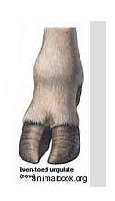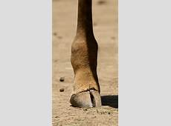

**2 .Odd toed ungulates**

These are ungulates with odd number of toes on each foot.

**Examples of odd toed ungulates**

* Rhinoceros
* Horse
* Elephant
* Zebra
* Donkey

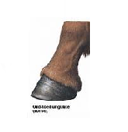 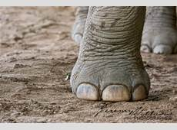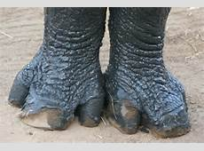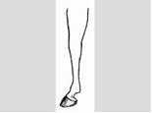

**Exercise**

1.What are mammals­?

2. State any two groups of mammals.

3. Give any three characteristics of mammals.

4. Identify one difference between mammals and birds**.**

5. Why are mammals able to produce breast milk?

6. Differentiate between ruminants and non-ruminants?

7. How do ruminants like cattle protect themselves from enemies?

8. Why is a goat grouped under ruminants?

9. To which group of mammals does a monkey belong?

10. In the space provided below, draw the foot of an even toed ungulate.

**Carnivores (flesh eating mammals**)

* These are mammals that feed on flesh.

**Characteristics of carnivorous mammals**

* They have well developed canine teeth for tearing flesh and protection.
* They have soft pads on their feet that make them to reach their prey without making any noise.
* They feed on flesh only.
* They have sharp claws for tearing flesh
* They have a good sense of smell and sight
* They run very fast and able to see at night (nocturnals).

**Sub-groups carnivores**

Dog family and cat family

**Cat family**

* Cheetah
* Lion
* Jaguar
* Leopard
* Tiger
* Domestic cat
* Mangoose

**Dog family**

**Examples of do family**

* Dog
* Fox
* Wolf
* Hyena
* Jackal
* Skunk.
* Skunks protect themselves by producing a bad smell.
* Dogs pant with their tongues out in order to regulate their body temperature in hot weather.
* Some carnivores are scavengers e.g. hyenas

**Scavenger mammals**

* These are mammals that feed on left over flesh killed by carnivorous mammals.
* They don’t kill their prey.
* They clean the environment by eating left over flesh.

**Examples of carnivores that feed on left over flesh (carrion)**

* Hyena
* Jackals

**Rodents (gnawing mammals**)

* These are mammals with well developed incisor teeth for rapid chewing.
* These are mammals that have chisel-like incisor teeth used for cutting food.
* They are vegetarians (herbivores).

**Examples of rodents**

* Rats
* Rabbits
* Hares
* Mice
* Guinea pigs
* Squirrels
* Moles
* Porcupines

**Insectivores**

* These are mammals that feed on insects and worms
* They have no teeth but have long and strong claws for digging into the soil.
* They are nocturnal (active at night)

**Examples of insectivores**

* Hedge hogs
* Shrews
* Pangolins
* Aardvark
* Spiny anteater

Animals that hunt during day and sleep at night are called diurnal animals.

NB **A hedgehog** protects itself by

* By rolling into a ball
* By using sharp spines on its back.

A skunk protects itself by producing a bad smell.

The ant eater has a long sticky tongue for trapping insects.

**Chiroptera (flying mammals)**

* These are mammals which can fly.

A bat is the only flying mammal.

Bats are nocturnal animals because they sleep during day and become active at night.

Bats use echoes to find food and dodge obstacles.

They rest with the head upside down/roosting

* For easy take off
* For protection from predators.

**Types of bats**

* Insect eating bats
* Fruit eating bats
* Blood sucking bats (Vampire bats)

**Importance of bats to man**

* Bats help in controlling diseases by feeding on insect vectors like mosquitoes.
* Some bats help in dispersing seeds.

**Marsupials (pouched mammals**)

* The word marsupial means a bag or a pouch.
* These are mammals which have a pouch or pocket on their abdomen.
* They carry their young ones in their pouches for the first ten months.
* They have mammary glands inside their pouch.

**Examples of pouched mammals;**

* Kangaroo
* Koala bears
* Wallabies
* Opasums

**Cetaceans (sea mammals)**

* These are mammals that live in seas and oceans.
* They have streamlined bodies to swim faster in water.
* They have high level of understanding next to primates.
* They breathe by means of lungs.
* They have a layer of fats called **blubber** which keeps them warm in water.
* They have flippers instead fore limbs

**Examples of cetaceans;**

* Whales
* Dolphins
* Hippopotamus
* Seals
* Porpoises

The whale is the largest mammal.

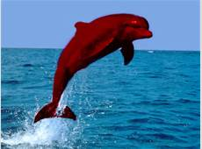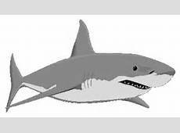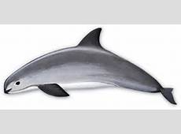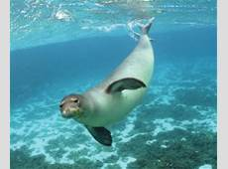

Dolphin whale porpoise seal

**Monotremes (egg laying mammals)**

* These are mammals that reproduce by laying eggs.
* They lay eggs that hatch outside the mother’s body.

**Examples of monotremes;**

* Spiny anteater or echidna
* Duck billed platypus.

They are the primitive mammals because they lay eggs and have beaks like birds.

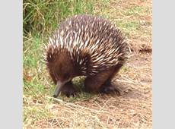 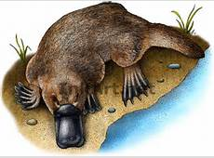

**Spiny anteater(echidna) duck billed platypus**

**Importance of mammals to people**

* Mammals provide food to man.
* They are a source of income. Others are kept in game parks for tourist attraction.
* Mammals like dogs are used by people for protection and hunting.
* Mammals’ urine and dung can be used to make manure for crops.
* Animal wastes are also used in the production of biogas.
* They provide good hides and skins for the leather industry and other purposes.
* Mammals can be used for transport, for example, camels, donkeys, horses etc.
* They can be used for ploughing land for crop farming e.g. oxen.

**Exercise**

1. Identify one example of a flying mammal
2. Why is the animal above referred to as a mammal?
3. How are bats useful in the environment?
4. What are cetaceans?
5. In which way is blubber useful to cetaceans
6. Give any two examples of cetaceans.
7. How does a hedgehog protect itself from danger?
8. What are carnivores?
9. Give any two examples of flesh eating mammals

**Birds**

These vertebrates with feathers on their bodies

**Characteristics of birds**

* They have feathers on their bodies.
* They have horny beaks
* Have scales only on legs

**Characteristics of birds:**

* Birds are warm blooded(homoeothermic)
* Their bodies are covered with feathers and they moult them every year.
* They have scales on their feet & legs
* They lay hard-shelled eggs
* Their eyes have three eyelids.
* Most birds can fly
* Most birds have hollow bones
* They breathe by means of lungs
* Their front limbs are modified as wings.
* Most birds care for their young ones
* They undergo internal fertilization
* They moult every year.

-Moulting is the shedding of feathers periodically.

**External features (structure) of a bird.**

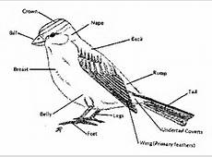

**Types of feathers**

* Quill or flight feathers
* Covert or body feathers
* Down feathers
* Filoplume or hair feathers

**Uses of feathers**

1. **To birds**

* Enable birds to fly
* Give the bird shape and colour for identification.
* Protect the bird from external injuries

1. **To people**

* Are sold to get money
* Are used for decoration
* Are used as costumes

**Classification of birds:**

Birds are classified according to type or shape of beaks, feet and food they eat**.**

**Groups of birds**

* + Birds of prey.
  + Perching birds.
  + Scratching birds.
  + Swimming birds.
  + Wading birds.
  + Flightless or walking birds.
  + Climbing birds.
  + Scavenger birds

**BIRDS OF PREY**

* These are birds that feed on flesh.
* Prey means an animal eaten by another animal.

**Characteristics (adaptations)**

* They have strong curved beak for tearing the prey
* They have a strong eye sight to locate the prey at a distance.
* They have strong curved talons/claws for holding/gripping the prey.

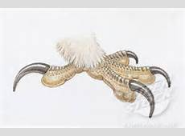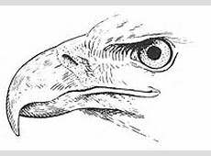

Sharp, strong and curved talonsSharp, strong and hooked beak

**Examples of preying birds**

* Eagle
* Kite
* Owl
* Hawk
* Secretary bird
* Falcons

A prey is an animal that is hunted and killed by another living organism for food.

**Exercise**

* 1. What are birds of prey?
  2. Give any two characteristics of birds of prey.
  3. State any two adaptations of birds of prey.
  4. Give any two examples of preying birds.
  5. How are preying birds dangerous in the environment?
  6. In which way are feathers useful to a music teacher?
  7. How are birds similar to mammals in terms of reproduction?
  8. How are feathers useful to birds?
  9. Why are most birds able to fly in air?.
  10. To which group of birds does the foot below belong?

**SCAVENGER BIRDS**

* These are birds that feed on left over dead flesh (curion).

**Characteristics**

* They have strong sharp curved beak for tearing flesh
* They have strong curved claws for tearing flesh

Scavenger birds help to clean the environment by eating dead decaying flesh.

**Examples of scavenger birds;**

* Marabou stork
* Vulture and crow

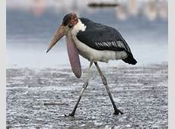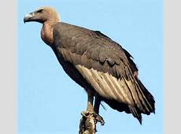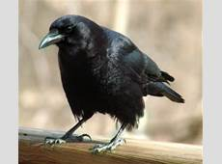

Marabou stork vulture crow

The structure of the beak and foot of a scavenger bird

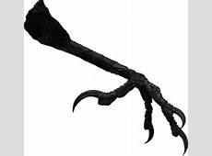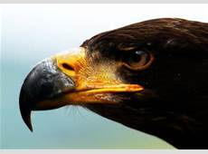

**SWIMMING BIRDS**

* These are birds that have a fully webbed feet and swim in water.

**Characteristics of swimming birds**

* They have fully webbed feet
* They have a spoon shaped beak
* They have flat broad breast bone.
* Their skins have oily glands that produce oil to protect their bodies against water.

**Examples of swimming birds**

Ducks, pelicans, geese, swans, penguin

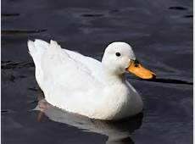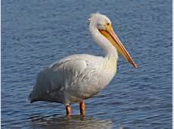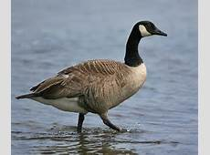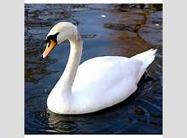

Duck pelican goose swan

Structure of the foot and beak of a swimming bird

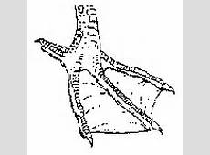

**WADING BIRDS**

* These are birds with half-webbed feet and walk in mud.
* Wade means to walk in mud.

**Characteristics of wading birds**

* They have half-webbed feet.
* They have a long beak to catch small animals in shallow water.
* They live along river banks and lake shores

**Examples of wading birds**

* Herons
* Crested cranes
* Flamingos
* King fisher
* Ibis
* White egrets

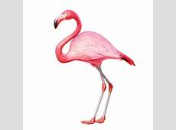 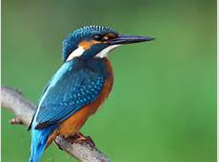 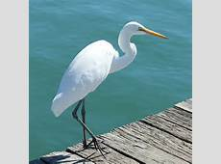

Flamingo kingfisher white egret

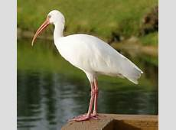 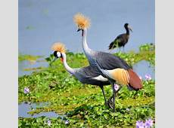 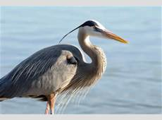

Ibis crested crane heron

Structure of the beak and foot of a wading bird

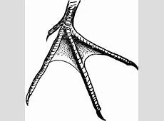

**FLIGHTLESS BIRDS (WALKING BIRDS**)

* These are birds that cannot fly.

**Characteristics of flightless birds**

* They have a lot of bone marrows
* They have small weak wings compared to their body size.
* They are heavy
* Some have scanty(few) feathers

**Examples of flightless birds**

* Emu
* Kiwi
* Ostrich
* Penguin
* Cassowary
* Rhea

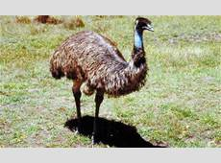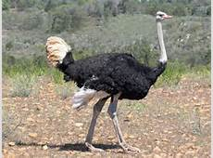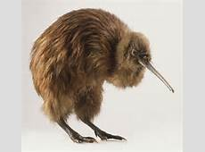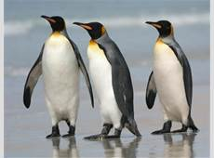

Emu ostrich kiwi penguin

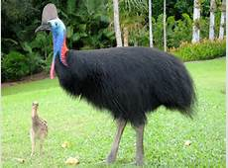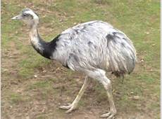

Cassowary rhea

NB: An ostrich is the largest and fastest flightless bird

**SCRATCHING BIRDS**

* These are birds that scratch the ground to find food.

**Characteristics of scratching birds**

* They have short pointed beaks
* They have strong blunt claws for scratching.

Examples include; chicken, turkeys, guinea fowls.

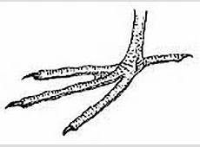

Structure of a beak and foot of a scratching bird

**CLIMBING BIRDS**

* These are birds which climbs trees

**Characteristics of climbing birds**

* They have two toes pointing forward and two toes pointing backward.
* They have strong pointed beaks for cracking seeds.

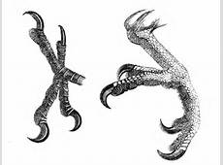

Examples of climbing birds; parrots, wood peckers, toucan,

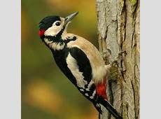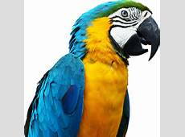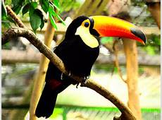

Wood pecker parrot toucan

**PERCHING BIRDS**

* These are birds that stay on tree branches.
* A perch is a place where birds rest or stay.
* Perching birds have one toe pointing backwards and three toes pointing forward.

**Groups of perching birds**

* Seed eaters---------pigeons, doves, weaver birds
* Insect eaters ------sparrows, robins, swallows, swifts
* Nectar suckers----sunbird
* Fruit eaters---------hornbill

**Exercise**

1. How are swimming birds adapted to swimming?
2. State any two examples of swimming birds.
3. Give two reasons why an ostrich cannot fly.
4. Apart from an ostrich, give any other two examples of flightless birds.
5. State any two characteristics of wading birds.
6. **G**ive any two examples of climbing birds.
7. Write down any two characteristics of climbing birds.
8. Give any **one** example of a nectar sucker.
9. How is a sun bird adapted to its mode of feeding?
10. Why are wading birds able to walk on water?

**Ways in which birds are adapted (best suited) for flying**:

* + They have streamlined bodies to reduce viscosity friction.
  + They have hollow bones to reduce weight.
  + They have no pinna to obstruct the flow of air.
  + They have hollow air sacs starting from the lungs.
  + They have a nictitating membrane which covers their eyes.
  + Have strong eel muscles to move their wings.

**Advantages of birds**:

* They are source of food to man.
* Their feathers are used for decoration.
* Some birds pollinate flowers
* Scavenger birds help to clean the environment

**Dangers of birds**:

* Many birds damage our crops.
* They make noise especially weaver birds
* They may keep vectors to human beings
* Some birds cause accidents on run ways at the airport

**Exercise**

1. How are scavengerbirdsuseful in the environment?
2. Give any two examples of scavenger birds.
3. Mention any one characteristic of scavenger birds.
4. Identify any three dangers of birds in the environment.
5. Point out two uses of birds to people.
6. How are birds best suited for flight?

**REPTILES (CRAWLERS)**

* These are cold-blooded scaly vertebrates.
* Some reptiles are oviparous while others are viviparous.
* Oviparous are animals that lay eggs.
* Viviparous are animals that give birth to live young ones

**Characteristics of reptiles:**

* They are cold blooded animals.
* They breathe by means of lungs.
* They lay eggs with shells.
* Their skins are covered with scales.
* Most reptiles have limbs except snakes.
* They undergo internal fertilization

**Classification (groups) of reptiles:**

* Lizards
* Snakes
* Tortoises and turtles.
* Crocodiles and alligators.

**SNAKES**

These are limbless reptiles

**Characteristics of snakes**

* They don’t have limbs
* Some are carnivorous
* They moult their skin after sometime.
* They have a sticky forked tongue used as a sense organ for smell and touch
* They move by slithering
* They have many ribs and vertebrae

**Classification of snakes**

* Venomous snakes
* Non-venomous snakes
* Constrictors

**Venomous snakes**

These are snakes that have poison glands that produce venom.

They have hollow fangs to inject venom into the victim

**Examples of poisonous snakes;**

Gabon viper

Puff-adder

Black mamba

Cobra

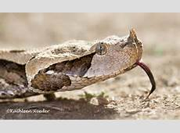 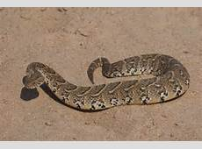 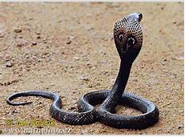

Gabon viper puff adder cobra

A diagram showing fangs

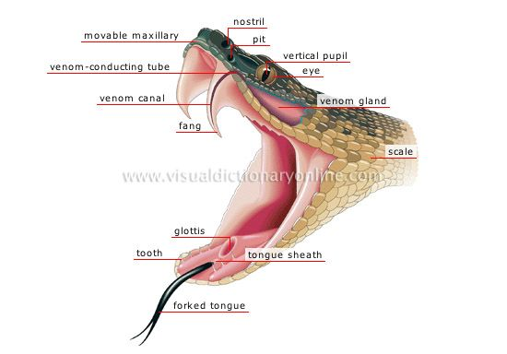

**Non-poisonous snakes**

These are snakes that do not have poison glands.

**Examples of non poisonous snakes**;

* Green snakes
* Brown house snakes
* Python
* Boars
* Anaconda

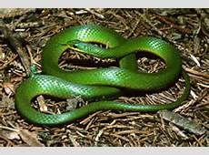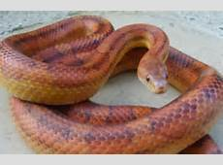

**Constrictors**

* They are also non-poisonous snakes.
* They have well developed teeth.
* They lick the prey to make them slippery for easy swallowing.
* They kill their prey by crushing and suffocating them to death.

**Examples of constrictors**;

Python

Boa

Anaconda

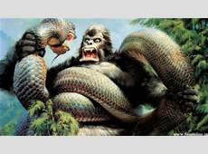 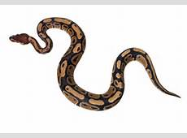 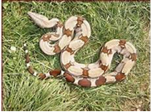

Anaconda Python Boa

**First aid for snake bites**

Tie a tourniquet slightly above the bitten part to prevent venom from going to the heart

Make simple cuts near the bitten parts to allow affected blood to ooze out.

Apply a black stone.

**NB**

**Venom** is used to make serum for treating snake bites

**Exercise**

1. To which group of cold blooded vertebrate d snakes belong
2. Write down any two characteristics of reptiles.
3. State any two importances of reptiles to people.
4. Give one example of a limbless reptile.
5. How does a snake move from one place to another?
6. Why is it important to make simple cuts near the bitten part of snake bite?
7. How is a tourniquet useful in giving first aid for snake bite?
8. Why is a cobra said to be a poisonous snake?
9. 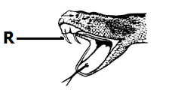Name the part marked **R**
10. In which way are snakes useful to people?

**LIZARDS**

**Characteristics of vertebrates**

They have two pairs of limbs

They have movable eyelids

They have sticky tongues

They grow tails if the old ones break off.

**Examples of lizards;**

* Chameleons
* Monitor lizards
* Common lizards
* Komodo dragons
* Geckos
* Green iguana

A chameleon protects itself by changing its body colours according to the environment (camouflage)

A chameleon uses its sticky tongue to get food

A chameleon has bulging eyes that turn in all directions

A gecko has suction pad on its feet to enable it move upside down on ceilings without falling.

Diagrams of the examples of lizards

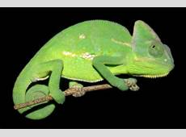 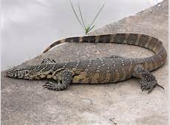 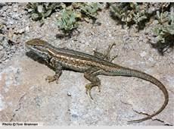

Chameleon monitor lizard common lizard

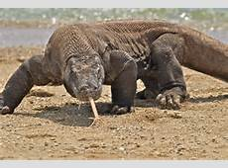 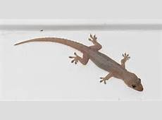

Komodo dragon gecko

**TORTOISE AND TURTLES**

* They have hard scaly shells on their bodies
* They breathe by means of lungs
* They move slowly
* Turtles have flippers for swimming
* Tortoises have raised shells while turtles have flat shells.
* Turtles, terrapins have their feet modified as flippers for swimming
* Tortoises move by walking using their strong legs.
* They lay their eggs in sand on the banks of water bodies.

NB A tortoise protects itself from enemies by hiding inside its shell

Diagrams

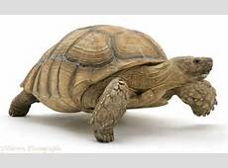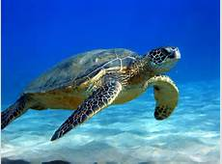

**CROCODILES AND ALLIGATORS**

* They are the largest reptiles
* They use their powerful tails for swimming and protection
* They have long powerful jaws
* They live in lakes and rivers.

**Importance of reptiles to man**

* Source of meat
* For tourist attraction
* Feed on insect vectors and pests.
* Their skins are used to make leather products like handbags, watch straps, shoes, belts, drums
* Snake venom can be used to make medicine for snake bites.

**EXERCISE**

1. How does a crocodile protect itself from enemies?
2. Apart from protection, give any other reason why a chameleon changes its body colour.
3. How are reptiles useful to people.
4. Suggest any two characteristics of reptiles
5. Give one reason why tortoise withdraws itself into the hard shell when touched.
6. State two ways in which reptiles are similar to birds.
7. In which one way are reptiles important to the leather industry?
8. How is the chameleon adapted to its mode of feeding?
9. Why is a gecko able to move upside on smooth walls and ceilings?
10. How does a gecko help to prevent the spread malaria at home?

**AMPHIBIANS**

Amphibians are vertebrates that live both in water and on land.

**Characteristics of amphibians**

* They are cold blooded
* They undergo external fertilization
* Amphibians live in water and breathe through gills while young
* They reproduce by laying eggs
* They have a three chambered heart

**Examples of amphibians**:

* Toads
* Frogs
* Newts
* Rubber caecilian
* Salamanders

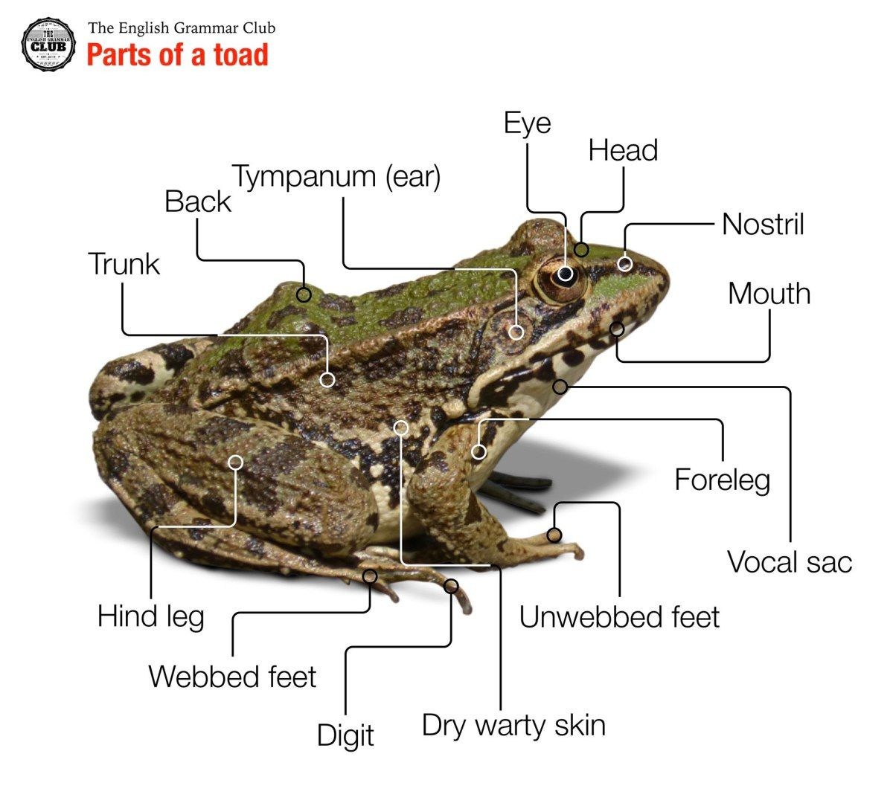

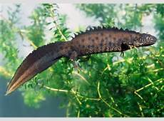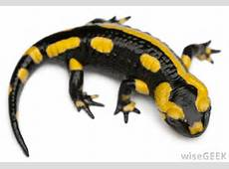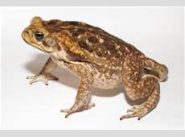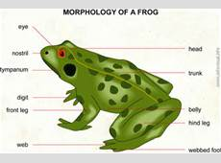

**newt salamander toad frog**

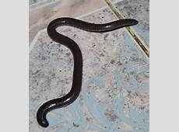

**Rubber caecilian**

**Differences between a toad and frog**

|  |  |
| --- | --- |
| Toad | Frog |
| Tadpoles are black | Tadpoles are brown |
| Live mostly on land while adults | Live mostly in water |
| Lay eggs in double spawns | Lay eggs in a mass raft |
| Have partly webbed hind limbs | Have fully webbed hind limbs |
| Have rough dry skin | Have smooth soft skin |
| Don’t have poison glands | Have poison glands |
| Have short hind limbs | Have long hind limbs |
| Breathe through lungs | Breathe through their moist skin and lungs |
| Toads have no teeth. | Frogs have teeth in their upper jaw |

**Reproduction in frogs and toads**

Males make noise to attract the females

A female lays eggs and the males shed sperms on the eggs for external fertilization.

The eggs have a smelly jelly that protects them from being eaten by predator.

The eggs hatch into tadpoles which have tails like fish.

**The diagram showing the lifecycle of a toad and frog**

**Frog toad**

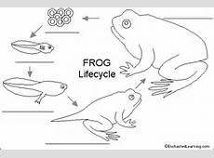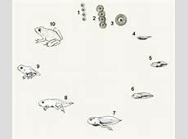

**Feeding habit in amphibians**

They feed on insects and worms

They use their sticky tongue to catch the prey.

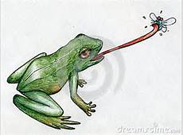

**Respiration in amphibians**

Frog can breathe through the lungs and moist skin

A toad can breathe the lungs.

**Ways in which frogs are adapted to the life in water**:

* They have streamlined body shape.
* They can take in dissolved oxygen.
* Frogs hibernate during dry season.

**Exercise**

1. Why is a toad referred to as cold blooded?
2. How is the breathing of tadpoles different from that of a toad?
3. To which group of cold blooded vertebrates do frogs belong?
4. How are frogs adapted to living in water?
5. Apart from frogs, give any two examples of amphibians.
6. In which way do amphibians like toads help to control the spread of diseases?
7. How do fish similar to tadpoles in terms of breathing?
8. How are the eggs of frogs protected from predators in water?
9. Give two differences between toads and frogs.
10. State any one similarity between amphibians and reptiles.

**FISH**

**Characteristics of fish:**

* They are cold blooded.
* They reproduce by laying eggs
* They undergo external fertilization.
* They use gills for breathing
* They have fins for movement in water
* They have a swim bladder to help them float on water
* They have scales on their body
* They are aquatic animals.
* They have a streamlined body to reduce friction in water called viscosity.

**Structure of a fish (Tilapia)**

**Functions of the parts of a fish**

**Scales**

* They protect the body of the fish from scratches.

**Nostrils**

* They are used for smelling and tasting

**Mouth**

* They Used for taking in water and food

**Gill covers (operculum**)

* They protect the gills.

**Lateral line**

* For detecting movement in water
* For detecting sound waves in water
* It is the sense organ for hearing in fish

**Pectoral fin and pelvic fin**

* They help the fish to swim upwards and downwards.

**Tail fin**

* It helps the fish to change direction in water or steering

**Types of fish and their examples**

* Bony fish
* Cartilaginous fish
* Lung fish

**Bony fish**

**Characteristics**

* They have many bones
* They have overlapping scales

**Examples of bony fish**

* Tilapia
* Nile perch
* Salmon
* Herring,

**Cartilaginous fish**

* They have soft bones called cartilages

**Examples of cartilaginous fish**;

* Dog fish
* Ray fish
* Skate fish

**Lung fish**

* They live in swamps, dirty pools and rivers.
* They hibernate in dry season

**Examples of lung fish;**

* Mud fish
* Lung fish
* Dipon
* Epiceratodus

**Respiration (breathing) in fish**

* Fish breathe in dissolved oxygen in water using the gills
* Gill rakers trap any solid particle which may damage the gills.

**Structure of the gills**

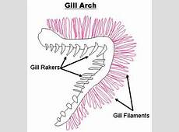

**Function of each part**

**Gill rakers**:

* It trap solid particles that may damage the gills

**Gill filaments:**

* They are for gaseous exchange

**Gill bar:**

* Itholds the gill rakers and gill filaments

**NB:** A fish dies shortly when removed from water because it lack dissolved oxygen

**Ways in which fish is adapted to living in water.**

* Streamlined body shape to reduce friction in water
* It has gills for breathing.
* Scales and colour provide it with protection.
* It has lateral line to detect waves and danger in water

**How fish protects itself**

* Using scales
* Some inject poison into their prey
* Some have electric organ to shock their enemies. E.g. the electric eel

**Importance of fish to man**

* Fish is a source of income.
* They are used as food.
* Fish help to control the spread of malaria
* Fish process sing industries provide jobs to people.
* They are used for decorating homes in an aquarium

**EXERCISE**

1. Give any two characteristics of fish
2. In which class of vertebrates do fish belong?
3. Why are fish regarded as cold blooded animals?
4. How are fish adapted to live in water?
5. State two ways in which fish protect themselves from enemies
6. Suggest one reason why it is important have a fish pond near home
7. What deficiency disease is prevented by feeding children on fish?
8. Which part of a fish has similar function as feelers of an insect?
9. Give one reason why a fish dies when removed from water
10. State one reason why people smoke fish

**INVERTEBRATES**

* Invertebrates are animals without backbones.
* Invertebrates are animals without a spine

**Classification tree for invertebrates**:

**Multicellular animals (Metazoan)**

**Coelenterates**

These have cylindrical bodies with only one opening acting as mouth and anus. Examples of coelenterates

* Corals
* Hydra
* Jelly fish
* Sea anemones

**Echinoderms**

* These live in the sea, they have shells with spines on their skin.

**Examples of echinoderms**

* Sea lilies
* Sea urchin
* Star fish
* Sea cucumbers

**Sponges**

* Sponges are collection of individual cells organized into one body living on the sea floor.

**Examples of sponges**

* Finger sponges
* Tube sponges

**Mollusks**

**Characteristics**

* They have soft un segmented bodies**.**
* They live on land, fresh water, and salty water.
* They reproduce by laying eggs.

Some have shells e.g. water snail.

**Examples of mollusks**

* Land snails
* Water snail
* Oysters
* Octopus
* Cuttle fish

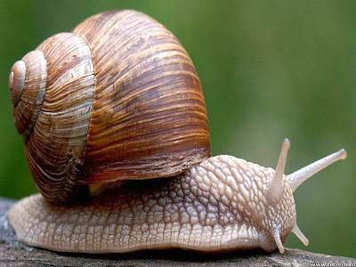  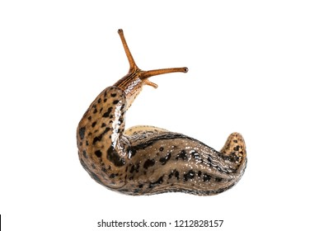 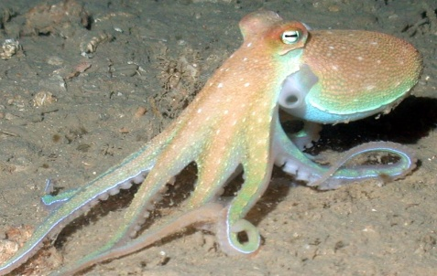

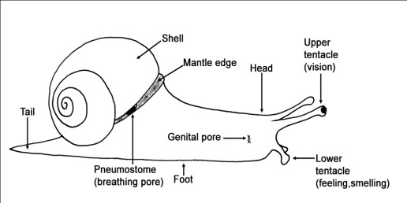  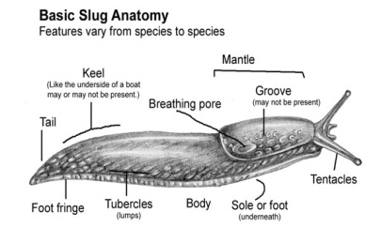 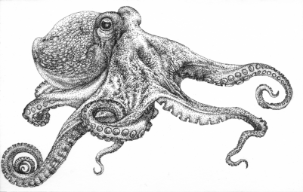

Water snail spread bilharziasis to people.

**Exercise**

1. What are invertebrates?
2. To which group of invertebrates do the slugs belong?
3. What are the uses of tentacles to a garden snail?
4. In which way is a fresh water snail dangerous to human beings?
5. How does fresh water snail protect itself from enemies?
6. Why are the shells of water snails included in the feeds of poultry?
7. Name the part marked X
8. Of what importance is part X

**WORMS**

* These are long thin soft bodied invertebrates.

**Characteristics of worms:**

* They breathe through their moist skin.
* They reproduce by laying eggs.
* Some live in soil, water while others live as parasites inside other animals.

**Groups of worms:**

**Segmented worms (annelids**)

These are worms whose bodies are divided into rings e.g. earth worms, leeches, bristle worm, lug worm etc.

NB: Earth worms are hermaphrodites.

* Earth worms help in soil aeration
* Earth worms die and form manure that increases soil fertility
* Earth worms come out of the soil after it has rained to get oxygen for breathing.

**Round worms (Nematodes**)

* These have non-segmented bodies which are streamlined

**Examples of round worms**

* Hook worms,
* Pin worms
* Thread worms
* Askaris worms
* Eel worms
* Filarial worms,

NB Hook worms enter our bodies by penetrating through bare feet.

* Hook worms feed on blood from our bodies causing anaemia

**Flat worms (Platy-helminthes**),

* These have flattened and segmented bodies.

**Examples of flat worms**

* Tapeworm
* Liver flukes

Tapeworm liver fluke

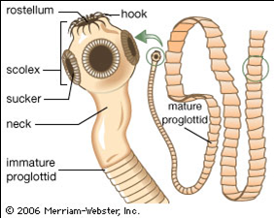 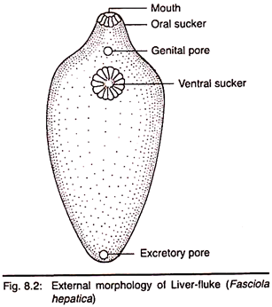 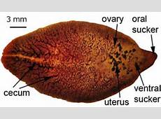

* Tapeworms enter our bodies by eating under cooked meat
* Tapeworms feed on digested food in ileum.
* Tapeworms use hooks and sucker for attachment on the host

**Dangers of worms**

* Hook worms feed on blood causing anaemia
* Tape worms feed on digested food causing malnutrition and stunted growth
* Pin worms cause the itching of the anus.

**Prevention of worm infection**

* Eating ready prepared meat.
* Proper disposal of faeces.
* Wearing shoes or sandals always.
* Disinfecting larine floors and keeping them clean.

**Exercise**

1. Explain the term worms**.**
2. Write down any one characteristic of worms
3. How are earthworms important to a farmer?
4. Suggest two ways in which tape worms enter our body.
5. How is the feeding of tape worms different from that of the hookworms?
6. State two ways of preventing hook worm infestation.
7. How are the suckers and hooks important to a tape worm?
8. Why does an earth worm come out of the ground immediately after raining?
9. State two dangers of worms to human beings.
10. How do worms take in oxygen from the environment?

**ARTHROPODS**

Theseare invertebrates with jointed legs and segmented bodies.

**Characteristics of arthropods:**

* They have jointed legs.
* They have segmented bodies.
* They have an exo-skeleton.
* They shed their cuticle through the ecdysis or moulting.

**Groups of arthropods**:

* Insects.
* Arachnids
* Crustaceans.
* Myriapods.

**INSECTS**

**Characteristics of insects**

* All insects have three pairs of jointed legs attached to the thorax.
* They have three main body parts.
* They have segmented bodies.
* They have two or more pairs of wings.
* They breathe through spiracles
* They have a pair of feelers

**Examples of insects**

* Houseflies
* Bees
* Cockroaches
* Preying mantis
* Butterflies
* Moths
* Grasshoppers
* Locusts
* Wasps
* Hornets
* Mosquitoes
* Tsetse Flies

**Structure of an insect**

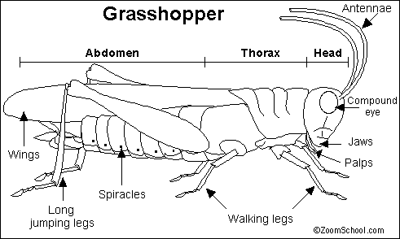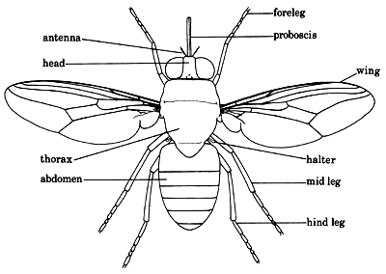

**Functions of each part**

**The feelers/antennae**:

* They are used for sensing danger

**Probosci**s:

* It is for sucking fluid foods

**Spiracles**:

* They are used for breathing

**Wings**:

* They are for flight

**Haltere**s:

* They are for balancing during flight

**Legs**:

* They have suction pads for walking on surfaces

**Ovipositor**:

* Used for laying eggs in female insects
* In some insects like bees, the ovipositor is modified as a sting.

**Thorax**:

* Provide attachment for legs and wings

**Abdomen**:

* Provides attachment for spiracles and ovipositor

**Metamorphosis in insects**

* Metamorphosis refers to the stages of growth in the life cycle of an insect.

**Types of metamorphosis**

* Complete metamorphosis
* Incomplete metamorphosis

**Complete metamorphosis**

* This is where some insects undergo four stages of growth in their lifecycle egg, larva, pupa and adult.

**Examples of insects that undergo complete metamorphosis;**

* Houseflies
* Bees
* Tsetse flies
* Butter flies
* Mosquitoes

**The lifecycle of a complete metamorphosis**

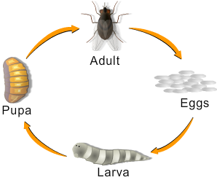

**Incomplete metamorphosis**

* This is where some insects undergo three stages of growth in their lifecycle. i.e. egg, nymph and adult

**Examples of insects that undergo incomplete metamorphosis;**

* Locusts
* Cockroaches
* Crickets
* Grasshoppers.

The lifecycle of an incomplete metamorphosis

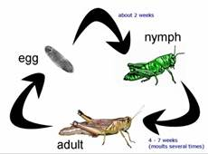

**Importance of insects**

* Butterflies help in pollination.
* We get silk from cocoons of butterflies
* Some insects are eaten in some societies e.g. grasshoppers, white ants, crickets.
* Some insects help in pollination
* Maggots help to reduce on the volume faeces in latrines

**Disadvantages of insects**

* Some insects are crop pests
* Caterpillars have bristle hair which cause irritation on the skin
* Some insects are vectors.

**Exercise**

* + 1. List down two groups of arthropods
    2. How are the following parts important to an insect?

1. Spiracles
2. Feelers
3. Proboscis
4. Halters
   * 1. How do bees and wasps protect themselves?
     2. Define the term metamorphosis
     3. Give one example of insects which undergo the following metamorphosis.

(i) Complete metamorphosis

(ii) Incomplete metamorphosis

* + 1. How is a wriggler different from a maggot?
    2. State any two uses of insects to people.
    3. What are arthropods?
    4. Why is a housefly regarded as an arthropod?
    5. Suggest one danger of insects to people.

**ARACHNIDS**

* These are arthropods with four pairs of jointed legs and two main body parts.

**Characteristics**

* They have two main body parts ( Head and cephalothorax)
* They have eight jointed legs
* They breathe through the lung books.
* They are wingless
* They use their webs for movement and trapping prey.
* They produce by laying eggs.

Examples of arthropods;

**Scorpions**

* Mites
* Ticks
* Spiders
* Fleas

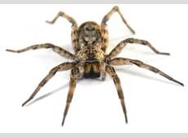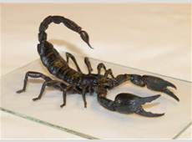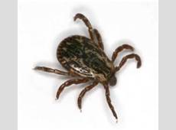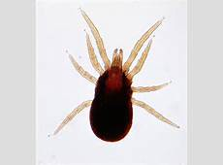

**Spider scorpion tick mite**

* Spiders produce spinnerets to make the webs
* Spiders use webs to trap their prey and for protection

**Myriapods**

* These are arthropods with many legs.
* They have many segments.

**Examples of Myriapods**

* Centipedes (chilopoda)
* Millipedes (diplopoda)

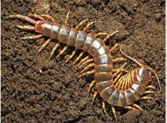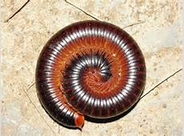

Centipede millipede

* Chilopoda have one pair of legs on each segment while diplopoda have two pairs of legs on each segment.
* Millipedes protect themselves from enemies by coiling and produce bad smell when disturbed.
* Millipedes help in soil aeration
* Centipedes protect themselves by paralyzing the enemy using its poisonous claws.

**CRUSTACEANS**

* These are arthropods with hard crusty skins.
* They breathe through gills.
* They have more than four pairs of jointed legs

**Examples of crustaceans**

* Crabs
* Lobster
* Shrimps
* Prawns
* Crayfish.

Crab lobster prawn

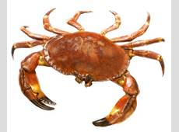 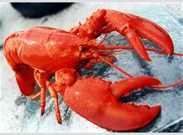 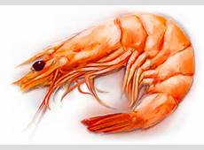

Shrimp Crayfish

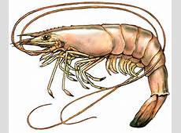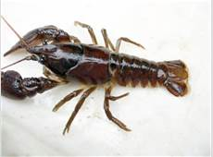

**Care and protection of vertebrates and invertebrates**

* Train trainable animals
* Treat sick domestic animals
* Cleaning their habits
* Conserving the natural habits and species for both domestic and wild animals
* Allow animals to feed freely
* Put laws that govern poaching and pollution.
* Gazette areas where to keep wild animals to prevent extinction
* Vaccinate all the animals
* Avoid over fishing

**Exercise**

1. What are living things
2. Give two characteristics of living things
3. What is classification?
4. Why is a monkey regarded as a living thing?
5. In which way are living things classified into their groups and sub-groups?
6. Why is it important to classify living things into groups and sub-groups?
7. State one reason why living things move from one place to another?
8. How can living things increase in number in the ecosystem?
9. Why is respiration important in living things?
10. A stone is not a living thing. Give a reason to support the statement.
11. Give any one way in which living things move.

12. Apart from animal kingdom, name two other major groups of living things

13. What is a cell?

14. State one structural difference between animal cell and plant cell.

15. Give two differences between plants and animals.

16. How do animals get their food?

17. Why are green plants able to make their own food?

18. In which way do animals depend on plants?

19. Why are fungi unable to make their own food?

20. Name one example of infectious protozoa.

21. In which one way are animals similar to plants?

22. How are arachnids different from insects?

23. Give two examples of arachnids

24. Give any three examples of crustaceans

25. In which one way are webs important to spiders?

26. State two reasons why a spider is considered as an arachnid

27. How does a millipede protect itself from enemies?

28. In what way is a spider different from a grasshopper in terms of breathing?

29. Give one reason why millipedes are useful to a farmer.

30. Suggest two ways of caring for vertebrates and invertebrates in the environment.

31. How is a spider able to trap its prey from the environment?

**SOUND ENERGY**

* Sound is a form of energy produced by vibration of objects.
* It is a form of energy that stimulates the sense of hearing.

**Sources of energy**

* A source of energy means its origin.

**Natural sources of sound**

* Earthquakes
* Thunder
* Wind
* Water falls
* Erupting volcano
* Baby crying
* Dog barking

**Artificial sources**

* Guitar
* Radios
* Clock ticking
* Bomb explosion
* Gun shooting
* Blowing whistles

**Types of sound**

**Noise**

* This is a disorganized sound.

**Examples of noise**

* Beating pieces of metals
* Sound from vehicles on streets
* Shouting and crying.

**Music**

* This is organised sound produced by regular vibration.

**Pitch:**

* This is the highness or lowness of sound

**Volume:**

* This is the loudness or softness of sound

**How is sound produced?**

* Sound is produced by vibration of objects
* Vibration is the to and fro movement of an object

**Exercise**

**1.** What is sound?

**2.** State any two sources of sound.

**3.** How is sound produced?

**4.** What do we call the highness and lowness of sound?

**Classes of musical instruments**

**String instruments**

These are instruments that produce sound by vibration of the string when plucked.

**Examples of string music instruments**

* Guitar
* Tube fiddle
* Bow harp
* Violin
* Viola
* Lyre

[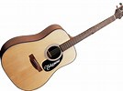](http://www.bing.com/images/search?q=picture+of+a+guitar&id=31FE15E5BFDE75E2D57EDA0E4C7CBD31F3281761&FORM=IQFRBA) [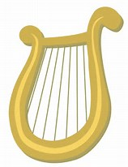](http://www.bing.com/images/search?q=picture+of+a+lyre&id=5402486806F15C4C63CB042DEAEF419C2917B749&FORM=IQFRBA) 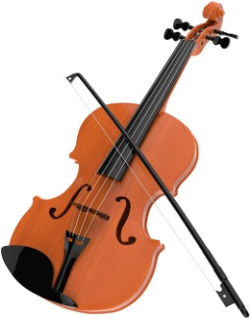

Guitar Lyre viola

**Wind instruments (aero phones**)

These are instruments that produce sound by vibration of air inside them when blown.

**Examples of wind music instruments**

* Trumpet
* Bottles
* Panpipe
* Horn
* Flute
* Saxophone
* Whistle
* Clarinet
* Trombone
* Trombone

[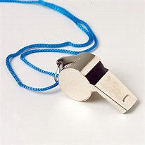](http://www.bing.com/images/search?q=picture+of+a+whistle&id=564119DD7144C3CA4C414FCDD043A3EEE459CBDC&FORM=IQFRBA) 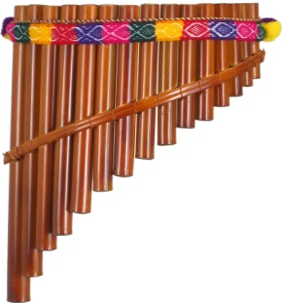 [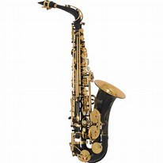](http://www.bing.com/images/search?q=picture+of+a+saxophone&id=94CCD2E2F635A60796A017A8D81A5A1B1419512A&FORM=IQFRBA)

Whistle panpipe saxophone

**Percussion instruments**

These produce sound by vibration of their surfaces when hit or beaten. E.g. drums, xylophone, shakers, thumb piano, keyboard, rattles, bell

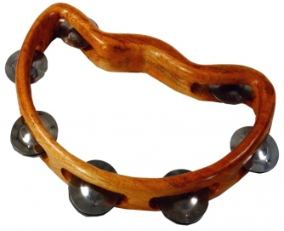[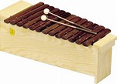](http://www.bing.com/images/search?q=picture+of+a+xylophone&id=6DCA208E071A3ECC79A122E3D617FFB72DAD1523&FORM=IQFRBA) 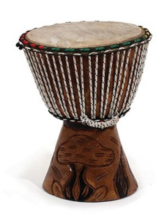Drum xylophone Rattles

**How sound travels**

* Sound travels by sound waves
* Sound travels through the state of matter

Sound travels;

* Fastest through solids because solids have the quickest vibrations
* Faster through liquids
* Slowest through gases

NB sound does not travel through the vacuum because it has no matter.

**Speed of sound**

Sound travels at different speed through the following states of matter

* Gases (air)--------------330m/s
* Liquids (water) --------1484m/s
* Solids-------------------1500m/s

**Calculations**

It took 4seconds for a man to hear a gun shot. How far away was the man from the firing point?

* Distance=Speed X Time
* Distance=330m/s X 4s
* Distance = 1320m

**Factors that affect the speed of sound**

* Temperature
* Wind
* Altitude

**Frequency**

This is the number of vibrations made in one second.

**Pitch of sound**

* Pitch is the highness or lowness of sound

**Factors that affect the pitch of sound**

* Length of the vibrating object
* Size of the object
* Nature of material of the object
* Tension of the material
* 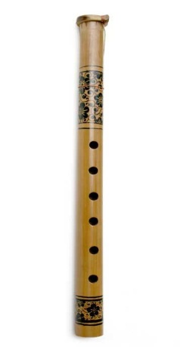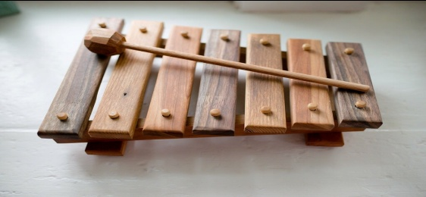Frequency
* Thickness

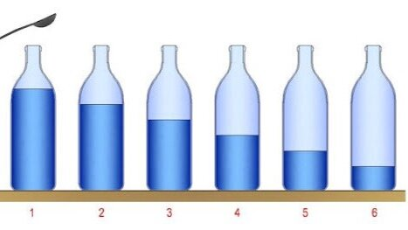 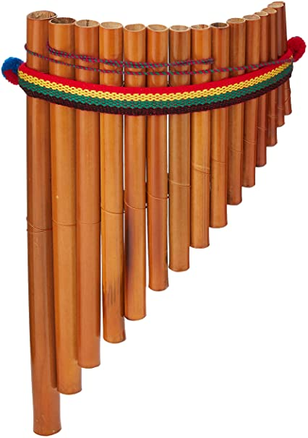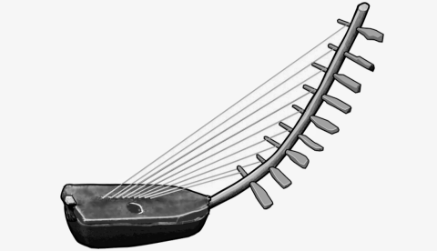

The bigger the space of vibrations the lower the pitch

Then smaller the space of vibrations the higher the pitch

Bottle one will produce higher pitch because it has a smaller space for vibrations

Bottle six will produce low pitched sound because it has the biggest space for vibrations

On a panpipe the shortest pipe will produce high pitched sound and the longest pipe will produce low pitched sound

On the bow harp the shortest string will produce high pitched sound while the longest string will produce low pitched sound

**Echoes**

* An echo is reflected sound.
* An echo is repeated sound.
* Echoes are formed when sound hits a barrier.

**How echoes are reduced in buildings**.

* Constructing a ceiling
* Putting carpets on the floor which are wooden
* Putting thick curtains on the walls, windows in big halls e.g. theatre, churches.
* Putting soft boards on walls

**Uses of echoes**

* They are used to measure the depth of water by echo sounders (fathometer)
* Bats used echoes to detect food and obstacles in their way.
* Echoes help pilots to dodge obstacles during flight
* Echoes help whales to detect danger in water

**NB**

* Smooth hard surfaces reflect sound while soft surfaces absorb sound.

**Exercise**

* 1. What is sound?
  2. State any two sources of sound.
  3. How is sound produced?
  4. What do we call the highness and lowness of sound?
  5. Mention any three groups of musical instruments
  6. To which group of musical instruments do the following belong

Guitar

Xylophone

7.How do the following musical instruments produce sound

Panpipes

A drum

8. How are echoes useful to bats?

9. In which state of matter does sound travel

(a) Fastest

(b) Slowest

10. Why doesn’t sound pass through a vacuum?

11. Mention two factors that affect the speed of sound.

12. Differentiate between pitch and volume

13. How can echoes be reduced in cinema halls?

**Volume of sound**

* Volume is the softness or loudness of sound
* Volume of sound depends on amplitude.
* Amplitude is the width of vibrations
* The greater the amplitude, the louder the sound
* Volume of sound can by increased by increasing the width of amplitude

**Diagrams**

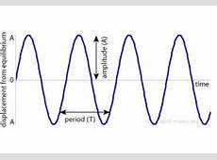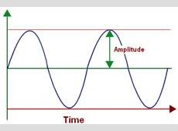

**STORING SOUND ENERGY**

**Methods of storing sound energy**

* Storing sound enable us to enjoy music for a long time
* Sound can be stored for future reference.
* By recording on magnetic tapes, records or compact discs (CDs)
* By writing it using sol-fa or staff notation (writing sound inform of symbols e.g. d.r.m.f.s.l.t.d:

**Devices that store sound**

* Digital versatile Disc
* Flash disc
* Cassette tapes
* Compact Discs
* Memory cards

**Ways of reproducing sound.**

* By singing using human voice
* By playing using piano
* Playing recorded sound on cassette players, film projectors, and DVD/CD players

**Devices that reproduce sound**

* Computers
* Mobile phones
* MP3 players
* Radio cassette tapes
* Gramophones
* Record players
* Film projectors
* Video compact disc players

**The mammalian ear**

This is the organ for hearing in all mammals.

**The ear has two major functions.**

Hearing

Body balance

**Structure of the human ear**

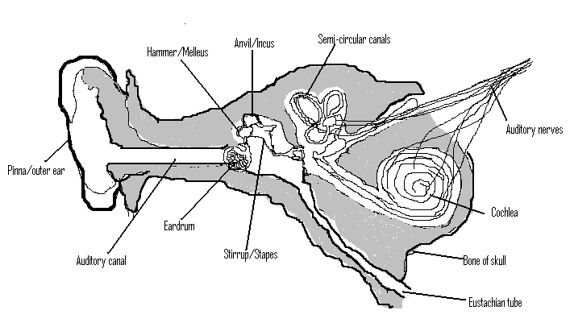

Regions of the ear

* Outer ear
* Middle ear
* Inner ear

**Outer ear**

* It is made up of the pinna and auditory canal ( ear canal)
* The pinna collects sound waves

**The auditory canal** transmits sound waves to the ear drum.

NB: Auditory canal has cilia and wax that traps dust and foreign bodies which may damage the ear drum

**Middle ear**

* It’s made of the ear drum eustachian tube and ossicles.
* Ossicles are the three small bones found in the middle ear

**The ossicles**

* Malleus Hammer
* Incus Anvil
* Stapes Stirrup

Use the formula **MIS** or **HAS**

**Ossicles**

* Theyamplify sound waves and send them into the inner ear

**Ear drum:**

* It vibrates and transmits sound vibrations to the ossicles

**Eustachian tube**:

* Balances air pressure in and out of the ear

**Inner ear**

* It’s made up of the cochlea, semicircular canal, Eustachian tube and the auditory nerve

**Semicircular canal:**

* They help in balance and posture

**Cochlea:**

* Cochlea changes sound vibrations to sound impulses or nerve messages

It is fluid filled i.e.

Endolymph and perilymph

**Auditory nerves**:

* They transmit sound impulses to the brain for interpretation

**Ear defects**

* These cause deafness.

Deafness is the inability to hear,

**Types of deafness**

**Partial deafness:**

This is a condition when one cannot hear well.

* It is caused by too much wax in the auditory canal

**Correction of partial deafness**

* By removing wax from the auditor canal (syringing)

**Permanent deafness**

* This is a condition when one cannot hear completely.

**Causes of permanent deafness**

* Damaged ear drum
* Infections by diseases e.g. Germany measles
* Inheritance from parents

**Sensory deafness**

* This is a condition when one cannot differentiate between sounds made**.**

**Causes of sensory deafness**

* Old age
* Fracture on the skull

**Diseases of the human ear**

* Otitis media
* Vertigo
* Otitis external
* Otitis internal

**Care for ears.**

* Avoid foreign bodies into the ear e.g. seeds and beads.
* Avoid boxing each other on ears.
* Avoid using sharp objects to clean ears because it damages the ear drum
* Avoid too much noise into the ears.
* Wash ears with clean water and soap regularly.

**Exercise**

1. Identify any two ways of storing sound
2. How can the store sound be reproduced?
3. How is stored sound important to people?
4. State the difference between music and noise.
5. What is the main function of the mammalian ear?
6. Which part of the ear is used to balance the body?
7. Name the three parts that make up the ear
8. How is the Eustachian tube important to the human ear?
9. What name is given to the three small bones found in the ear?
10. Write any three ways of caring for the ear
11. Mention any two types of deafness.
12. What causes permanent deafness?
13. Explain the term deafness

**THE CIRCULATORY SYSTEM**

* This is a group of body organs that work together to transport blood throughout the body parts**.**
* The circulatory system is made up of three parts.
* The heart, blood vessels and blood

**The heart**

* The heart isa muscular organ which pumps blood to all body parts.
* The heart is made up of cardiac muscles.
* The heart is enclosed in a tough membrane called **Pericardium.**
* This produces a lubricating fluid which reduces friction.
* The normal heart beat of a person is 72 times per minute but it can go beyond if there is an excitement, fear or infection
* The heart is divided into 4 chambers
* The two upper chambers each called auricle or atrium while the lower chambers are called ventricles.
* The left and right hand sides are divided by a thick wall called septum.

**The structure of the human heart**

**Functions of parts of the heart**

**Vena cava:**

* It receives deoxygenated blood from other bodies of the body.

**Pulmonary artery:**

* Ittransports deoxygenated blood to the lungs for oxygenation

**Pulmonary vein**:

* It carries oxygenated blood from the lungs to the heart

**Aorta:**

* It transports oxygenated blood from the heart to all body parts.

**Valves:**

* They prevent the quick back flow of blood.

**Septum**:

* It separates the left and right side of the heart.

NB: The main function of the mammalian heart is to pump blood to all body parts.

**How the heart works:**

* Oxygenated blood from the lungs enters the heart through pulmonary vein on the left auricle and deoxygenate blood from body tissues enters the right auricle through vena cava.
* The left ventricle is thicker and muscular with high pressure because it pumps blood for a long distance to all body parts through aorta.
* The right ventricle pumps blood through pulmonary artery to the lungs.
* The muscles of the auricles and ventricles are supplied with oxygenated blood by **coronary arteries** which branch from the aorta.

**Types of Blood vessels:**

There are three blood vessels, namely:-

Arteries, veins and capillaries

**Arteries:**

* They transport oxygenated blood away from the heart apart from the pulmonary artery.
* They are thick walled, muscular and elastic.
* They have a narrow lumen
* They carry blood with high pressure.

**Structure of an artery**:

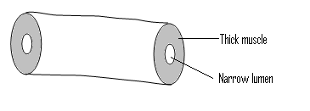

**Veins:**

* They carry deoxygenated blood towards the heart apart from the pulmonary vein.
* They are thin walled with a wide lumen
* They carry blood with low pressure

**Structure of a vein**:

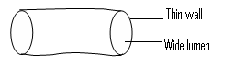

**Differences between veins and arteries**

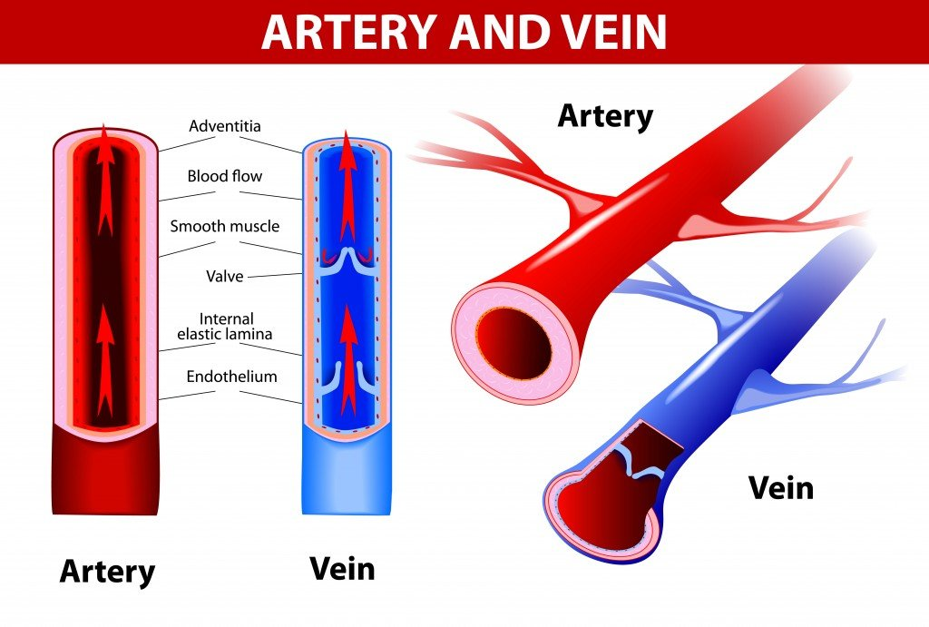

**Arteries Veins**

* Have a narrow lumen - Have a wide lumen
* They are thick walled -They are thin walled
* Don’t have valves. -Have valves to prevent back flow of blood
* Carry blood away from the heart. -Carry blood towards the heart.
* Carry blood at a high pressure. - Carry blood at a low pressure

**Capillaries:**

* These are tiny blood vessels found in every living tissue of our body.
* They connect arteries to veins.
* Our bodies have more capillaries than veins.

**Structure of capillaries**

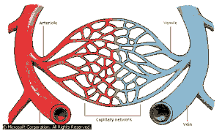

**NB:**

* Oxygenated blood is bright red while de-oxygenated blood is dark red
* All arteries join to form the aorta which is the biggest artery.
* All veins join to form the vena cava which is the biggest vein
* The smallest vein is called venule
* The smallest artery is called arteriole.

**Exercise**

1. Name the membrane in which the heart is enclosed**?**
2. Identify the artery that transports deoxygenated blood to the lungs.
3. Point out the four chambers of the heart.
4. Give one functional difference the pulmonary artery and the pulmonary vein
5. Why is the left part of the heart thicker than the right part?
6. State any one structural difference between veins and arteries.
7. Identify the smallest blood vessels in the body.
8. Name the biggest vein in the body
9. How is right ventricle of the heart adapted for its function?
10. Which type of blood is transported by the arteries?

**BLOOD**

* Blood is a red fluid (liquid) that flows round the body.

**Components of blood**

* Red blood cells (erythrocytes)
* White blood cells (leucocytes)
* Platelets (thrombocytes).
* Plasma (the liquid part)

In a normal health person, there are about 5-6 litres.

**Red blood cells**:

* Red blood cells transport oxygen
* They are red because of Haemoglobin (a protein with iron in its molecule).
* Haemoglobin is a red pigment which easily combines with oxygen to form oxy -Haemoglobin.
* Red cells are made in the red bone marrow of short bones, e.g. sternum, scapula, ribs, vertebra and pelvis.
* Red blood cells don’t have nucleus.
* It is affected by plasmodia germs that cause **malaria**.

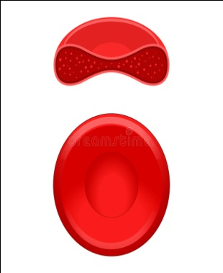**Structure of a red blood cell**

**White blood cells**:

These are larger than red blood cells.

* They have a nucleus but no Haemoglobin in their cytoplasm.
* They are made in the white bone marrow, lymph nodes and the spleen.
* The main function of white blood cells is to defend the body against diseases

**How are white blood cells adapted for their function?**

* Engulfing and digesting the germs before they produce symptoms.
* By producing antibodies against germs
* By producing antigens against the germs

NB: white blood cells are affected by **HIV/AIDS**

**Structure of a white blood cell**

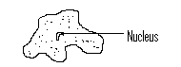

Differences WBC and RBC

White blood cells have nucleus while red blood cells have no nucleus.

WBCs have irregular shapes while RBCs have regular shapes

WBCs have no haemoglobin while red blood cells have haemoglobin

**Platelets:**

These are very tiny blood cells.

They are made in the bone-marrow.

They are responsible for clotting of blood.

**Structure of platelets**

● ●

● ● ● ●

● ● ●

**PLASMA:**

* This is a yellow pale liquid part of blood.
* It consists of blood protein, dissolved food, mineral salts, urea, carbon dioxide, hormones

**Functions of plasma**

* It transports digested food, mineral salts, urea, carbon dioxide, hormones.
* It distributes heat to all body parts

**General Functions of blood:**

* Blood carries digested food and oxygen to all body parts.
* It carries away waste products from body tissues to where they are removed out of the body, e.g. urea, uric acid, seat, excess mineral salts. Carbon dioxide from body tissues to the lungs.
* It defends the body against disease infections.
* It distributes heat to all parts of the body or it regulates body temperature.
* It carries hormones which help the body to work properly.

**Blood groups:**

**Blood transfusion** is the transfer of screened blood from one person to another as long as the blood groups agree.

There are four blood groups, namely: A, B, AB, and O.

**Donor:** Is a person who gives out blood.

**Recipient / Receiver:** is a person who receives blood.

These blood groups were first discovered by an Austrian scientist called Karland Steiner in 1890.

* A person, whose blood group is AB, can receive blood from any person of any blood group. Therefore, he is called a universal recipient.
* A person whose blood group is ‘O’ can give blood to any person of any blood group. Therefore he is called a universal donor. BUT a universal donor must receive blood from a person with group ‘o’ only.

Today because of HIV virus or AIDS, all donated blood is first screened before transfusion

**Exercise**

1. What is blood?

2. Name any three components of blood.

3. State any three uses of blood in the body

4. How are the following components of blood important in the body.

(a) White blood cells

(b) Red blood cells

(c) Platelets

5. Define the blood transfusion

6. Explain the meaning if the following terms

(a) donor

(b) Recipient

7. Name the scientist who discovered blood groups.

8. Who is a universal donor?

9. Who is a universal recipient?

10. How is blood transfusion important to casualties?

**BLOOD CIRCULATION**

* Blood circulation is the act of blood moving round the body.
* Blood circulation was first discovered by Sir William Harvey.
* Doctors listen for the heart beat and sounds produced during breathing using an instrument called **Stethoscope.**



They put it on the chest of the sick person.

* Doctors also use an instrument called **Sphygmomanometer** to measure blood pressure.
* It is normally tied around one’s hand and pumped.

**Organs involved in blood circulation**

* Heart
* Brain
* Lungs
* Liver
* Kidney

**Diagram showing the human circulatory system**

**Diseases of circulatory system**

These are diseases that affect the blood circulatory system

**Diseases of the heart**

High blood pressure

Heart attack

**Non-communicable diseases**

* Blood cancer (Leukaemia)
* Heart attack (heart failure)
* Blood clot (coronary thrombosis)
* Anaemia
* Haemophilia
* Heart stroke
* Sickle cell anaemia

**Communicable diseases**

* Malaria
* HIV and AIDS

**Effects of HIV/AIDS**

**Individual:**

* Loss of weight
* Stress
* Ill health
* Loss of appetite
* Loss of employment

**Family:**

* Loss of income
* Mistrust among family members
* Neglection of sick members

**Community:**

* Loss ofimportant people
* Poverty

**How to maintain proper working of circulatory and respiratory systems**

* Eating food rich in a balanced diet
* Doing regular physical exercises
* Eating food containing low animal fat

**Advantages of regular physical exercises**

* The heart muscles grow stronger and longer.
* The heart delivers more blood to the body muscles.
* They reduce the level of fats in the body to prevent obesity.
* They improve blood supply to the heart muscles.
* The risk of heart diseases and high blood pressure is reduced.
* Ligaments and tendons become stronger and reduce chances of getting injured.
* Joints become more flexible.
* Digestion of food is carried out quickly and easily.

**Exercise**

1. What is blood circulation?
2. How is blood circulation important in the body?
3. State the uses of the following instruments

(a)Stethoscope

(b) Sphygmomanometer

1. Identify the blood vessel that carries blood from the ileum to the liver
2. Give one reason why blood goes to the lungs before it goes to all parts of the body?
3. Write one disease and disorder of the circulatory system
4. Which component of blood is destroyed by HIV/AIDS**?**
5. State any two signs of HIV/AIDS
6. Mention any two effects of HIV/AIDS to the community.
7. Suggest any one importance of physical exercises to our body.

**THE WORLD OF LIVING THINGS**

**CLASSIFICATION OF PLANTS**

Classification of plants means grouping plants according to their different characteristics.

Plants are classified into two;

1. Flowering plants
2. Non-flowering plants.

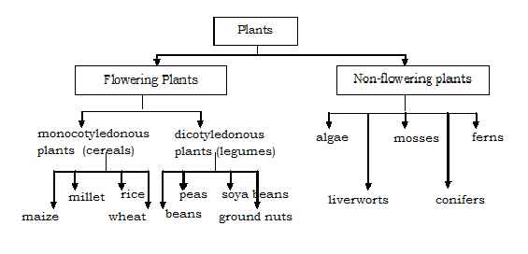

**FLOWERING PLANTS**

Flowering plants are plants that bear flowers and reproduce by means of seeds.

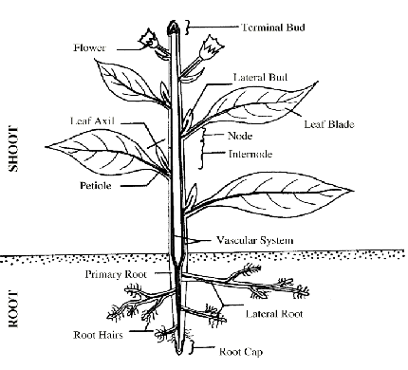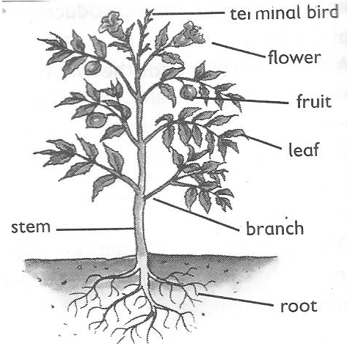**PARTS OF A FLOWERING PLANT**

* Flowering plants have both root system and shoot system
* The root system is the part that grows in the soil
* The root system involves main root, lateral roots, root hair and the root cap
* Shoot system is the part that develops from the plumule

Flowering plants are sub-divided into two;-

* Monocotyledonous.
* Dicotyledonous.

**LEGUMES:**

* These are plants with root nodules.

**Examples of legumes**

Beans, ground nuts, soya beans, peas, simsim, sun flower.

Note: **L**egumes are sources of proteins

* Legumes have root nodules
* Root nodules store nitrogen fixing bacteria.
* Nitrogen fixing bacteria trap nitrogen and convert it into nitrates in the soil.

**Characteristics of dicotyledonous plants (legumes)**

* They have a tap root system.
* They have two cotyledons.
* The seeds undergo epigeal germination
* They have network leaf venation.
* Some legumes have root nodules.

[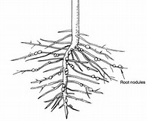](https://www.bing.com/images/search?view=detailV2&ccid=jLfBH/xV&id=2CD21BF1CC54BB66A127C53AB1BD0A6C96F4AEF4&thid=OIP.jLfBH_xV34VmIqJJrfkeDAEsD4&q=roots+of+legumes&simid=608022844930720214&selectedIndex=194)

**Cereals**

* These are plants with one cotyledon
* They are also called grains.

**Examples of cereals**

* Maize
* Millet
* Sorghum
* Rice
* Wheat
* Barley

Cereals are sources of carbohydrates.

**Characteristics of monocotyledonous plants (cereals)**

* They have only one cotyledon
* They have a fibrous root system.
* They have a parallel leaf venation
* The seeds undergo hypogeal germination.

**Exercise**

1. In one sentence state what you understand by the term classification of plants
2. Name the two groups of plants
3. Apart from root system, identify any other system of a flowering plant
4. Write one way under which roots are useful to;

People

Plants

1. Give two differences between cereals and legumes
2. Why is a maize grain called a cereal crop
3. Give two differences between cereals and legumes.
4. Apart from having root nodules, give another characteristis can 0f legumes.

**Types of root systems**

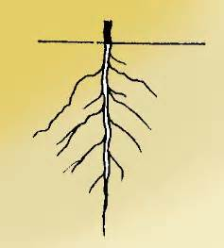**Tap root system**

Tap root grows directly from the radical of the germinating embryo

They are commonly found in dicotyledonous plants.

**[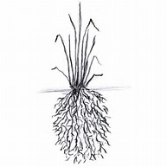](https://www.bing.com/images/search?view=detailV2&ccid=gtubFXOt&id=AA48D7DBF1EACAA07CEC90BBE6608B4DE574D2ED&thid=OIP.gtubFXOtFZ_NuVtNHnlhPwEsEs&q=fibrous+roots&simid=608010106037406775&selectedIndex=23) Fibrous root system**

Fibrous roots grow without a tap root or main root.

They are commonly found in monocotyledonous plants.

**Function of roots to a plant**

* Roots hold the plant firmly in the soil
* Root hairs absorb water and mineral salts from the soil

**NB**: Mineral salts enter by a process called **osmosis**.

**Osmosis**

This is the movement of molecules from the region of low concentration to that of high concentration through a semi-permeable membrane.

* Some plants store their food in swollen roots.
* Prop roots provide extra-support to plants
* Breathing roots absorb oxygen especially in the mangroves.
* Root nodules of legumes store nitrogen-fixing bacteria that improve soil fertility.

**Importance of roots to people:**

* Swollen roots with stored food are sources of food to people e.g. Cassava.
* Some plant roots acts as herbs to cure some diseases e.g. Mangoes, Blackjack.
* Big dry roots acts as source of wood fuel to people.
* Some big roots can be used in making craft items.

**TYPES OF ROOTS**

* Primary roots
* Secondary roots
* Prop roots
* Stilt roots
* Buttress roots
* Clasping roots

**Primary roots** are roots that grow directly from the radical of a seed.

Tap roots and fibrous roots are the examples of primary roots

**Secondary roots** are roots that develop from the other parts of a plant like the stem and leaves.

They mainly grow to give extra support to the plant with weak stems.

**Examples of secondary roots include;**

**Prop roots**: Prop roots are common to plants such as, maize, millet, sorghum and wheat.

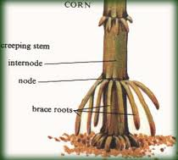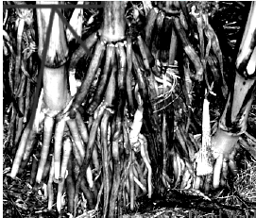

They mainly grow to provide extra-support to the plant especially at the flowering stage.

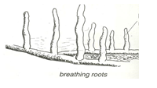**Breathing roots** grow from the stem underground moving upwards.

They act as breathing organs.

They take in air for respiration of roots.

**Buttress roots** enlarge and give more support to a plant e.g. fig tree, jackfruit

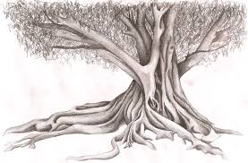

**Clasping roots** enable plants with weak stems climb other plants and trap sunlight energy.

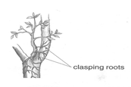

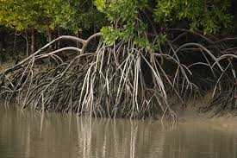**Stilt roots** are found on plants which commonly grow in muddy or swampy areas.

**Note:** some plants have swollen roots which store food for the plant.

**PLANT STEMS.**

The stem is the biggest part of the shoot system of a plant.

It holds leaves, flowers, fruits, branches and terminal bud

**Types of stems**

Upright/erect stems:

Underground/storage stems

Climbing stems/clasping.

Examples of upright stems include paw-paws, mangoes, maize, beans etc

Examples of underground stems are; stem tubers, bulbs and corms.

**Climbing stems** are weak stems of plants that cannot support themselves upright.

Plants climb others for support in order to get light

**How plants climb others**

Plants with weak stems climb other by;

1. Use of tendrils

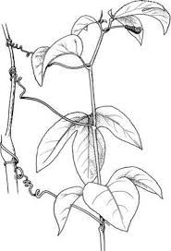 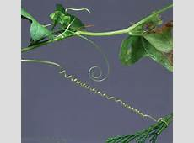

1. Use of hooks

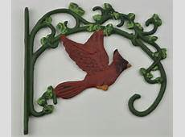

1. Twining or clasping

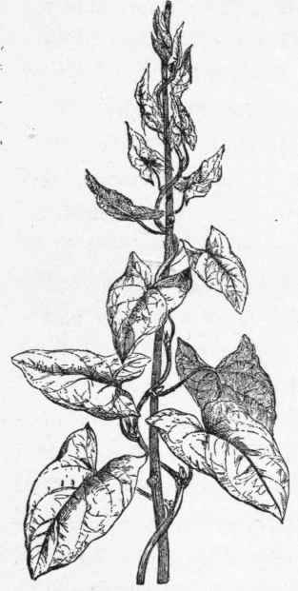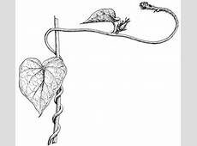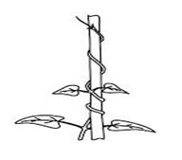

**Stem tubers**

Stem tubers are crops with underground swollen stems which store food.

**Examples of stem tubers**

Cocoyam

Irish potatoes

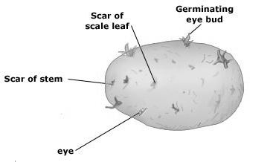

**Rhizomes**

Rhizomes are plants that grow horizontally under the ground with stored food.

**Examples of rhizomes**

Ginger

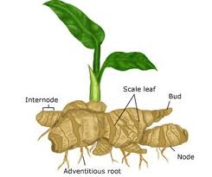

Cana lilies

Corms grow vertically under the ground with stored food rich in carbohydrates.

**Functions of stems to a plant**

* They hold and space out leaves to receive the sunlight energy
* Stems transport water and mineral salts from the roots to the leaves
* Green stems help in the process of photosynthesis
* Stems conduct manufactured food in the leaves to all other parts of the plants.
* Stems hold flowers and fruits for easy pollination and dispersal
* Some plant stems have thorns for protection

**Functions of stems to people**

* Some plant stems act as a source of food to both people and animals
* Big stems provide people with timer and poles for construction
* Plant stems act as a local medicine to cure some animal diseases
* Some plants are harvested to provide wood fuel to people
* Some plant stems are used for propagation like cassava, sugarcanes and rose flowers.

**PLANT PROPAGATION**

* Propagation is artificial methods used to obtain new plants

**Types of reproduction**

**Asexual reproduction**:

* This is the type of reproduction which does not involve gametes.

**Sexual reproduction**:

* This is the type of reproduction which involves gametes.

NB: Gametes are reproductive cells.

**Types of propagation**

**Vegetative propagation**:

* This is where part of a plant is used to obtain a new plant.

**Methods of vegetative propagation**

**Marcotting**

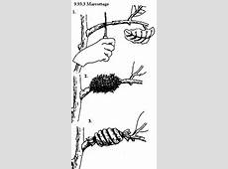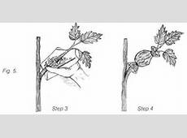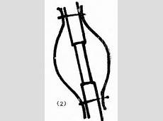

Layering

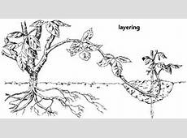

Grafting. Can be done in tomatoes, apples, oranges, lemon, etc

[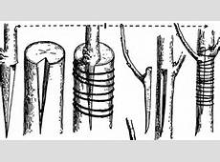](http://etc.usf.edu/clipart/87100/87133/87133_inlaying-grafting_lg.gif)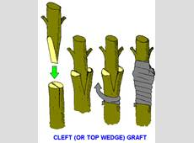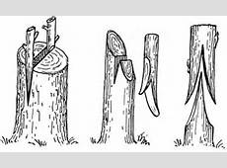

Budding

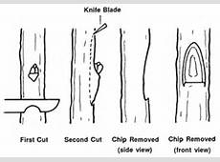

Use of leaves e.g.bryophyllum

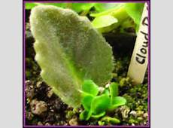

Use of stems

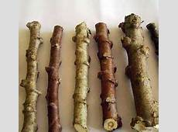

**Examples of plants propagated by use of their stems;**

Cassava

Sugarcanes

Sweet potatoes

**Use of bulbs such as onions, garlic and spider lily**

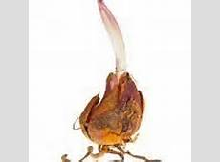Onions provide iron to our bodies.

**Use of suckers**

**Sucker of a banana plant**

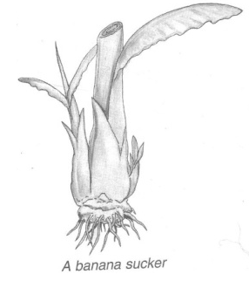

Examples of plants propagated using suckers

Bananas

Sisal

Pineapples

Some plants are propagated using tubers such as;.

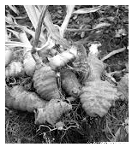**A structure showing parts of stem tuber.**

**Examples of plants propagated using stem tuber**

Irish potatoes

Cocoyam

Some plants are propagated with the help of corms

**Examples of plants propagated using corms**

Coco yams

Gladiolus

Crocus

Some plants are propagated using the rhizomes.

**Rhizomes** are swollen underground stems with stored food.

**Example of plants propagated using rhizomes**

Ginger

Cana Lilly

Zoysia grass

Turmeric



**Exercise**

1. State what you understand by the term plant propagation
2. Give two methods of plant propagation
3. State how the following plants can be propagated;
4. Sweet potatoes
5. Sisal
6. Give two advantages of vegetative propagation over seed propagation.
7. Name any one crop raised in a nursery bed

**PLANT LEAVES**

* Leaves are the green parts of a plant with stomata for gaseous exchange.
* Leaves have chlorophyll to trap sunlight energy and manufacture its starch.
* Leaves also form the shoot system of a plant.

**A drawn structure showing a leaf**

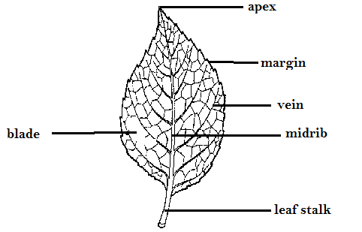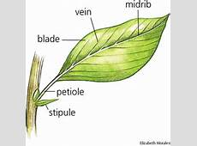

**Functions of the above parts**

**Blade**

* It has a surface area for easy trapping of sunlight energy by the help of chlorophyll
* It’s where the stomata are found.
* It helps in the manufacturing of starch

**Stomata**

* It’s called stoma for singular and stomata for plural.
* They are small holes on the leaf where gaseous exchange takes place.
* They also open to allow water escape during the process of transpiration.
* The stomata also let in carbon dioxide by diffusion during day time and oxygen during night time.

**Leaf veins**

* They are hollow to allow distribution of water and nutrients within the leaf

**Leaf apex**

* It’s the sharp tip part of a leaf to provide protection to the leaf

**Leaf stalk / petiole**

* This provides attachment of the leaf to stem or a branch.

Note: There are some processes that take place in plant leaves namely;

* Photosynthesis
* Breathing
* Transpiration

**TYPES OF LEAVES**

**Types of plant leaves**

Simple plant leaves

Compound leaves

**Simple leaves**

Simple leaves are leaves completely not divided.

**Examples of simple leaves**

1. Simple serrated leaf 2. Simple palmate leaf

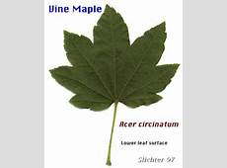

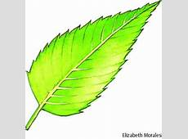

3. Simple lobed leaf 4. Simple entire leaf

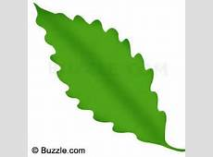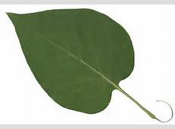

5. Simple divided entire leaf

**Compound leaves**

Compound leaves have divided lamina

Compound leaves have more than one leaf-let on one leaf blade or stalk.

A compound leaf has completely separate portions called leaflets

**Examples of compound leaves;**

* Compound trifoliate like Beans leaves
* Compound bipinnate like Jacaranda leaves/ mimosa plant
* Compound digitate leaf like Silk cotton leaves
* Compound pinnate e.g. acacia leaves /encalyptus

**Drawn structures showing examples of compound leaves**

|  |  |  |  |
| --- | --- | --- | --- |
| Bipinnate | Pinnate | Trifoliate | Digitate |
|  |  |  |  |

**USES OF LEAVES AND LEAF VENATION**

**Leaf venation**

* Plant leaf venation refers to the arrangement of veins in a leaf.
* Veins in a plant leaf help in the circulation or distribution of water and mineral salts.

**Types of leaf venations**:

There are basically two types of plant leaf venation namely;

* Network leaf venation
* Parallel leaf venation

Plants with a network leaf venation have a structure in the lamina like a net in their leaves

Network leaf venation is a characteristic of dicotyledonous plants.

**A drawn structure showing a network leaf venation of a plant leaf**

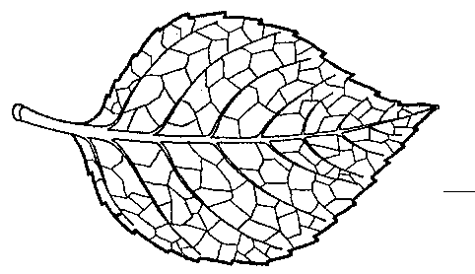

* Network leaf venation is common in both simple and compound leaves.
* Parallel leaf venation is where leaves have veins running parallel from the leaf stalk to the tip or apex.
* Parallel leaf venation is a characteristic of monocotyledonous plants.

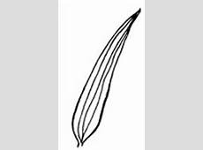**Drawn structure showing a leaf with parallel leaf venation**

**Note**:

Parallel leaf venation is mainly found in simple entire leaves.

**PHOTOSYNTHESIS IN PLANTS**

**Photosynthesis in plants**

Photosynthesis is the process by which green plants make their own food.

The word “photo” means light, “**synthesis**” means to make or “**buildup**”

**Raw materials needed**

**Water**

* To dissolve the mineral salts in a leaf.
* To soften the leaf for easy diffusion of starch.

**Carbon dioxide gas**

* This is synthesized to make carbon
* Both water and carbon dioxide combine to build up glucose stored in the plant leaves as starch.

**Conditions necessary for photosynthesis**

**Chlorophyll**

* It to trap the sunlight energy

**Sun light energy**

* Ithelps to break down water into hydrogen to speed up the formation of the starch.

**Note**:

* Oxygen is a by-product of photosynthesis while starch is the main product.
* Animals get oxygen from the process of photosynthesis.
* Photosynthesis cannot take place at night due to the absence of the sunlight energy.
* Photosynthesis is a chemical change in plants.

**TRANSPIRATION IN PLANTS**

* Transportation is also a process in plants that take place in the leaves and some stems.
* Transpiration is the process by which plants lose water as vapour into the atmosphere
* Transpiration takes place in plants through the stomata of leaves, lenticels and in the cuticle of stems

**Note:** Let the learners participate in carrying out an experiment under the guidance of the teacher

**Illustration showing transpiration in plant leaves.**

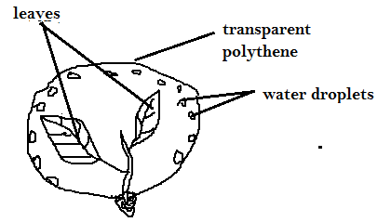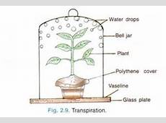

**How plants benefit from the process of transpiration (importance);**

* Plants are able to absorb water and mineral salts from the soil through their roots up to the rest of the plant parts.
* Transpiration helps in cooling the plant during a hot day.

**Note**:

* The transpired vapour from the plants helps in the formation of rain.

**Dangers of transpiration**

* Plants lose even the useful water they need during a dry season. This may make plants dry up to death
* It lowers the crop yields due to less water left in the plant.

**Ways plants reduce the rate of transpiration.**

* Some plant leaves are modified into thorns. E.g. cactus.
  + 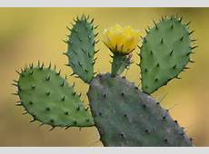
* Some plant leaves have few stomata and distributed at the lower part of the leaf.
* Some plants have leaves with a small surface area to reduce the rate of water loss
* Some plants reduce the rate of transpiration by shedding their leaves especially during dry season e.g. deciduous plants (Mvule, Oak & fig trees)
* Leaves have a wax-like layer to cover their stomata to limit the water loss.
* Stems have tough cuticles and lenticels to guard against water loss.

**Factors that affect the rate of transpiration in plants;**

The following are the conditions that either increase or decrease the rate of transpiration;

**Wind**

Wind blows off the water molecules on the plant leaf giving chance or space for more vapour to come out. This increases the rate of transpiration.

**Humidity:**

Humidity is the amount of water vapour in the atmosphere.

High rate of humidity lowers the rate of transpiration and vice versa.

**Temperature**:

High temperature during hot days causes plant leaves to lose a lot of water than on cool days.

**Sunlight:**

Heat from the sun causes the opening of the stomata, lenticels and cuticle hence creating more chances of losing water.

**Surface area of the leaf:**

Plants with small surface area of their leaves lose water at a lower rate than those with larger leaf surface area.

**Number of stomata:**

Plant leaves with fewer stomata have a low rate of transpiration

The higher the number of stomata, the higher the rate of transpiration

Some leaves have stomata at the lower side of the leaf

**NB:** Most transpiration takes place in leaves

**FLOWERS**

* The flower is the reproductive part of a plant.
* A flower is mainly used for reproduction in a plant.
* The flower has both the female and male gametes
* A gamete is a reproductive cell

**Parts of a flower**

* The female part called **pistil**(gynoecium).

Pistil is made up of stigma, style, ovary and ovules

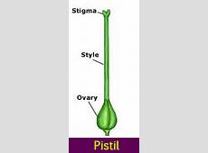

Male part called ***stamen*** (androecium)

Stamen is made up of the filament and anther head.

The male reproductive cells are the pollen grains and female are the ovules.

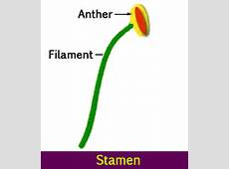

**Drawn structure showing parts of a flower**

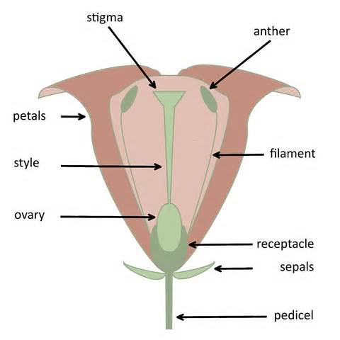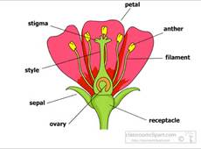

**Functions of the parts**

**Petals**, the brightly coloured petals help to attract pollinating agents such as insects.

A group of petals is called ***corolla***

**Sepals**- Green sepals help to manufacture food for the plant.

- Protect the inner parts of the flower at an early stage (bud stage)

A group of sepals is called ***calyx***

**Style**: is a passage of the pollen grains to the ovary

The style also holds the stigma in position

**Ovary**. It produces the ovules.

A mature fertilized ovary turns into a fruit

**Filament**. Holds the anther heads in position

**Antherheads**. Produce pollen grains.

**Stigma**. It receives pollen grains. m

**POLLINATION**

* **Pollination** is the transfer of pollen grains from the anther heads to the stigma of a flower.
* Pollination helps to allow fertilization in plants
* **Fertilization** is the union of both female and male gametes to form a zygote.

**Types of pollination**

* Self-pollination
* Cross pollination

**Self-pollination** is the transfer of pollen grains from the anther heads to the stigma of the same flower

Flowers with self-pollination have shorter stigma compared to their anther heads.

They also have brightly coloured petals to attract pollinators

**Note:**

* Some flowers are adapted to self-pollination by:
* Both the anther and stigma maturing at the same time
* The flowers remain closed until self-pollination takes place

**Structure illustrating self-pollination**

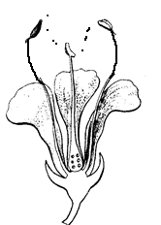 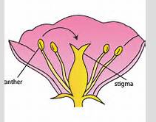

**Cross-pollination** is the transfer of pollen grains from the anther heads of one flower to the stigma of another flower but of the same type or species.

In cross–pollination, the anther heads are shorter than the stigma.

**Flowers are able to carry out cross-pollination by**;

* Maturing of anther heads and stigma at different times
* Having one productive gamete on each plant i.e. paw-paw plants

**Illustration showing cross-pollination**

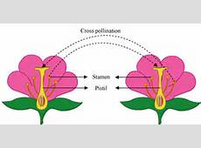

**Note**: **Agents of pollination** refers to the factors that are responsible or cause pollination to take place. These include;- **wind, insects, birds, people** etc.

**Insects-pollinated flowers**: These are flowers pollinated by insects.

**Characteristics of insect pollinated flowers**

* They have good scent.
* They have brightly coloured petals.
* They produce sticky pollen grains.

**Wind pollinated flowers**:These are flowers pollinated by wind.

**Characteristics of wind pollinated flowers**

* They produce a lot of pollen grains
* They have no scent
* They have dull coloured petal

**SEEDS**

A seed is a mature fertilized ovule.

A seed develops into a young plant or a seedling under favourable conditions.

**Classification of seeds**

* Dicotyledonous seeds
* Monocotyledonous seeds

**Dicotyledonous seeds** are seeds with two cotyledons

These seeds can be split into two equal parts of the cotyledons

**Examples of dicotyledonous seeds**

* Bean seeds
* Peas
* Groundnut seeds

All dicotyledonous seeds undergo epigeal germination.

**A drawn structure showing parts of external and internal parts of a bean seed.**

|  |  |
| --- | --- |
| **External Parts** | **Internal parts** |
| 01 010 |  |

**Monocotyledonous seeds**

Theseare seeds with only one cotyledon.

They are mainly grains or fruits. Examples include; maize, millet, sorghum, etc.

Monocotyledonous seeds undergo hypogeal germination.

**Drawn structures showing external and internal parts of a maize grain**

|  |  |
| --- | --- |
| **External parts** | **Internal parts** |
| 01 011 | 01 012 |

**Functions of the above parts**

**Seed coat (testa)** It protects the inner delicate parts of the seed

**Cotyledon**

Absorbs stored food from the endosperm and supplies it to the embryo during germination.

**Endosperm**

Stores food in monocotyledonous seeds

**Plumule**

It grows into shoot system

**Radicle**

It grows into the root system.

**Micropyle**

**I**t allows air and water into the embryo.

**GERMINATION IN PLANTS**

* Germination is the development of a seed embryo into a seedling under favourable conditions.
* During germination, the Radicle grows into the root system to support the seedling firmly into the soil.
* The radicle also grows root hairs to absorb water and mineral salts from soil.

**Types of germination**

There are basically two types of germination

* Epigeal germination
* Hypogeal germination

**Epigeal germination** is a type of germination where the cotyledon comes out of the ground.

**Examples of plants that undergo pigeal germination**

* Beans,
* Soy beans,
* Groundnuts.

Epigeal germination is a common characteristic of dicotyledonous seeds

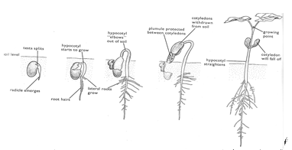**Drawn structure showing the different stages in epigeal germination**

**Hypogeal germination**:

This is a type of germination in which the cotyledon remains under the ground.

This type of germination is a common characteristic of monocotyledonous seeds.

Examples of crops that undergo hypogeal germination

Maize

Millet

Rice

Sorghum

**Stages involved in hypogeal germination.**

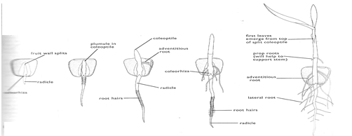

**Conditions necessary for seed germination**

A seed will only germinate under favourable conditions such as, oxygen, water and warmth.

**Oxygen**:

it is used by the growing embryo for respiration.

**Warmth**:

it provides good temperature for germination to take place.

**Water**:

it dissolves food in the cotyledon or endosperm for growing embryo.

Seed viability is the ability of a seed to germinate under favourable conditions.

**Seed viability**

This is the ability of a seed to germinate if all necessary conditions for germination are available

**A viable seed should be;**

* Mature and dry
* Whole without a hole / wrinkles
* Health and of a good variety

**Seed dormancy**

This is the inability of a seed to germinate if all necessary conditions for germination are available

**Factors that can lead to seed dormancy**

* Rotten seeds
* Wrinkled seeds
* Holes on the seed
* Immature seeds
* Diseased seeds

**FRUITS**

A fruit is a mature fertilized ovary

A fruit is any structure in flowering plants that contains mature fertilized ovules.

A fruit has two scars i.e. style scar and stalk scar.

Groups of seeds;

* Juicy fruits (succulent fruits)
* Non juicy fruit (dry fruits)

**JUICY FRUITS/SUCCULENT FRUITS**

Juicy fruits are groups of fruits with juicy pericarps.

**Examples of juicy fruits**

Berries

Pomes

Drupes

*(a)****Berries***

These are fruits with many seeds

**Examples of berries**

Guavas

Tomatoes

Oranges

Lemon

Passion fruits

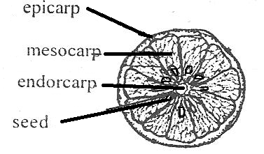

*(b)****Drupes***

These are fruits with only one seed such as avocado fruit and mango fruit.

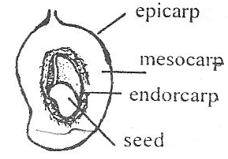

*(c)Pomes* are fruits with few seeds like an apple,[*Cotoneaster*](https://en.wikipedia.org/wiki/Cotoneaster), [*Crataegus*](https://en.wikipedia.org/wiki/Crataegus), [loquat](https://en.wikipedia.org/wiki/Loquat), [medlar](https://en.wikipedia.org/wiki/Medlar), [pear](https://en.wikipedia.org/wiki/Pear), [*Pyracantha*](https://en.wikipedia.org/wiki/Pyracantha), [toyon](https://en.wikipedia.org/wiki/Toyon), [quince](https://en.wikipedia.org/wiki/Quince),[[2]](https://en.wikipedia.org/wiki/Pome#cite_note-Pereira-2)[rowan](https://en.wikipedia.org/wiki/Rowan), and [whitebeam](https://en.wikipedia.org/wiki/Whitebeam).

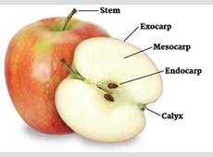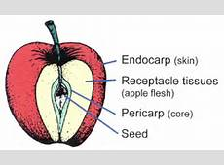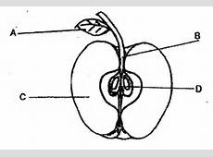

**Dry fruits**

These are fruits whose pericarp is usually dry hard and woody.

**Divisions of dry fruits**

* Splitting (dehiscent fruits)
* Non-splitting (indehiscent fruits)

**Splitting fruits**

These are seeds which have capsule or pods that split to disperse their seeds Examples of splitting seeds

Beans

Peas

Castor oil

***Non-splitting fruits*** have one seed only.

These are seeds whose pericarp does not split to disperse the seeds but have structures for their mode of dispersal.

**Examples of non splitting seeds**

Black jack

Maize,

Sunflower

Tridax

**Note**:

* Some fruits develop from one flower. They are called ***simple fruits***.
* Sometimes all flowers on a stalk make one fruit. Such fruits are called ***compound***or***multiple fruits*** eg. Pineapple.
* Some fruits are not formed from the ovary of a flower but from some other parts of a flower. Such **fruits** are called ***false fruits***. E.g. an apple which develops from a receptacle

**NON-FLOWERING PLANTS**

Non-flowering plants are groups of plants that do not bear flowers.

Non-flowering plants are subdivided into three namely;

* Spore producing
* Coniferous plants
* Algae

Spore producing plants are groups of non-flowering plants that reproduce by means of spores.

A spore is a single cell that can develop into a new plant under favorable conditions.

**Examples of spore producing plants**

* Liverworts
* Mosses
* Ferns
* Horsetail

**Ferns** are the most advanced group of spore producing plants with proper leaves, stems and roots.

**Mosses** are small green cushion-like and grow commonly on house roof verandas, tree trunks, and in damp soils.

**Liverworts** have leaf like structures and commonly grow in wet moist places.

**Illustrations showing different examples of spore producing plants**

**Fern mosses liverwort**

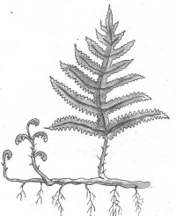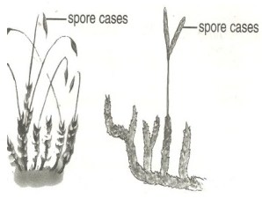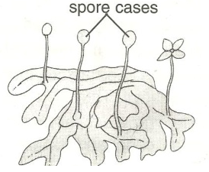

**Note**:

All spore producing plants are green and therefore able to make their own food.

**Coniferous plants** are true non-flowering plants that do not bear flowers but reproduce by means of seeds protected in hard structures called **cones**.

Conifers have roots, stems and small needle shaped leaves.

**Examples of coniferous plants include,** pines, cedar, podo tree, cypress, fir tree, gingko

**Economic importance of conifers**

* Some are planted in compounds to provide shade and also act as wind breaks.
* Some conifers are planted around the compounds and farmers to act as live fences

**Algae**

* These are simple plant like organisms which grow in water and in other dump places.
* They differ from plants in that their cells are not clearly organized into tissues for a specialized function

**Examples of algae**

* Spirogyra, which looks like long green threads.
* Sea weeds
* Algae reproduce by cell division

**A diagram of a spirogyra**

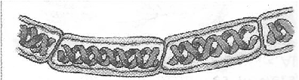

**NB:** Green algae are found in a variety of habitats including fresh water, the sea, soil, tree trunks but the majority is aquatic.

**Uses of algae to people**

* Sea weeds like red algae can be eaten.
* Sea weeds provide a number of important food additives
* They also provide an agar used for growing micro-organisms
* Algae are used in the production of biofuels.

**Exercise**

1. In one sentence show the meaning of non-flowering plants
2. Mention the two main groups of non-flowering plants
3. Conifers cannot bear flowers. How do they reproduce?
4. State two ways in which coniferous plants can be useful to people
5. Briefly explain why algae are not classified as plants.
6. How can algae be useful to an industrialist who deals in food processing?

**SEED AND FRUIT DISPERSAL**

Dispersal is the scattering of a seed or fruit from the mother plant to other area.

In some plants only seeds are dispersed while other plants it’s the fruits.

**Importance of seed and fruit dispersal**

* Dispersal enables plants to colonize new areas
* Dispersal reduces competition for light and the nutrients among plants.
* Dispersal increases the chance of the plant survival.

**Agents of seed and fruit dispersal**

* Wind.
* Animals.
* Flowing water.
* Self-mechanism.

**Types or mechanisms of seed dispersal are;**

* Wind dispersal
* Animal dispersal
* Water dispersal
* Explosive mechanism.

**Characteristics of seeds dispersed by animals**

* They are heavy and have juicy mesocarps
* Some seeds are sticky
* Some have hook-like structures to enable them attach themselves on the animals’ bodies
* Some have hard seed coats to protect them from the digestive juices.

**Examples of seeds dispersed by animals**

* Mango fruit
* Guava fruit
* Jack fruit
* Black jack
* Avocado fruit

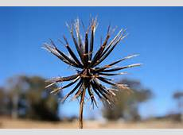 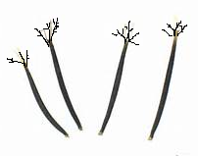

**Characteristics of seeds dispersed by wind**

* Many are small and light to be easily carried by wind.
* Some like jacaranda seeds have wing-like structures for floating in air.
* Some like a dandelion have a parachute hair structure

dandelion

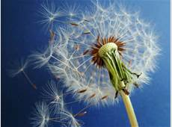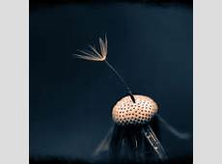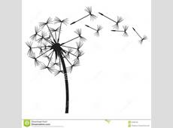

tridax

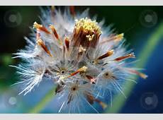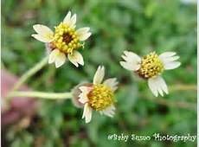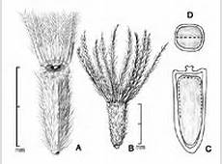

Jacaranda

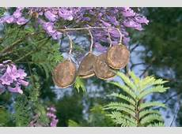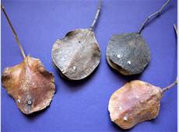

Seeds dispersed by **self mechanisms**split their pods when ripe and disperse their seeds.

**Examples of seeds dispersed by self mechanism**

Castor oil

Peas

Beans.

Seeds dispersed by **flowing water** are of plants that grow on water or near river banks.

**Examples of water dispersed seeds**

* Water lilies and coconut fruits
* Water lily

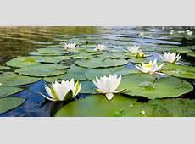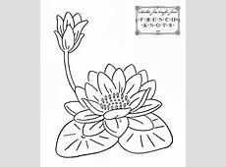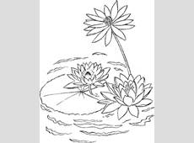

Coconut

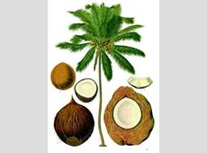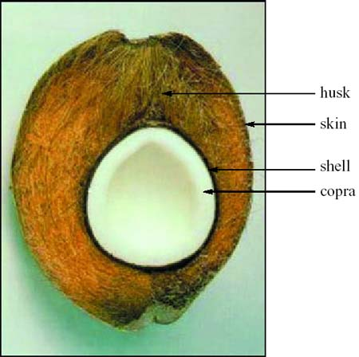

The husks of the coconut has many air spaces trapped inside it and this helps it to float

**THEME: SCIENCE IN HUMAN ACTIVITIES AND HUMAN OCCUPATION**

**TOPIC : KEEPING CATTLE**

**KEEPING CATTLE**

Keeping cattle refers to the act of rearing bulls, cows, calves, buffalos and heifers.

Animal husbandry refers to the act of rearing farm animals or livestock.

Farm animals include;-

Pigs, sheep, goats, cattle, and rabbits

**A drawn structure showing the external features of a cow and a bull**

Cow Bull

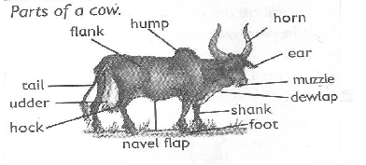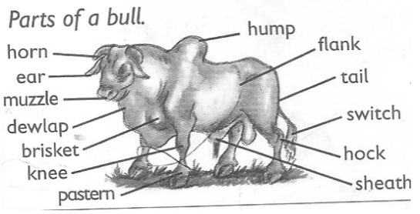

**Importance of keeping cattle**

Reasons why people keep cattle;

* Cattle provide people with milk and meat which are sources of proteins.
* Waste materials (dung) from cattle acts as natural manure used to improve soil fertility
* Hooves and horns are used to make enamel items like plates and cups.
* Hides from cattle are used in making leather products.
* Cow dung can be used in building local houses and making biogas
* Keeping cattle is a source of employment.

**TYPES OF CATTLE**

A type of cattle is a class of cattle kept for a specific purpose. Specific purpose may be;

* For milk production
* For meat (beef) production
* For provision of animal labour
* For both milk and meat production

**Examples of types of cattle**

* Dairy cattle for milk production
* Beef cattle for beef (meat) production
* Dual-purpose cattle for the both milk and meat.
* Draught cattle or work cattle

**Characteristics of dairy cattle**

* They have a thin body that carries little meat
* They have a wide and well set hind limbs
* They have big udders with four medium teats and produce a lot of milk.
* They have triangular body shape and usually docile/humble.

**A drawn illustration showing body shape of dairy cattle.**

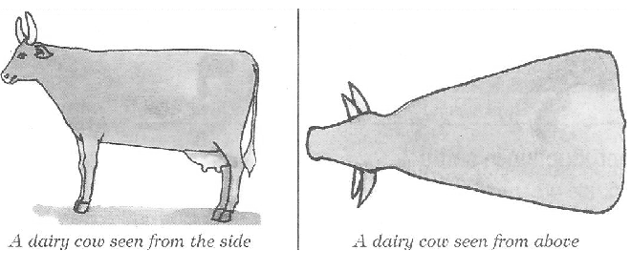

**Examples of dairy cattle include.**

* Friesian
* Ayrshire
* Guernsey
* Jersey
* Jamaican hope
* brown Swiss cattle

**BEEF CATTLE**

Beef cattle are groups of cattle kept for meat (beef) production.

**Examples of cattle kept for meat production**

* Aberdeen angus
* Here ford
* Charolais
* Short horn
* Galloway
* American beef master

**Characteristics of beef cattle**

* They have abroad rectangular body shape
* They mature quickly and give plenty or high quantity of meat
* They are very stubborn with no horns
* They have thick muscles.

**An illustration showing the body shape of beef cattle**

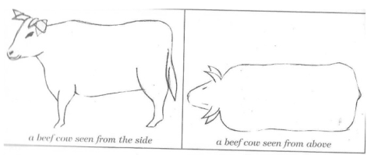

**Dual purpose cattle**

These are groups of cattle kept for both milk and meat production

They are mainly local meat products.

**Examples of dual purpose cattle**

* Sahiwal
* Red poll
* Milking short horn

**Note**:

Dual Purpose Cattle have characteristics of dairy cattle and beef cattle

**BREEDS OF CATTLE**

**A breed of cattle** is a family of cattle having specific characteristics.

**Specific characteristics may include;**

* Colour of cattle
* Size of the animals
* Productivity of the animals.

**Breeds of cattle**

* Local breeds of cattle (indigenous)
* Exotic breeds of cattle
* Cross breeds

**Local breeds or indigenous cattle**

These are breeds of cattle that have lived in East Africa for a long time.

They are also called the native breeds kept for both milk and meat production.

**Examples of local breeds of cattle**

* Small east African zebu
* Boran cattle.
* Sanga cattle
* Ankole cattle

**Characteristics of local breeds of cattle**

* They are resistant to tropical diseases
* They have the ability to walk long distances
* They produce good naturally flavoured products
* They can survive on poor pasture and tropical weather conditions.
* They grow and mature slowly
* They are small in size and produce less meat and milk

**Disadvantages of local breeds of cattle**

* They produce less meat and milk
* They have a slow growth rate

**Exotic breeds of cattle**

* These are groups of cattle breeds imported into East Africa.

**Characteristics of exotic breeds of cattle**

* They grow quickly with no horns
* They are not resistant to diseases.
* They need a lot of attention and care.
* They produce a lot of milk and beef

**Cross breeds**

These are breeds of cattle obtained after mating a local breed with an exotic breed.

This is the best way of improving upon the quality of local breeds of cattle.

Examples of cross breeds of cattle

**Other ways of improving on the quality of local breeds**

* By proper feeding
* By selective mating
* By proper housing
* By proper disease control

**BREEDING IN CATTLE**

**Breeding** is the act of maintaining or improving the desired characteristics in cattle.

**Desired characteristic in cattle**

* Size of the animal.
* Resistance to diseases.
* Animal’s skin colour
* Productivity of the animals

**Types of breeding**

* Line breeding
* Inbreeding
* Cross-breeding
* Out breeding
* Upgrading

**Line breeding**

This is the act of mating closely related animals such as cousins.

This type may result into poor production in animals

**Inbreeding**

This is the act of mating closely related animals such as a brother and a sister

This method if not properly practiced, it may also produce poor quality animals.

**Out breeding**

This is the practice of mating related animals but from different flocks or herds.

This method helps to restore the qualities in cattle that may be disappearing from a flock.

**Cross breeding** is the practice of mating a local breed with an exotic breed of cattle.

After cross breeding, a cross-breed or a hybrid is obtained.

Cross-breeding helps to improve animals with poor qualities

**Upgrading:**

This is the act of improving upon the qualities of one breed.

This is done by mating breeds of superior qualities several times to obtain good breeds in the herd.

**REPRODUCTION IN CATTLE**

**Reproduction,**

* **Reproduction** is the ability to increase in the number of a species of living things
* Cattle reproduce naturally when bulls mate with cows on heat.
* Cows undergo sexual reproduction which involves mating and production of gametes.
* **A gamete** is a reproductive cell. In animals the male gametes are called sperms. While the female gametes are called ova (plural) and an ovum (singular)

**The reproductive system of a cow**

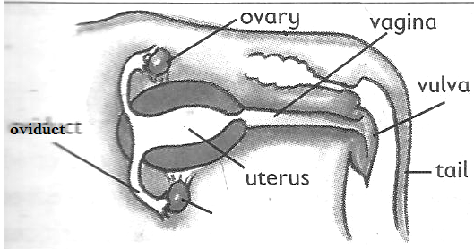

**Functions of different parts**

**Vulva:**

It receives and guides the penis

**Vagina:**

It is where semen is deposited

**Cervix:**

It closes the lower end of the uterus during pregnancy

**Ovary:**

It produces the ova and hormones that help to control the sexual cycle

**Ova:**

These are the female reproductive cells produced by the ovary

**Oviduct/fallopian tube:**

This is the place where fertilization takes place.

**Uterus:**

It is where implantation takes place (development of the foetus)

**Reproductive system of a bull**

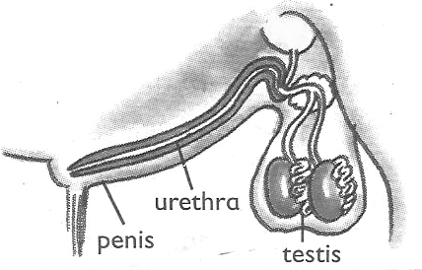

**Functions of parts**

**Testes**

It produce sperms

**Spermducts**

It carry sperms

**Urethra**

It passes out urine and sperms

**Penis**

It delivers semen in the vagina of a cow

**Epididymis**

It stores sperms

**HEAT PERIOD AND INSEMINATION (SERVICES)**

**Heat Period**

* This is the time when a cow is in need of a bull for mating.
* Mating takes place only when a cow is on heat.

**Signs of a cow on heat**

* It becomes restless
* It mounts other cattle
* It stands while others are lying down
* It urinates frequently
* It puts its tail on the side to enable its vulva to be seen
* There is a mucus discharge from the vulva
* Its vulva swells and changes its colour
* There is a drop in its milk production
* The cow makes a lot of noise (Bellows frequently)

**Insemination**

Insemination is the act of depositing sperms into the female reproductive organ of the cow.

For insemination to take place, the cow or a heifer should be on heat i.e. after showing signs

**Types of insemination**

* Natural insemination
* Artificial insemination

**Natural insemination** involves the use of a bull to mount the cow on heat in order to deposit the sperms into the vulva.

**Advantages of natural insemination**

* Natural insemination saves time
* It does not need a trained inseminator in order to carry it out.

**Disadvantages of natural insemination**

* More sperms are wasted in one cow.
* It’s very expensive to buy and maintain a bull
* Stronger bull can cause injury to weak cows
* Once the bull dies, sperms are also lost.

**Artificial insemination**

Artificial insemination is the to act of introducing sperms in the vagina or vulva of a cow by the help of a trained veterinary officer.

Semen used is got from health bulls and with desired characteristics.

Sperms are injected into the vagina using an insemination syringe.

**Advantages of artificial insemination**

* It reduces the cost of keeping many bulls on the far,
* It’s cheaper to buy semen than buying and maintaining a bull.
* It prevents injury to small cows and heifers by bigger or heavy bulls.
* It helps to control inbreeding and unwanted pregnancies in cattle
* It promotes selective breeding.

**Disadvantages of artificial insemination**

* It’s difficult and expensive to maintain proper storage of sperms.
* It can’t be applied to animals whose signs of heat can’t be easily identified.
* It requires a trained experienced inseminator
* Animals are denied chance to enjoy sex.

**OTHER PRACTICES CARRIED OUT ON CATTLE FARMS**

**Castration**

Castration is the removal of the essential male sex organs called testes. The main aim of castration is to make the bull unable to fertilize a cow.

**Methods of castration**

* Open castration method.
* Closed castration method
* Use of the loop or elastrator method.

In a *closed castration method*, an instrument called a burdizzo is used to crush the tubes leading to the scrotum.

We can also use a rubber ring to seal the sperm ducts and thus killing the epididymis

**A drawn structure showing a burdizzo**

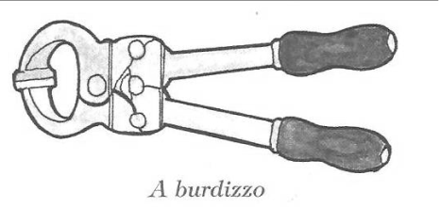

**Note:**

When the jaws of the burdizzo are closed, the spermatic cord is crushed destroying the spermatic nerves.

**Advantages of castration:**

* Castrated bulls grow faster and fatten
* Castrated bulls are calm, humble and easy to handle
* Castration helps to prevent inbreeding (unwanted pregnancies in the herds)
* Castration also helps to prevent diseases on a farm

**Disadvantages of castration**

* Animals are denied chance to enjoy natural sex.
* There is loss of blood from the animal leading to anaemia.
* The wounds may become septic and animal may die if not treated well.

**Note:**

The use of the ring prevents blood from flowing into the testis that will cause them to shrive and fall off.

In an open castration, the scrotum is cut open using a razorblade or a sharp knife and the testes are removed.

**DEWORMING AND DEHORNING.**

**De-worming**

This is the act of giving drugs to animals to kill internal worms.

**Ways of de-worming animals.**

**Drenching:**

This is the act of giving liquid medicine to animals through the mouth. It can be by using a drenching gun.

**Dozing:**

This is the act of giving solid medicine to animals in order to kill internal worms.

**Importance of deworming**

Deworming kills internal parasites like tape worms etc.

**Dehorning**: is the removal of horn buds from the calf to prevent growth of horns.

Dehorning should be done when the calf is about 2-3 months.

**Methods of dehorning**

* By use of chemical (done between 3-14 days)
* By use of a hot iron (between 7-30 days)
* Use of spoon dehorners. (between 1-2 month)

**Advantages of dehorning**

* It makes the animal easy to handle
* It increases the space in kraals, milking shades and in vehicles during transportation.
* Many animals can be kept in a small space
* It reduces the risk of injury among cows.

**STEAMING UP AND CALVING**

**Steaming up**

This is the act of feeding in calf-cow on feeds rich in proteins.

In calf-cow is one which has shown up **signs of pregnancy**

**Signs of pregnancy in cattle**

* The udder increases in size and filled up with milk.
* There is mucus discharge around the cervix
* The uterus enlarges in size between 2-3 months

***Lactation period*** is a period when a cow produces milk after giving birth.

**Calving**

This is the act of giving birth by a cow

**Advantages of steaming up**

* It enables the foetus to grow well
* It helps to increase the period of lactation.
* It also prepares the cow for calving.

**An illustration showing developing foetus**

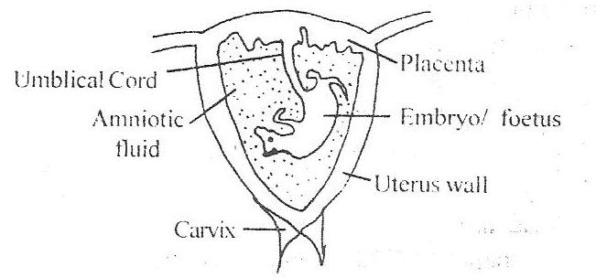

**Note:**

**The placenta**

It stores oxygen and digested food before reaching the foetus.

**Umbilical cord**

This is a passage of food and oxygen to the foetus

It also transports wastes from the foetus to the placenta.

**Amniotic fluid**

This acts as a shock absorber for any external pressure.

**Calving**

Calving is the act of producing calves by a cow.

**Signs of calving in cows**

* Discharge of a lot of fluids from the vulva
* Restlessness
* Loss of appetite
* Labour pains
* Isolation

**Colostrum**

Colostrum is the first milk produced by a cow after calving.

**Importance of colostrums**

* Open the digestive tract of a calf
* Provide a calf with a balanced diet
* Boosts the immunity of a calf

**Fertilization**

This is the union of a male and female gamete to from a zygote. This takes place in the **oviduct or fallopian tube.**

**MILKING IN CATTLE**

**Milking is** the method of obtaining milk from the cow’s udder.

* Milk is got by squeezing the teats of cow
* Milk is secreted from the mammary glands of a female animal.
* Milk contains over 85% water and 15% proteins fats, calcium, phosphorous

**Types of milking**

* Hand milking
* Machine milking

***Hand milking*:** is the act of squeezing the teats of a cow using hands.

This method can be used to 1-3 animals.

***Machine milking:*** is the act of using a machine to squeeze the teats of cow.

Machine milking is the best for more than five animals.

**Note**:

A cow can hold up or hide milk if it’s disturbed.

**Disadvantages of machine milking**

* Needs a trained person to operate machine.
* The machines are expensive to buy.
* The udder may be injured in case of a machine fault.

**Ways of obtaining clean milk.**

* Prepare the milking place clean and free from dust.
* Wash all the milking containers clean.
* Wash the teats of the cow with warm water to stimulate milk let down.
* Tie the hind legs of the cow and give the cow some feeds to keep busy and relaxed.
* After milking, filter the milk and use a strip cup to detect mastitis in milk.
* Put the milk in clean containers and cover.

**Note**:

A lactometer is used to detect the presence of water in milk

It is also used to check if fats have been removed from milk

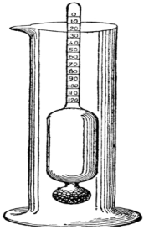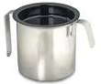**Structure of a lactometer Structure showing a strip cup**

* Before actual milking is done, the farmer should smear milk jelly or cream to the teats to prevent them from cracking.
* A cow having mastitis should be milked last and its milk should be poured as treatment goes on.

**PRESERVATION OF MILK AND MILK PRODUCTS**

The following are the products got from well processed milk.

|  |  |  |
| --- | --- | --- |
| **Milk products** | **How it’s made** | **Usage** |
| Cheese | Made by sour milk then thickening it by salting | Milked into dishes |
| Fresh milk | Boiling and refrigerating | Drunk and added to dishes |
| Skimmed milk | Separating fats from milk | For frying foods |
| Yoghurt | Turning milk after removing fats | Used to be mixed into rice and other foods |
| Ghee | Made by boiling butter | For frying foods |

**Preservation of milk**

Milk should be protected from contamination by bacteria for future use.

**Methods of milk preservation**

* Pasteurization
* Sterilization refrigeration
* Boiling and quick covering

**Sterilization**

* Thisinvolves killing bacteria in milk with maximum boiling followed by covering it on cooling

**Pasteurization**

* This involves strong heating and sealing milk before germs enter.
* This method was discovered by Louis Pasteur.

**Note:**

Boiling is not preferable method because some milk is lost during evaporation.

**Reasons why farmers should keep milk records**

* To know the amount of milk produced per a cow at a certain period of time.
* It enables a farmer to select animals with less productivity rate for treatment.

**CATTLE PARASITES**

A parasite is an organism that depends on another organism for food and shelter without killing it.

**Groups of cattle parasites**

* External parasites (ecto-parasites)
* Internal parasites (endo-parasites)

**External parasites (ecto parasites)**

These are parasites that live outside the body of the animal.

They suck blood from the animal making them anaemic

**Examples include:**

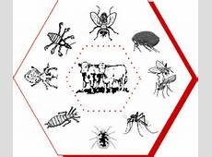

Ticks, lice, mites, tsetse flies, fleas etc

Ticks suck blood from the animals and spread tick borne diseases such as;

* Heart water.
* East coast fever
* Anaplasmosis
* Red water

Tsetse flies spread germs that cause Nagana or trypanosomiasis to cattle.

**Internal (endo) parasites**

These are parasites that live inside the body of the animals and mainly in the intestines.

They suck blood and feed on the digested animal’s food.

**Examples of internal parasites in cattle**

* Hook worms feed on blood
* Tape worms feed on digested food
* Liver flukes live in the bile duct or liver.

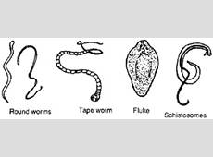

**Ways of controlling cattle parasites**

* Spraying the animals using acaricides
* Practicing rotational grazing to avoid tick borne diseases
* Dipping cattle into chemicals
* De-worming cattle to kill intestinal worms

**CATTLE DISEASES**

Cattle diseases are classified into three groups according to the causative agents

* Bacterial diseases
* Viral diseases
* Protozoan diseases

**Causes of sickness in cattle**

* Lack of essential nutrients in their feeds
* Unhygienic conditions like dirty feeding troughs.
* Overcrowding of animals
* Physical injuries and infections caused by micro-organisms

**Signs of a sick animal include;**

* Animals appears gloomy and restless
* Body temperature may be high or low
* It may pass out urine with strange colours
* Difficulty in breathing or even coughing
* Diarrhea or scouring may occur

|  |  |  |  |
| --- | --- | --- | --- |
| **Name of disease** | **How its spread and caused** | **Signs and symptoms** | **Prevention control and treatment** |
| **Bacterial diseases** | | | |
| Anthrax | Caused by Bacteria  Spreads through body contacts and contaminated feeds | High fever  Loss of appetite to graze.  Sudden death  Blood stained dung | Bury deeply dead animals  Burn the dead animals  Vaccinate animals every year  Separate infected animals |
| Mastitis | Caused by bacteria  Spreads through body contact with an infected animal | Milk with blood stains or pus  Swollen and painful teats and udder.  A cow refuses to be milked and suckled | Early treatment by using antibiotics  Use a strip cup regularly |
| Pneumonia | Caused by bacteria  Spreads from contaminated air and dirty living pens | Difficult breathing, coughing,  Nasal discharge  Loss of appetite  High fever | Use well ventilated dry and clean pens.  Treat the animal at the early stage of the disease |
| Tuberculosis | Breathing in air with tuberculosis bacterial  Spreads through milk of infected cows | Coughing  Loss of weight  Loss of appetite | Kill infected animals  Separate infected animals from health ones  Have proper sanitation  Early treatment using antibiotics |
| **Viral diseases** | | | |
| Foot and mouth disease | Spreads through sharing feeding containers  Through body contacts with infected animals | Swollen teats and lameness  Blisters on top of hooves and mouth (muzzle)  Loss of appetite to graze  High temperature  Reduction in milk production | Separate sick animals  Vaccinate after every 6months  Application of a quarantine. |
| Rinderpest | Spread through body contact with an infected animal | Soars in the mouth  Sunken eyes  Nasal discharge  Tears from eyes  High temperature  Diarrhea with blood stains | Separate sick animals  Regular vaccination  Slaughter the infected ones |
| **Protozoan disease** | | | |
| Nagana (trypanosomiasis) | Spreads through the bites of infected tsetse flies | Loss of weight  Anemia  Loss of appetite  High fever | Spread the tsetse flies using insecticides |
| East coast fever | Through bites of infected ticks  (brown ear tick) | Nasal discharge  Diarrhea  Loss of appetite  High temperature  Weakness | Dipping and spraying animals with acaricides to control ticks |
| Heart water | Through bites of infected ticks  (brown ear tick) | Animals walk in circles.  Animals place their heads on objects  When the animal falls, legs keep paddling in air | Dipping and spraying animals with acaricides to control ticks  Treat early cases with tetracycline antibiotics and sulphadilimidine |
| Red water | Spread through tick bites (red ticks Spreads through tick bites (red tick) | High fever  Reddish urine due to damaged liver.  Animal licks soil | Vaccinate regularly.  Dip and spray with the acaricides to kill ticks. |

**GRAZING /FEEDING IN CATTLE**

**Methods of grazing**

There are three main methods of grazing cattle namely;

* Rotational grazing
* Zero grazing
* Herding or free range system

**Rotational grazing**

This is the type of grazing in which animals graze on one portion of pasture at a time. This can be done using the following systems;

* Paddocking
* Strip grazing
* Tethering

**Paddocking**

This is when a farmer feeds his animals on a big pasture land divided into paddocks.

Cattle are fed on grass in a paddock and when the grass is no longer enough they are moved to another paddock.

**An illustration of paddock grazing**

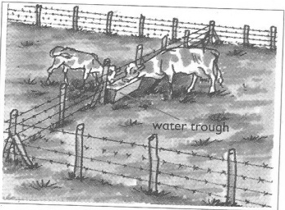

**Advantages of paddock grazing**

* Paddocks help to avoid overgrazing
* Paddocking controls pests and diseases
* Paddocking enables the animals to have grass all the time.
* It lessens the labour used to look after the animals after setting up paddocks.
* Paddocks help to control the spread of diseases
* The dung and urine of the animals are evenly distributed.

This allows for new grass to grow well in all paddocks.

**Disadvantages of Paddocking**

* The materials needed are expensive
* Animals have no choice of the type of plants to eat
* It requires a big portion of land
* The barbed wires can tear the skin of the animals

**Strip grazing**

This is where small sections called strips are created using temporary electric wires to restrict movements of animals.

Animals graze in gazetted area.

**Advantages**

* Pasture is evenly used
* Diseases and vectors are controlled
* Labour is reduced on the farm

**Disadvantages**

* It’s expensive to start and maintain
* It requires few animals to be kept

**Tethering**

This involves tying the animal on a tree or a peg using a rope to graze in a limited area

This is the most common method used in East Africa.

**A structure showing tethering method**

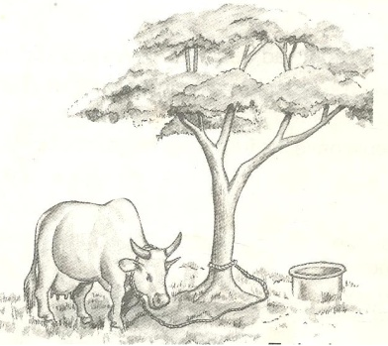

**Advantages of tethering method**

* It’s cheap and appropriate to maintain
* No fencing is required
* Pasture chosen by the farmer is always the best

**Disadvantages**

* It can only work best for few animals
* Animal feeding is only limited to areas around the peg.
* It requires the farmer to keep transferring the animals when pasture is over.

**HERDING AND ZERO GRAZING**

**Herding (free range grazing)**

This is a system where animals are left free to graze on different types of pasture as monitored by a herdsman.

This system is mainly practiced by Nomadic pastoralists

**Advantages**

* Animals are able to do some exercises as they graze
* It does not require any fencing
* The animals graze on different pastures of their choice

**Disadvantages**

* Animals need a herdsman to look after them all the time
* Animals can easily stray and destroy farmer’s crops
* Inbreeding is difficult to control

**Zero grazing**

This is a system where animals are kept under a special structure and water or feeds are provided.

Small cubicles are made for resting of the animals or feeding.

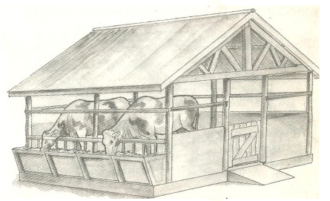**An illustration of zero grazing**

**Advantages of zero grazing**

* It’s easy to collect manure (Farm Yard Manure)
* Animals are easy to control and monitor
* Feeds are not wasted since animals are given only what is enough.
* Animals are protected from bad weather like sunshine and heavy rains

**Disadvantages of zero-grazing**

* It’s very expensive to start and maintain
* The farmer gets over worked
* There is easy spread of diseases and pests
* It involves of either buying feeds or growing fodder crops
* Much labour is required to feed and monitor the animals

**HOUSING OF CATTLE AND FENCING**

Like any other animals, cattle need good housing. They should be provided with shelter for the following reasons;

* To protect them from bad weather like heavy rain and strong sunshine.
* To protect cattle from thieves and attacks by wild animals
* To maintain their health and ease their feeding

**Qualities or characteristics of a good house of cattle**

The house for cattle is called a byre / kraal.

It has the following characteristics;

* Well ventilated for free air circulation.
* Has a strong floor made of concrete for easy cleaning.
* Has a slanting to enable urine drain out.

**Materials used to build cattle houses**

Wood, concrete, metals, bricks, plastics, stones etc.

**Fencing**

A fence is a barrier of life or dead materials divided in areas of land

**Types of fences**

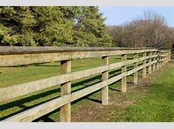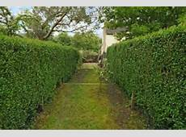Planted fences Constructed fences

Planted (natural) fences are made by planting certain types of plants along margins of a given piece of land.

Constructed (artificial) fences, are fences were people-made materials are used to create a barrier along a particular piece of land.

The materials used when constructing artificial fences include;

* Treated poles
* Bubbled wires
* Bricks
* Wire nets
* Chain links

This type of fence is the most popular one.

**Importance of fencing**

* Natural fences act as wind breaks thus controlling soil erosion
* Natural fences can maintain soil fertility by adding humus to soil
* Fencing controls the spread of pests and diseases to animals
* It also prevents animals from destroying people’s crops
* It allows proper use of pasture and makes culling easy

Livestock farming is the rearing of farm animals.

**Importance of livestock farming to people**

* It’s a source of income when animals and their products are sold
* It’s a source of food
* It provides employment opportunities to people

**REQUIREMENTS FOR STARTING A LIVESTOCK FARM**

**Land**

This is a place on which the farm is started.

**Ways of obtaining land**

* By buying
* Through inheritance
* From donation

**Capital**

This is the money used to buy things needed to start a farm. Some of the things the money may be used for include;

* Buying land if it is to be bought
* Constructing animal houses, stores, office and stationery.
* Preparation of pasture
* Bringing water on the farm
* Paying workers and experts for the treatment and vaccination of the farm animals before the farm starts producing.
* Buying drugs, acaricides and necessary equipment for the farm.

**Labour**

This includes people who do activities on a farm both skilled and unskilled workers.

**Market**

In livestock farming, marketing refers to the demand for cattle or their products.

Demand for cattle products means the desire and ability to pay for the products.

Therefore, it’s important to know whether people are ready to buy the products from the farm.

The type of livestock*,* the farmer needs to identify which animals he or she wishes to keep.

**THE ENVIRONMENT**

**RESOURCES IN THE ENVIRONMENT**

**RESOURCES**

* A resource is any material used for certain purpose.
* A resource is anything that can satisfy people’s needs.
* A resource can be any object or living component of the environment.

**Types of resources**

* Renewable resources / inexhaustible resources
* Non- renewable resources / exhaustible resources

**Renewable resources** are resources that can be replaced naturally when used up.

**Examples of renewable resources**

* Water
* Plant
* Animals
* Air
* Soil
* Sunshine

**Importance of plants as resources**

* Some plants are eaten as food.
* Plants provide wood fuel to people when dried
* Some plants are used as herbal medicine to cure animal diseases.
* Plants provide raw materials for furniture and crafts
* Plants help in the rain cycle through transpiration.

**Non-renewable resources:**

* These are resources that cannot be replaced naturally when used up.
* These resources can be exhausted in case they are not properly handled and preserved.

**Examples of non renewable resources**

* + - Rocks
    - Petroleum
    - Minerals
    - Sand
    - Clay Soil

**Ways people use animals a resource**

* Animal products (meat and milk) are good sources of proteins to people’s diets.
* Animals provide labour such as pulling carts, ploughing and for transport.

**Examples of such animals include**;

* Horses
* Camels
* Oxen.
* Donkeys.

**NON LIVING THINGS AS RESOURCES**

Non-living components in the environment are used by people for certain purpose.

**These include**: air, water, soil, sun and minerals.

* Water is a renewable resource because it can be replaced naturally through the rain cycle.
* Air is also a renewable resource because it can’t get exhausted in the environment.
* **Air is a mixture of gases** such as, oxygen, carbon dioxide, nitrogen, argon, krypton, neon etc.
* Wind is air in motion caused due to difference in temperature of places.

**Ways air is used as a resource in the environment.**

* Air from the environment is breathed in by people and animals
* Oxygen from the atmosphere helps in the processes of germination, burning and rusting.
* Carbon dioxide gas is also used as a preservative gas for tinned or canned foods.
* Carbon dioxide is used in fire extinguishers.

**Ways water is used as a resource.**

* Fast flowing water helps in turning turbines used in generation of hydro-electric power.
* Water serves as a habitat for aquatic life 9fish, amphibian, marine mammals etc)
* Water helps in plant processes such as germination and photosynthesis.
* Water is used as a raw material in industries and for cooling machines.
* Water is used for domestic activities.

**Minerals in the environment**

* Minerals are resources dug from underground
* Minerals were formed from the remains of animals and plants that lived many years ago after their death and decomposition.
* Minerals are non-renewable resources in the environment

**Examples of minerals**

* Oil
* Clay
* Chalk
* Copper
* Gold
* Petroleum
* Uranium
* Coal
* Rocks
* Tin

* Minerals from which metals are made are got from ores which contains more than one metal.
* Coal and oil are used to provide fuel in many ways. Coal can also be burnt to produce thermal electricity.
* Crude oil is taken to refinery to obtain pure oil by a process called fractional distillation.

**Products obtained from petroleum.**

* Petrol
* Diesel
* Oil
* Kerosene

A **rock** is made up of many minerals tightly packed to form a solid.

**Fossils** are remains of plants and animals that had lived many years ago.

* Their remains include; bones, teeth, roots, stems or leaves.
* Fossils are mainly found in stone quarries

**Uses of rocks**

* Rock contains minerals
* Rocks tell the earth’s history
* Rocks are used as raw materials for construction work

**RESOURCES IN THE ENVIRONMENT**

* A Resource is any component of the environment used by man to satisfy his needs.
* An energy resource is any component of the environment man uses to provide useful energy.
* Energy is the ability of the body to do work.

**Types of resources**

* Renewable resources
* Non-renewable resources

**Renewable resources**

* These are things that can be replaced naturally when used up.

**Examples of renewable resources**

* Plants
* Animals
* Water
* Soil
* Wind /Air
* Sun

**Ways renewable resources can be renewed naturally**

* Reproduction
* Weathering of rocks
* Decomposing
* Rain cycle
* Plants and animals can be renewed through reproduction.
* Soil can be renewed by weathering of rocks and decomposition of organic matter.
* Water can be renewed through the rain cycle.

**Non-renewable resources**

* These are things that cannot be replaced naturally when used up.

**Examples of non renewable resources**

Rocks

Minerals

Fossil fuels

**ROCKS**

These are solid hard substances that exist naturally under the earth’s crust on the earth’s surface

**MINERALS**

These are valuable substances that exist naturally in the environment.

**FOSSILS**

* These are plants and animal remains which were buried underground many years ago.

**Fossil fuels**

* These are fuels got from plant and animal remains which were buried under ground many years ago.

**Examples of fossil fuels**

* Petroleum
* 2.Coal
* 3.Natural gas

**Petroleum or crude from minerals oil**

* Petroleum is an energy resource dug from underground formed from animals which lived and died many thousand years ago. These were covered by layers of soil in the swamp. The changes in the earth created a lot of heat and pressure on them which caused them to change into petroleum or crude oil.

**Petroleum products**

1. Petrol
2. Diesel
3. Aviation fuel
4. Kerosene or Paraffin

* The different fuels are got from petroleum or crude oil in a refinery by the process of fractional distillation. This is possible because different fuels boil or vaporize at different temperatures. From petroleum we get chemicals used to make plastics, polythene bags, Vaseline, polythene sacks, cosmetics, detergents, toothpaste, synthetic rubber, grease, oil, insecticides, paint, and fertilizers.
* When mining petroleum in oil well, they first come to a layer of gas wells or gas mixed with petroleum. This gas is then got, purified and put in gas cylinders and then it is used for cooking, lighting and welding.

**Coal**

* Coal is a solid black fuel dug from underground and it is formed by the plant remains which were buried underground many years ago. Large forests got buried deep in the ground and due to land movements, heat and pressure they slowly changed into coal.
* Coal burns to produce heat and boils water to form steam. The pressure of the steam turns the turbines which drive generators to produce thermal electricity.

**Uses of coal**

* It is used as a fuel in steam engines and locomotives.
* It is used for processing iron ore
* It is used for making tar used for surfacing roads.
* It is used to produce thermal electricity.
* From coal we get coal gas that is used for cooking, lighting and heating houses to make them warm in winter.
* Coal gives chemicals used for making drugs, dye, fertilizers, perfumes, paint, explosives and antiseptics.

**Uranium**

* This is a grey mineral dug from underground.

**Ways uranium is used as an energy resource**

* Uranium is used to make atomic bombs or nuclear bombs.
* Uranium is used as a fuel in nuclear power sub-marines.
* The atoms of uranium are burn in nuclear reactors to produce steam which is used to generate atomic electricity or nuclear electricity.

**Ways water is used as an energy resource**

* Flowing water is used to produce hydroelectricity.
* Tides are used to produce tidal energy.
* Boiling water provides us with steam as an energy resource which is used to drive steam engines in ships and trains.

**Hydro electricity**

* This is the type of electricity produced by the power of fast flowing water.
* Hydroelectricity is produced when the power of fast flowing water turns turbines which drive generators to produce hydroelectricity.

**Tidal energy**

A tide is a regular rise and fall in the level of water of the sea or ocean. This is caused by attraction of the sun and the moon.

* The rising of water takes about 6 hours while the falling also takes another 6 hours and this takes place every day.
* Tidal power stations have been built in some places where tides occur. This movement of water in tides turns the turbines which drive generators to produce hydroelectricity

**Steam**

* Steam is an energy resource produced by boiling and evaporating water.
* Steam has a lot of water and therefore possesses kinetic energy which is used to drive steam engines in boats, ships, and trains.
* Steam is also used to turn turbines which drive generators in nuclear reactors to produce atomic electricity.

**Geothermal energy**

* This is the type of electricity got from hot springs. The hot springs discharge water heated by a natural process in the earth. The hot springs are called geothermal springs.
* The word geo means earth while thermal means heat.
* Hot springs originate when surface water which comes from rain or snow sinks underground and it is heated by hot rocks to produce steam which turns the turbines then drive generators to produce geothermal electricity.
* Examples of hot springs in Uganda are found in Kitagata in western Uganda and on top of Mt. Elgon.
* Many people believe that certain minerals found in hot springs relief certain sicknesses and that is why some people bathe in it and also drink it.

**Importance of plants as resources**

* Some plants are eaten as food.
* Plants provide wood fuel to people when dried
* Some plants are used as herbal medicine to cure animal diseases.
* Plants provide raw materials for furniture and crafts
* Plants help in the rain cycle through transpiration.

**Ways how plants are used as energy resource**

* They are source of food used to produce energy
* They are a source of herbal medicine.
* They are source of wood fuel
* They are used as shelter by some animals.
* They provide building materials
* They provide timber for making furniture.
* Plant materials are used in brooders to provide warmth to chicks.
* Plants provide shade.
* Plants carry out transpiration form rainfall.
* Plants provide fibres like cotton, sisal, jute, linen.
* Plants purify the environment by absorbing carbon dioxide and releasing oxygen.
* They provide raw materials for industries.

**Energy resources from plants**

* Firewood
* Wood fuel
* Food
* Bio fuel
* Biogas

**Wood fuel**

* Wood in form of charcoal and firewood is used by man to cook food and provide us with heat and light.
* When wood is burnt in limited supply of oxygen, charcoal is got.
* Wood is a hard material made from trees such as fire wood and charcoal.

**Wood conservation**

* Wood conservation is the protection of trees for sustainable supply of wood fuel.

**Ways of conserving wood**

* Encouraging a forestation
* Creating natural forest reserves.
* Sensitizing people about the value of trees.
* By using energy saving stoves.
* Rural electrification
* Using alternative sources of energy

**Energy saving stoves**

* These are cooking stoves consuming less charcoal and fire wood.

**Advantages of using energy saving stoves**

* They save energy by using less cooking fuel and burning longer.
* They conserve the environment by saving charcoal or fire wood which reduces deforestation.
* They can retain heat for a long time

**An improved energy saving charcoal stove.**

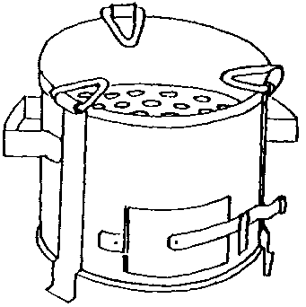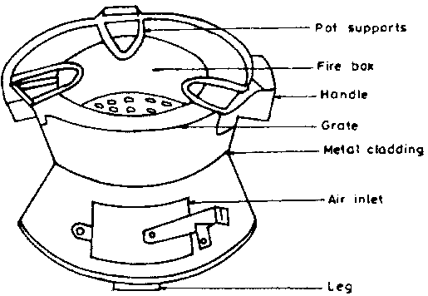

**Bio fuel**

* These are cooking materials from plants instead of fire wood and charcoal e.g. briquettes.
* Briquettes are small hard blocks made from charcoal dust, saw dust and coffee husks.
* They are used for cooking.

**Ways people use animals a resource**

* Animal products (meat and milk) are good sources of proteins to people’s diets.
* Animals provide labour such as pulling carts and ploughing
* Animal hooves are used for making glue.
* Some animals like dogs are used for hunting and for protection at home.
* The dung and urine got from animals are used for making farm yard manure.
* Animal provide fibres like wool, mohair, silk to man.
* Their skins and hides are used to make leather products like shoes, bags, belts, wallets.
* Some animals are used in transport.

**Examples of animals used for transport**

* Horses
* Camels
* Oxen.
* Donkeys.

**Animals as energy resources**

* Some animals are used as a source of food.
* Animals like oxen are used for ploughing land.
* Some animals used for transporting goods and people like donkeys, camels and horses are
* Some animals like the oxen are used to pull carts.
* Animal dung and urine are used for making biogas.

**Ways how the sun is used as an energy resource**

* The sun is a natural source of light energy which enables us to see.
* The sun provides us with heat which is used to evaporate water bodies and transpiration in plants to form rainfall.
* The heat from the sun is used to preserves food by sun drying
* The sun is used to dry our wet clothes.
* The sunlight enables green plants to make their own food during photosynthesis
* The sun (morning sunshine) enables our skin to make Vitamin D
* The sun acts as a disinfectant to kill germs.
* The sun is used to make solar electricity. The solar panels absorb heat from the sun. The solar cells convert solar energy to solar electricity which can be used for cooking and lighting.

**Ways how soil is used as an energy resource**

* Soil is a loose natural material which covers the surface of the earth.
* It is used for growing crops.
* It is used for constructing houses.
* Clay soil is used for modeling and pottery.
* It is used for making roads.
* It is used for making glasses

**Ways how wind is used as an energy resource**

* Wind is air in motion while air is a mixture of gases
* Wind is used for winnowing of cereals.
* Wind enables boats, ships and the dhows to sail on water.
* Wind is used to run windmills which turn turbines that drive generators to produce electricity.
* Wind is used to run windmills to pump water from underground.
* Wind is used to run windmills to grind cereals.
* Wind helps in seed dispersal.
* Wind is used for pollinating flowers.
* Wind speeds up the rate of evaporation of water from wet clothes making them to dry faster.
* Wind is used to fly kites.

**Components of air and their uses**

|  |  |  |
| --- | --- | --- |
| Component | % | Uses |
| Nitrogen | 78 | Used in electric bulbs  Used in legumes to make proteins  Used to preserve sperms used in artificial insemination.  Used for making artificial fertilizers like ammonium nitrate, NPK. |
| Oxygen | 21 | Used in respiration  Supports burning.  Supports germination  Supports decomposition of organic matter to form humus |
| Carbon dioxide | 0.03 | Used in fire extinguishers to put out fire.  Used by green plants during photosynthesis  Used to preserve the taste of canned foods and drinks. |
| Rare/inert/ noble gases  (argon, neon, helium, krypton, xenon | 0.97 | Used in electric bulbs. They don’t allow evaporation of tungsten.  Used for welding |

* 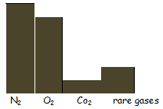

**Breezes**

* A breeze is the movement from a cold place to a warm place.
* There are two types of breezes. i.e. sea breeze and land breeze.

**Sea breeze**

* This is the blowing of cool air from the water body to the land during day time. It occurs along water bodies like coast, seas, oceans and lakes.

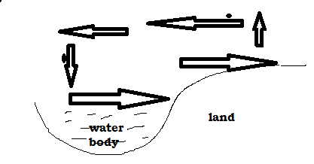

**Land breeze**

* This is the blowing of cool air from the land to the water body at night.
* 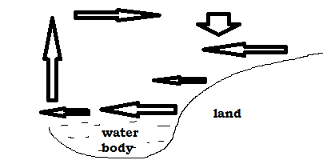

**Biogas / Bio fuel**

* Biogas is a natural gas from decomposed organic wastes.
* It is made from plant remains and animal droppings.

**Plant remains**:

Food leftovers and banana peelings

**Animal remains**:

**C**ow dung and urine

* Biogas is scientifically called methane produced from rotting organic matter.
* These materials are put in an air tight container called biogas digester where they are worked on by anaerobic bacteria which ferment the wastes to form a gas called methane/ biogas.
* Slurry is a mixture of organic wastes and water.

**Biomass** refers to the total quantity of living organisms in an area.

**Biogas**

* Biogas production from plants
* Biogas is scientifically called methane produced from rotting organic matter.
* We get it from waste plant materials like banana peelings, weeds, left over foods, and animal materials like animal excreta.
* These materials are put in an air tight container called biogas digester where they are worked on by anaerobic bacteria which ferment the wastes to form a gas called methane/ biogas.
* Biomass refers to the total quantity of living organisms in an area.

**A structure of a biogas digester**

* 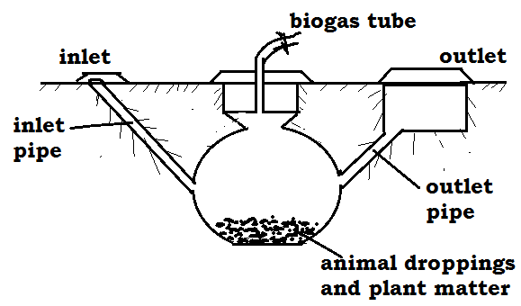

**The uses of each part**

* **Inlet pipe**:

Used for putting /inserting plant and animal waste into the digester.

* **Outlet pipe**:

Used for removing old used up matter in form of manure to the garden.

* **Emptying tank**

It is where used up matter is collected before it is used in the garden.

* **Biogas tube**:

It is used to trap biogas and take it for heating and lighting.

* **Biogas storage tank**:

It is where biogas is stored before it is used.

**Uses of biogas**

* It is used for cooking.
* It is used for lighting.
* It is used for heating

**Advantages of using biogas**

* It is cheap
* It does not pollute the environment
* The materials are readily available.
* The used up matter can be used as manure

**Non-renewable resources**

These are resources that cannot be replaced naturally when used up.

These resources can be exhausted in case they are not properly handled and preserved.

**Examples of non renewable resources**

* + - Rocks
    - Petroleum
    - Minerals
    - Sand
    - Clay Soil

**NON LIVING THINGS AS RESOURCES**

Non-living components in the environment are used by people for certain purpose.

**Examples of non living things used as resources**

* Air
* Water
* Soil
* Sun
* Minerals
* Water is a renewable resource because it can be replaced naturally through the rain cycle.
* Air is also a renewable resource because it can’t get exhausted in the environment.

**Air is a mixture of gases** such as, oxygen, carbon dioxide, nitrogen, argon, krypton, neon etc.

* Wind is air in motion caused due to difference in temperature of places.

**Minerals in the environment**

* Minerals are resources dug from underground
* Minerals were formed from the remains of animals and plants that lived many years ago after their death and decomposition.
* Minerals are non-renewable resources in the environment because they cannot be naturally replaced once depleted

**Examples of minerals**

* Oil
* Clay
* Chalk
* Copper
* Gold
* Petroleum
* Uranium
* Coal
* Rocks
* Tin
* Minerals from which metals are made are got from ores which contains more than one metal.
* Coal and oil are used to provide fuel in many ways. Coal can also be burnt to produce thermal electricity.
* Crude oil is taken to refinery to obtain pure oil by a process called fractional distillation.

**Products obtained from petroleum.**

* Petrol
* Diesel
* Oil
* Kerosene
* A **rock** is made up of many minerals tightly packed to form a solid.
* **Fossils** are remains of plants and animals that had lived many years ago.
* Their remains include; bones, teeth, roots, stems or leaves.
* Fossils are mainly found in stone quarries

**Uses of rocks**

* Rock contains minerals
* Rocks tell the earth’s history
* Rocks are used as raw materials for construction work

**NON LIVING THINGS AS RESOURCES**

**Ways air is used as a resource in the environment.**

* Air from the environment is breathed in by people and animals
* Oxygen from the atmosphere helps in the processes of germination, burning and rusting.
* Carbon dioxide gas is also used as a preservative gas for tinned or canned foods.
* Carbon dioxide is used in fire extinguishers.

**Ways water is used as a resource.**

* Fast flowing water helps in turning turbines used in generation of hydro-electric power.
* Water serves as a habitat for aquatic life 9fish, amphibian, marine mammals
* Water helps in plant processes such as germination and photosynthesis.
* Water is used as a raw material in industries and for cooling machines.
* Water is used for domestic activities.

**ALLOYS**

* An alloy is a mixture of two or more metals

**Examples of alloys**

* Brass
* Bronze
* Cupronickel
* Solder
* Dentist amalgam

**Importance of making alloys**

* Alloys make the metal harder
* Alloys lower the melting points of metals.
* Alloys make the tear or wear of metals difficult

**Metals used to make alloy**

* Copper
* Zinc
* Tin
* Mercury
* Lead

**A table showing an alloy, how it’s made and its use**

|  |  |  |
| --- | --- | --- |
| **Alloy** | **Combination** | **Importance** |
| Brass | Copper and zinc | Decorating the ornaments  Making wires, tubing cases of bullets |
| Bronze | Copper and tin | Decorating metals  Making coins |
| Solder | Leas and tin | Filling dental cavity in the teeth |
| Cupronickel | Copper and nickel | Making silver coins |
| Manganese steel | Iron and manganese | Making garden gates etc. |

**Note**:

**Fuels** are materials that can burn to give out heat and light.

**Examples of fuels**

Charcoal

Coal oils

Fire wood

Petroleum

**CONSERVATION OF RESOURCES**

* Conservation of resources is the protection of the resources in the environment from exhaustion.
* Conservation involves caring for the resources to avoid the exhaustion for future use.
* Man uses resources from the environment to obtain useful energy.

**Reasons why resources should be conserved**

* For future use
* To prevent extinction
* For future generation
* To modify weather
* To promote tourism

**Ways of conserving non renewable resources**

* By making alloys
* By recycling
* Using them sparingly
* Using alternative sources of energy other than fossil fuels

A **fibre**

* This is any material from plants or animals that is made up of threads and can be used as a resource.

**Types of fibres**

* Natural fibres
* Artificial or synthetic fibres

**Groups of natural fibres**

* Plant fibres
* Animal fibres

**Examples of plant fibres**

* Sisal
* Cotton wool
* Raffia
* Helm
* Jute
* Silk
* Linen

**Examples of animal fibres**

* Silk
* Mohair
* Wool
* Fur
* Hides
* Skins

**Synthetic fibres**

* Nylon
* Polyester
* Rayon
* Acrylic
* Animals provide energy for pulling carts and ploughing like oxen
* Animals also provide transport e like donkeys, horses and camels.
* We need to conserve plants, animals, minerals, water, soil, wildlife
* **Wildlife** refers to animals and plants in the entire environment outside our homes.

**Ways of conserving resources in the environment.**

* Use of modern farming practices such as terracing, inter cropping
* Enforcing laws against bush burning and swamp drainage
* Gazette and protecting swamps and forests
* Practicing agro-forestry, reforestation and a forestation
* Use of other alternatives to wood fuel such as use of solar electricity
* Banning the trade in wildlife products

**Exercise**

1. What do you understand by the term conservation of resources?
2. Give two ways of conserving the following resources in our environment

a) Minerals

b) Wild life

c) Soil

1. Briefly explain the term fibre
2. Give two examples of plant fibres
3. What is a resource?
4. What is an energy resource?
5. Identify the instrument used to measure energy.
6. Which units do we use to measure energy?
7. What are renewable resources?
8. Write four examples of renewable resources.
9. What are non-renewable resource
10. Write three examples of non-renewable resources.
11. What are fossils?
12. Give two examples of fossil fuels.
13. Write two fuels got from petroleum.
14. Write any two uses of coal.
15. What is a tide?
16. What is tidal energy?
17. Name the raw materials used for making biogas.
18. How do we call the process by which biogas is made?
19. Give two uses of biogas
20. State two advantages of using biogas

**INTERDEPENDENCE OF THINGS IN THE ENVIRONMENT**

**Interdependence:**

It is the way things benefit on each other in the environment.

**ENVIRONMENT:**

It refers to things surrounding people.

**Components of the environment**

The environment is divided into two groups:

* Living things like plants and animals
* Non living things like water bodies, air and soils

**How plants depend on animals.**

* Plants get carbon dioxide.
* They get manure.
* They are pollinated
* They get care.
* Plants are dispersed.

**How animals depend on plants.**

* They get Oxygen.
* They get food.
* They get habitat.
* People get fire wood from them.
* They get building materials.
* They get herbal medicine.

**Animals depend on other animals in the following ways;**

* Some feed on others(predators)
* Some animals live in/on others.eg internal parasites and external parasites.
* Some provide transport to others.eg Donkey, Ass, Camels
* Some provide security e.g. Dog

**Plants depend on other plants in the following ways.**

* The weak get support from other plants.eg Morning glory
* Some parasitic plants obtain food from the host plants.
* Some tall plants provide shade to small trees.
* Some plants protect small trees against strong wind.

**Interdependence of living things and non living things**

**Ways animals depend on non living things (air, water, soil)**

* Termites / earthworms live in the soil.
* People use soil to build houses, pottery etc
* People get rocks for construction of roads, houses etc
* Animals drink water.
* Animals breathe in air.
* Animals get heat and light from the sun.

**Ways plants depend on non living things (air, water, soil)**

* Plants breathe in air.
* Plants get heat and light from the sun.
* Plants grow on soil.
* Plants use water to make food.

**Ways non living things benefit from living things.**

* Plants purify air by absorbing carbon dioxide from it
* Plants control silting of water bodies
* People add manure to the soil

**AGRO FORESTRY**

* This is the growing of trees along side crops

**Importance of growing crops and trees together**

* Trees provide shelter to other crops
* Trees control soil erosion
* Crops get protection from wind and strong sunshine
* Some trees have nitrogen fixing bacteria that make the soil fertile
* Double income e.g. food and timber
* Reduce global warming as trees use carbon dioxide
* Trees contribute to rainfall formation

**Growing trees and keeping animals on the same farm**

* Trees provide shade to animals
* Trees provide oxygen to animals
* Trees purify the environment by using the carbon monoxide gas
* Some leguminous trees are used as animal feeds
* The farmer can get double income

**Rearing animals and growing crops on the same farm.**

* Animals get food
* Crops get manure
* The farmer can get double income
* Animals give carbon dioxide to crops
* Crops provide oxygen to animals

**Rearing and caring for animals, growing crops and trees on the same farm.**

* Some trees are used to make live fences(hedge)
* Some leguminous trees may be used as sources of animal feeds.
* Trees provide oxygen to animals.
* Animals give carbon dioxide to plants.
* Animal wastes are used as manure.

**Tree growing**

* Trees grow from seeds.
* The seeds selected should be healthy.

**Indigenous trees**

These are trees that have been growing in Uganda for many years  
Examples include.

* Musizi
* Acacia
* Mvule
* Mahogany

**Characteristics of indigenous trees;**

* Produce hard wood.
* Take long to mature.
* Can withstand rough soil and weather.
* Grow in the wild.

**Exotic trees:**

These are the recently introduced species of trees.

**Examples of exotic trees**

* Cypress
* Pine
* Cedar
* Black wattle
* Eucalyptus
* Ficus tree

**Characteristics of exotic trees**

* They produce soft wood.
* They mature faster than the indigenous trees.
* Need proper care.
* Some cannot withstand harsh weather.

**Starting a tree nursery bed**

**A nursery bed**  
A nursery bed is a small piece of land prepared for raising seedlings  
**Reasons for growing crops in a nursery bed**

* It protects seedlings from bad weather conditions.
* It makes it easy to care for seedlings e.g. weeding, thinning, spraying etc.
* It enables the seeds to germinate well as the soil is loose and moisture.

**TYPES OF NURSERY BEDS**

* Nursery bed-raised on the ground.
* Seed boxes-Wooden boxes filled with soil.
* Soil blocks-Soil put in polythene bags and sacks.

**Care for seedlings in the nursery bed.**

* Watering.
* Thinning.
* Spraying.
* Hardening off seedlings.

**A seed bed**  
It is a large piece of land where seedlings are planted for further growth

**Steps taken when starting a nursery bed**

* Choose a good site, clear the land and dig deep to make the soil fine.
* Add manure in the nursery bed and mix it well with soil.
* Furrow the soil using a stick and plant the seeds you have selected.
* Cover the prepared area with mulches, provide a shade and water.

NB: Remove the shade when the seedlings are about to be transplanted.

**What is hardening off?**  
It is the making of seedlings get used to garden conditions.  
**At this time the following are done.**

* Shelter is removed.
* Watering is reduced.

The garden conditions are sunshine, too much rain fall and pests.  
**Transplanting**  
It is the process of transferring seedlings from the nursery bed to the main field  
(seed bed)  
It should be done in the evening when the weather is cool and wet to prevent the plants from losing a lot of water due to transpiration of water

**Ways of caring for trees in agro forestry**  
**Watering**

This is the application of water to plants.  
**Fencing**

This is the construction of wooden fence around the gardens or individual plants.  
**Transplanting**

This is the removal of seedlings from the nursery bed to a seed bed.  
**Spraying**

This is the application chemicals to plants to kill pests   
**Mulching**

This is the covering of top soil with dry plant materials.

**Pruning**

This is the cutting of excess branches of a plant.

**Advantages of pruning**

* Reduce competition for air.
* Controls pests by removing hiding places for pests.
* Eases harvesting.
* Reduces transpiration.
* Reduces weight of a plant.
* Pruned materials can be used for mulching.

**Thinning**:

The removal of excess or poorly growing seedlings from the garden

**Advantages of thinning**

* Gives enough space for other crops to grow.
* Control the spread of diseases.
* Control the spread of pests.
* Eases spraying.
* Improves yields and quality of harvest.

**Staking**:

This is the providing of support to plants with weak stems.

**Reasons why staking is carried out on a farm**

* Controls ground pests.
* Eases weeding.
* Eases harvesting.
* Eases pruning.
* Eases spraying.
* Improves plant access to sunlight.

**Crop spacing**: the leaving of open spaces between individual plants.

It is the planting of crops leaving spaces between individual crops.

**Importance of crop spacing**

* Reduces competition for water and space.
* It ensures proper circulation of air to the plant.
* Plants get enough sunlight.
* Easy weeding.
* Easy harvesting.

**Tree and pests and their control**  
**What is a pest?**  
**A pest** is a living organism that destroys crops.  
**A vermin** is an animal pest.  
Examples of vermin include; rats, monkeys, elephants etc.

**Examples of crop pests**

|  |  |  |
| --- | --- | --- |
| **PEST** | **CROPS ATTACKED** | **DAMAGE.** |
| Mealy bug | Pineapples, coffee | Leaves turn yellow or pink. |
| Aphids | Oranges, coffee, cabbages etc | Wilting back of terminal bud. |
| Banana weevils | Bananas | Leaves turn yellow Bananas fall easily. |
| Codling moth. | Citrus fruits like oranges and mangoes | Fruits fall off. |
| Thrips | bananas | Premature ripening of bananas Banana fruits burst. |
| Moles, rats, squirrels, mice, cane rats. | Cereals | Direct consumption of seeds and stems. |
| Citrus black fly. | Citrus fruits | The flies suck sap from leaves and tender shoots. |
| Leaf miners | Coffee, cocoa, pineapples, aloevera, sisal | Plant’s ability to make sugar is reduced. |
| Cut worms | vegetables | Leaves are destroyed. |
| Locusts | All crops |  |
| Army worms | Cereals and grasses |  |
| Maize stalk borer | Maize |  |
| Boll worm | Cotton |  |
| Antestia bug | Coffee |  |
| Game animals e.g. monkeys | Oranges, mangoes |  |
| Birds. | Maize, sorghum. |  |

**Methods of controlling pests**

* Weeding.
* Crop rotation.
* Early planting.
* Spraying with pesticides.
* Plant clean materials.
* Use of birds to eat lady birds. (Biological method)

**Crop diseases.**

|  |  |  |  |  |
| --- | --- | --- | --- | --- |
| **DISEASE** | **CROP** | **CAUSE** | **SIGN** | **CONTROL** |
| Panama disease | Bananas | fungus | Plant Banana Wilts | Burn entire stock Plant healthy suckers |
| Cigar End rot | Banana | fungus | Banana tips resembles burning cigar | Burn infected crops. |
| Banana bacterial wilt | Banana | bacteria | Banana stem rots and falls down |  |
| Powdery mildew. | Mangoes | fungi | Powdery patches on leaves | Spray with fungicides |
| Green mould | Citrus fruits | fungi | The stem dries with a green powder | Spray with fungicides. |
| Stem pitting | Citrus fruits | fungi | Dry patches on the stem. | Spray with fungicides. |
| Tomato blight | Tomatoes, potatoes | bacteria | Yellow leaves |  |
| Crown gall | fruits | bacteria | Leaves shrink |  |
| Fire blight. |  | bacteria | wilting |  |
| Rust fungus | Cereals | fungi | Black spot on leaves |  |
| Root rot | Tea plants | fungi |  |  |
| Coffee berry diseases(CCB) | Coffee | fungi | Brown spots appear on berries. |  |

**Factors that affect crop production**

* Crop pests and diseases.
* The use of poor methods of farming.
* The harvesting of immature seeds.

**WEEDS**

Weeds are unwanted plants that grow in the garden

**Examples of weeds**

* Blackjack
* Spear grass
* Couch grass
* Star grass
* Nut grass
* Wandering jew
* Sword grass
* Sodom apple
* Guinea grass

**Advantages of weeds**

* Some weeds can be used to mulch the garden
* Some weeds are used for thatching houses
* Some weeds are used as animal feeds
* Weeds controls soil erosion in the environment
* Weeds rot and decay to form humus which improves soil fertility
* Weeds cover the soil preventing evaporation of water from the soil
* Leguminous weeds add nitrogen in the soil
* Some weeds are eaten as food by people

**Disadvantages of weeds**

* Weeds compete with crops for sunlight, water and mineral salts
* Weeds lower crop yields
* Weeds lower the quality of the produce
* Weeds harbor pests which destroy crops
* Some weeds are poisonous to people and other animals
* Weeds are costly to a farmer because he has to employ people to remove them

**METHODS OF CONTROLLING WEEDS IN A GARDEN**

**1. Using mechanical methods**

* Regular cultivation of the garden, using hoes, Ox- ploughs and tractors
* Slashing the weeds from the garden
* Uprooting weeds from the garden

**2. Using cultural methods**

* Practicing mulching in the garden

**Mulching** controls weeds by cutting off the sunlight supply from the weeds and also suffocates the weeds.

**3. Using biological method**

* Introducing animals to eat up the weeds.

4. **Using chemical method**

* Spraying weeds using Herbicides

**MULCHING**

* Mulching is the covering of top soil with dry plant materials.

**Examples of materials used to mulch the garden**

* Coffee husks
* Rice husks
* Dry banana leaves and fibres
* Saw dust
* Wood shaving

**Advantages of mulching**

* It controls soil erosion by reducing the speed of flowing water
* It keeps moisture in the soil by reducing the rate of evaporation of water from the
* soil
* It controls the growth of weeds
* It improves on soil fertility by decomposing the mulches.
* Mulching improves on water infiltration in the soil

**Disadvantages of mulching**

* Wet mulches can grow into dangerous weeds
* Some mulch are fire hazards
* Mulches may be a breeding place for crop pests
* Mulching is tiresome and expensive

**CROP ROTATION**

* Crop rotation is the growing of different crops on the same piece of land seasonally

**Advantages of crop rotation**

* It controls pests in the garden by breaking the life cycle of crop pests
* Crop rotation controls soil erosion in the garden
* Crop rotation improves on soil fertility.
* It improves on crop yields

**Factors to be considered when carrying out crop rotation**

* Legumes should be included in the rotation
* Crops that use the same nutrients should not follow each other
* Deep rooted crops should be alternated with shallow rooted crops
* Bush fallowing should be allowed (to allow the soil to regain its fertility)

**PLANT TRAINING**

* Plant Training means directing a plant to grow in a certain direction to form a
* desired shape

**Advantages of plant training**

* It enables a plant to grow above the ground
* It enables all the parts of a plant to get enough sunlight
* It makes the spraying of plants easy
* It makes weeding easy
* It makes harvesting easy
* It makes pruning easy
* It prevents rotting of fruits like in tomatoes

**Methods of plant training**

* Staking
* Propping
* Trellising

**Staking**

This is a method used to provide support to plants with weak stems to grow above the ground using stick frames.

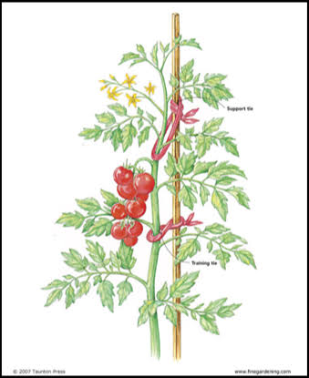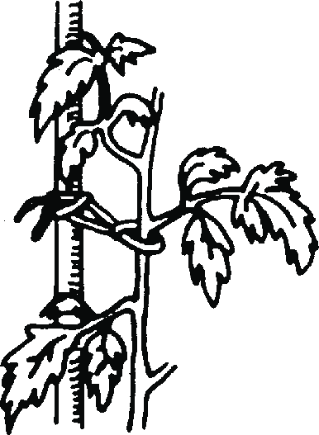

**Plants that are staked**

* Pumpkins
* Passion fruits
* Vanilla
* Tomato plants
* White yams

**Propping**

This is a method of giving extra support to weak plants using the ‘Y’-Shaped sticks

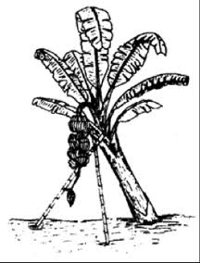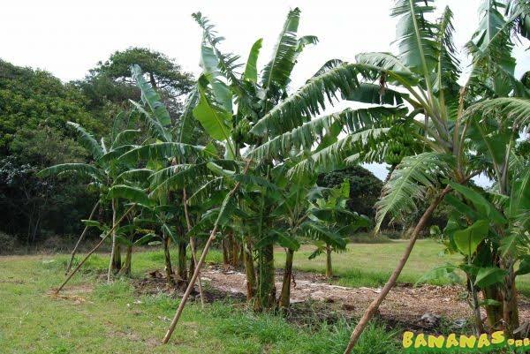

**Examples of plants that are propped**

* Banana plants
* Cocoa plants
* Coffee plants

**Trellising**

This is a method of giving support to climbing plants using sticks that cross each other to form a net.

Sometimes nylon nets are used.

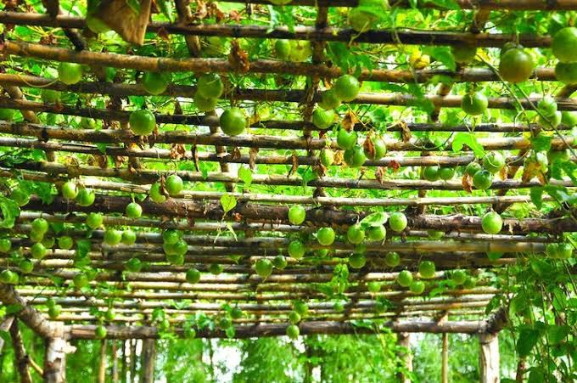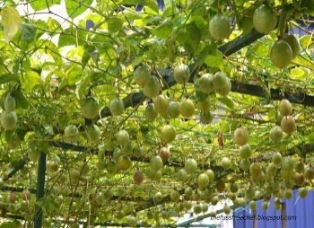

**Examples of plants that are trellised**

* Passion fruits

**GAP FILLING**

* This is a practice done to fill the spaces in a crop garden of seeds which failed to germinate or seeds which die after transplanting.
* Gap filling helps a farmer to keep the right plant numbers in the garden which helps to improve on crop yields.

**PRUNING**

This is the cutting of excess leaves and branches from a plant.

Pruning is done using a garden tool called a secateur or pruning sews.

**Plants which are pruned**

* Banana plants
* Avocado plants
* Mango plants
* Coffee plants
* Orange plants
* Tomato plant

**Advantages of pruning**

* It reduces the rate of transpiration on a plant
* It reduces the hiding places for pests
* It makes plants to gain proper shape
* It enables all parts of a plant to get enough sunlight
* It creates space for easy spraying of pesticides
* It creates enough space for weeding
* It creates enough space for harvesting
* It enables plants to put on big and healthy seeds and fruits

**THINNING**

Thinning is the removal of excess, weak and poor growing plants from the garden or seedlings from a nursery bed.

**Examples of plants that are thinned**

* Maize
* Rice
* Sorghum
* Millet
* Bananas
* Cabbage
* Tomatoes

**Advantages of thinning**

* It reduces competition for nutrients among crops
* It reduces the hiding places for pests
* Plants get enough space to grow well
* It creates enough space for weeding
* It creates enough space for spraying
* It creates enough space for harvesting

**WOOD HARVESTING**

This is the removal of mature and ready trees from the environment.

Wood should be harvested from mature trees to enable us get good quality timber that can last longer.

**Proper ways of harvesting trees**

**1. Coppicing**

* Cutting of the whole tree but leaving room for it to sprout again.
* This is when a tree is cut and the trunk is left a few centimeters from the ground and the branches are allowed to grow out of the remaining trunk.
* This method is suitable for harvesting wood for making furniture, constructing buildings, getting electricity poles, timber and fencing poles.

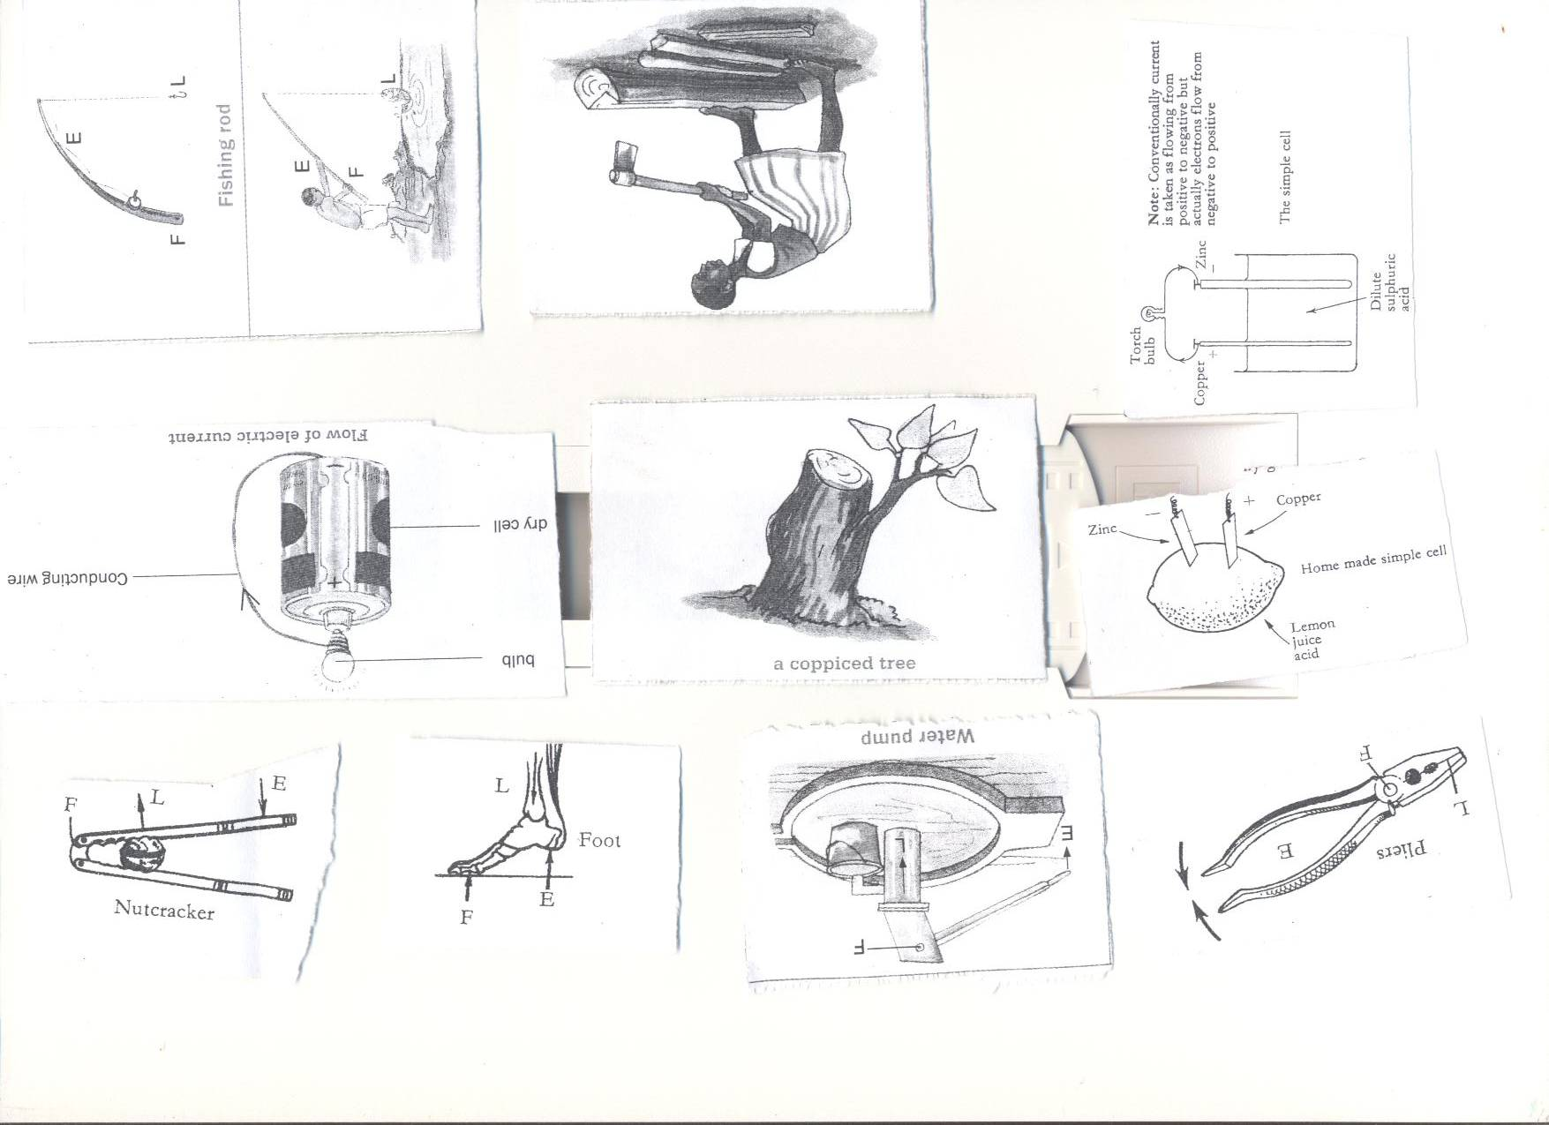

**2. Pollarding-** The cutting of the top part of a tree allowing new branches to develop.

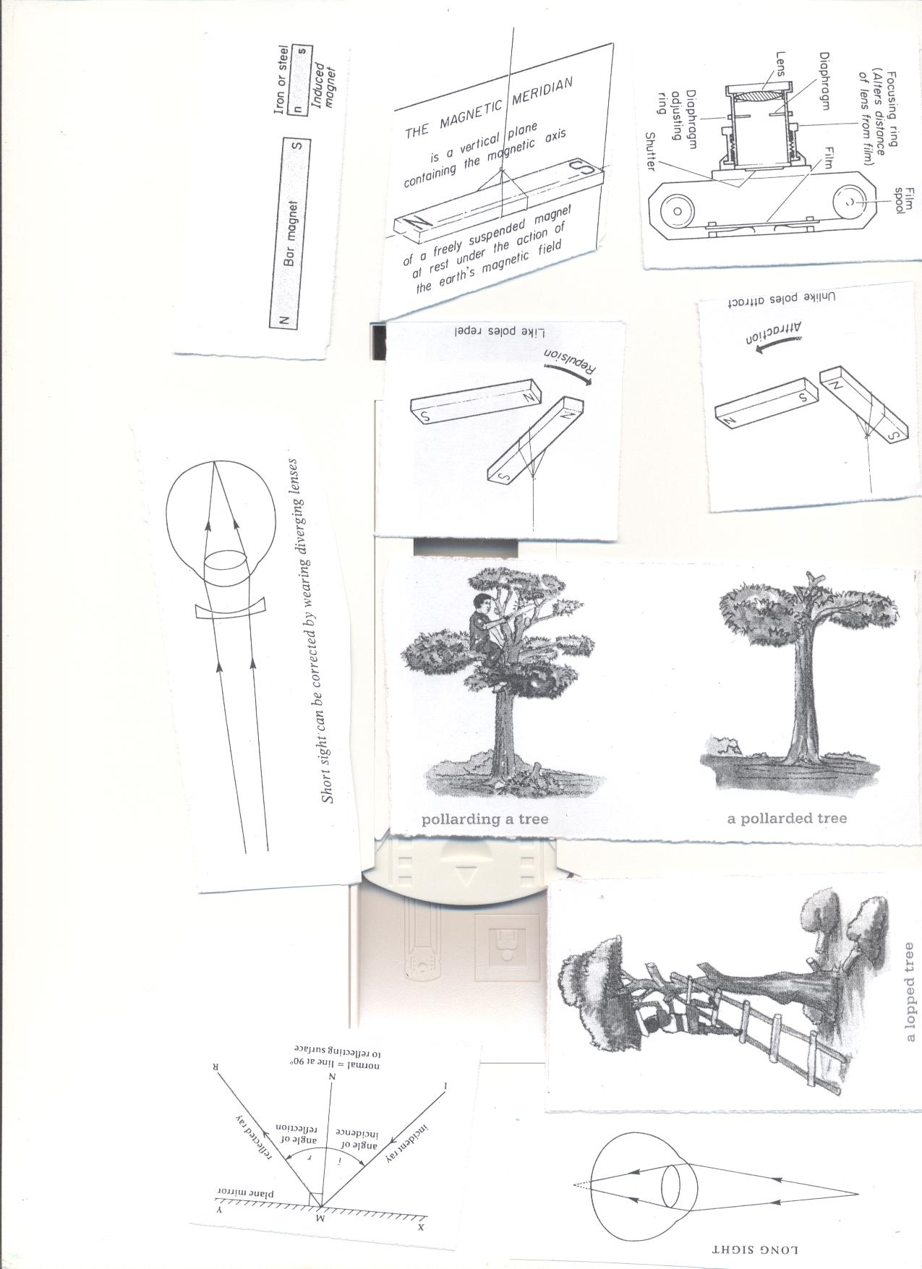

**3. Lopping**- Cutting of the side branches from the trunk and leaving the top ones to grow.

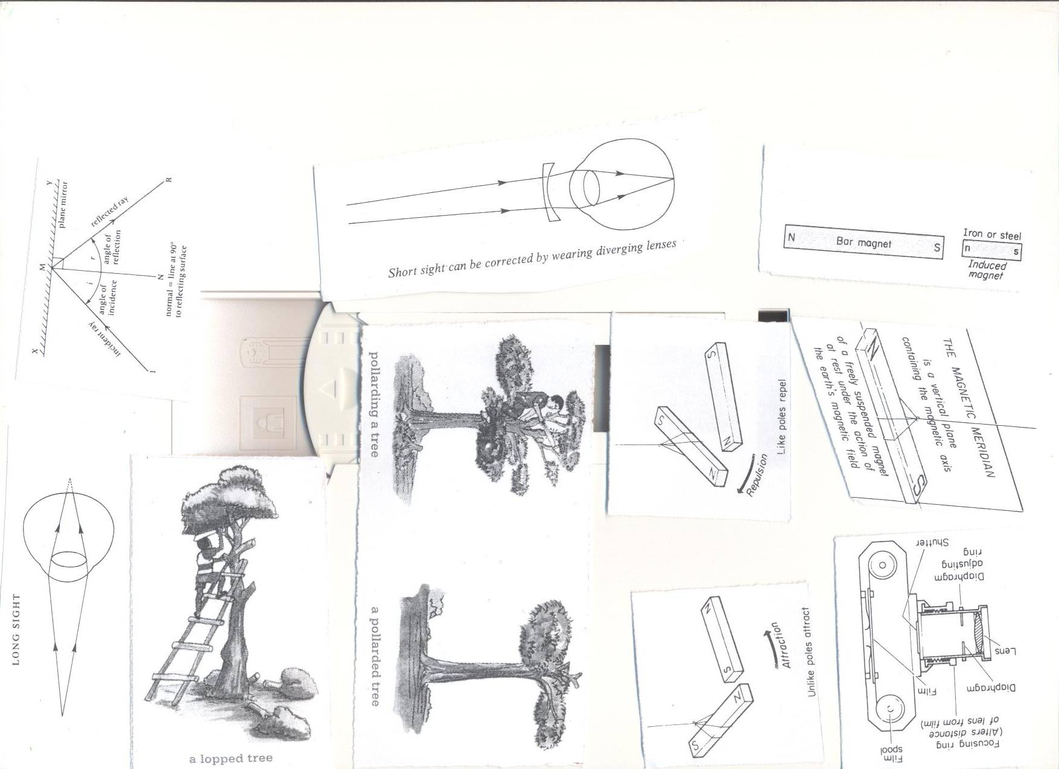This method is suitable for providing wood for charcoal and firewood.

**4. Selective felling**

This is a method of harvesting wood where good mature trees are cut down and young ones are left to grow. This method helps to conserve forests in the environment.

**Starting and managing a school/home wood project (wood lot)**

A wood lot is a piece of land where trees are grown for small scale production.

**Advantages of starting a wood lot**

* Production of food for the family.
* Source of income.
* Practicing the science learnt in class.
* Trees provide shelter.
* Trees are source of wood fuel.

**Factors to consider when starting a tree and crop growing project**

* Site-near your home.
* Soil drainage.
* Nearness to the water source.
* Fertility of the soil.
* Security.
* Accessibility.
* Nearness to the home/school.

**Factors considered when choosing crops or trees for planting.**

* Those which mature faster
* Those that give high yields.
* Those that are not easily attacked by disease
* Those which are multipurpose.

**Preparing wood for different purposes and proper storage**  
**Uses of wood**

* For charcoal.
* For fire wood.
* For medicine.
* For timber.
* To make electricity and telephone poles.
* For increase/produces a pleasant smell when burnt.

**Wood for firewood**

* It is split, dried and then kept in a shed.
* Trees store much water inside their cells.
* When is split water evaporates from it.

**Wood for electricity and telephone poles**

* Poles are treated with chemicals known as wood preservatives.  
  A strong salt can act as a **wood preservative.**
* The bark is first removed then soaked.

**Wood for timber**

* Trees are cut into different pieces.
* The pieces are put under shade to dry at slow pace.

**Seasoning**  
It is the putting of pieces of timber under shed to dry at slow pace.  
If timber is dried under direct sunshine it gets twisted/out of shape.  
The twisting of the pieces of timber is referred to as **warping.**  
**Reasons for seasoning timber**

* To prevent it from splitting.
* To prevent it from warping/bending.

**WOOD PRESERVATION**

* This is the treatment of wood with chemicals to enable it last longer.
* This is done to prevent wood from rotting and damage by pests.

**Wood pests include**

* Carpenter bees
* Beetles
* Termites

**WOOD PRESERVATIVES**

* These are chemicals used to treat and preserve wood to enable it last longer

**Examples of wood preservatives**

* Varnish
* Burnt engine oil
* Dye

**Ways of preserving wood**

* Applying burnt engine oil on wood to cut off the water supply to wood that would encourage rotting
* Painting of wood prevents water contact on wood and pest attack
* Smearing wood with vanish and dye to keep away pests

**Young farmers club**

* It is a club in a school in which members learn practical skills about keeping animals and growing crops

**Promotion of Young farmers club**

* Some schools have gardens where they practice farming.
* They organize trips to agriculture research stations.
* Organizing agricultural exhibition

**Importance of young farmers club**

* Learners get skills for farming
* It helps learners to learn good farming methods

**QUESTIONS**

1. What is agro forestry?

2. Suggest any one importance of keeping animals and growing crops on the same piece of land at the same time?

3. Suggest one method of properly harvesting trees.

4. Why is it important to treat wood for electric poles before planting them?

5. How are young farmers clubs important in schools?

6. Why is it important to keep records on farms?

7. Give any one reason why it is important to keep trees.

8. Write down any one disease that affects bananas.

9. How important are the following farm practices important on a farm.

Thinning b) staking c) pruning

10. How are vermins different from vectors?

11. Why is it important for farmers to plant their crops in nursery beds?

12. State any three crops that can planted in a nursery bed.

13. State one thing done to seedlings in a nursery bed that are about to be transplanted.

14. Why watering seedlings important when they are in a nursery bed

15. Mention any one characteristic of exotic trees.

**THE HUMAN BODY**

**RESPIRATORY SYSTEM**

**The respiratory system:**

**Respiration** is the process by which the body uses food and oxygen to release energy, heat, carbon dioxide and water vapour.

Respiration takes place in the **body cells.**

**Organs/ major parts of the respiratory system**

* Nose
* Trachea Or Wind Pipe
* Bronchus
* Lungs
* Diaphragm

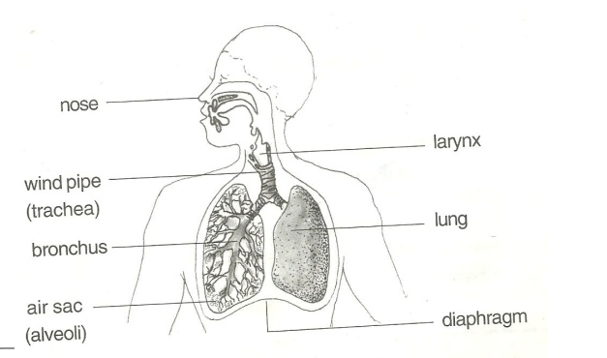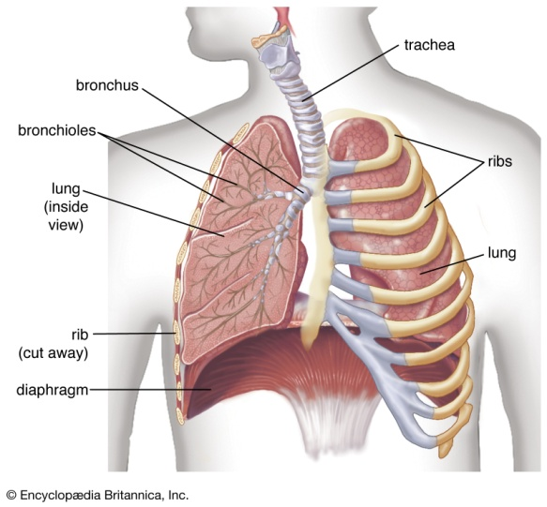**PARTS OF THE RESPIRATORY SYSTEM**

**Functions of the parts**

**The nose:**

* It contains mucus and tiny hair (cilia)
* Cilia traps dust that enters with air
* Mucus helps to moisten and warm air.

**The wind pipe/trachea**

* It’s made up of soft bones called cartilage to keep it open all the time
* It also contains hair and mucus

**The epiglottis:**

Closes to prevent the food from entering into the wind pipe on swallowing

**The lungs:**

* This is the organ where gaseous exchange takes place.
* It has got air sacs (alveoli) with a network of blood capillaries to absorb oxygen and pass out carbon dioxide.

**Rib cage:**

* Protect the lungs and heart against external harm.
* It’s also covered with a pleural fluid to prevent friction between the thorax and lungs to the ribs.

**Note**:

* Gaseous exchange takes place at the **air sacs.**

**BREATHING**

* Breathing is the act of taking in of oxygen and sending out of carbon dioxide from the body.
* Breathing involves exchange of gases in an organism
* Breathing starts from taking in air through the nose to the lungs.

**Types of breathing:**

**Types of breathing**

* Inspiration (inhalation)
* Expiration (exhalation)

**Breathing in / inspiration / inhalation**.

* Inspiration is the act of drawing in air into the lungs through the nose.
* The air we breathe in contains more oxygen than carbon dioxide.
* We breathe in to increase oxygen supply in the body
* Oxygen is used by the body to burn food and produce energy during respiration
* Respiration is the oxidation of food to produce energy in the body cells

**Events during inhalation / breathing in**

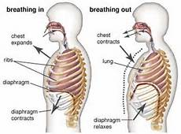

* The diaphragm moves downwards. (Diaphragm contracts and flattens)
* Ribs move upwards and out wards.
* Lungs expand
* The chest increases in volume
* Air is drawn into the lungs.

**Expiration / breathing out / exhalation**

* This is the act of taking out of air from the Lungs through the nose.
* We breathe out to reduce carbon dioxide in the body.
* Air we breathe out contains more carbon dioxide than oxygen
* During breathing out, we also lose excess heat and vapour from the body.

**Events during expiration / breathing out / exhalation**

* The diaphragm moves upwards to its domed shape.
* The ribs move down wards and inwards
* The lungs reduce in size
* Carbon dioxide dissolved in the blood plasma diffuses from the capillaries into the alveoli and exhaled out.
* Abrupt coughing is caused when an external matter enters the trachea or wind pipe

**Illustration showing a model of breathing**

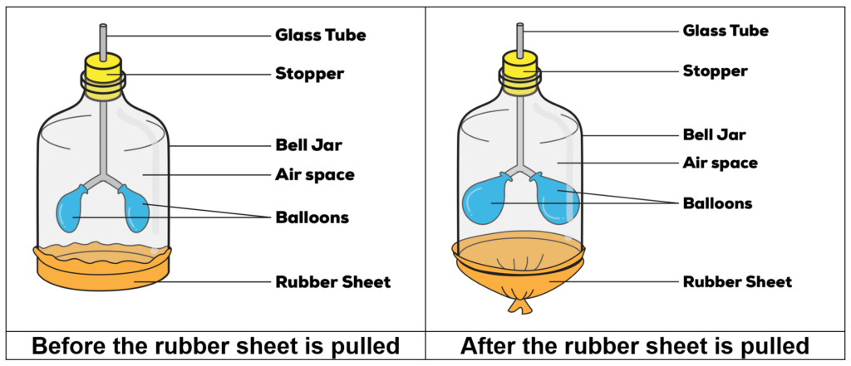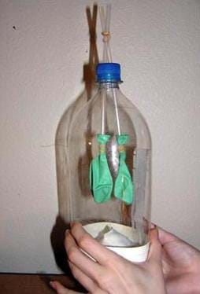

Glass tube For the trachea/bronchus

Balloons For the lungs

Bell jar or Glass jar For the rib cage

Rubber sheet or Polythene paper For the diaphragm

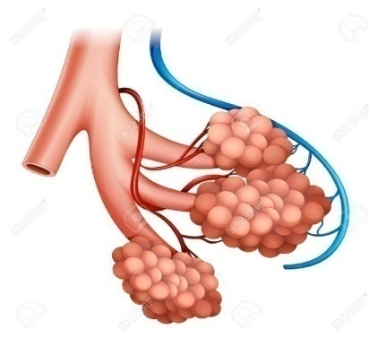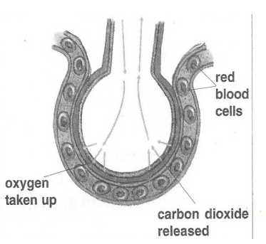**An illustration showing gaseous exchange at the alveoli**

**Note**:

* Alveoli are plural while alveolus is singular.

**Gaseous exchange in the alveolus**

* Gaseous exchange takes place in the alveoli and in the air sacs of lungs.
* When blood reaches the alveoli, carbon dioxide is lost and oxygen is added to blood.
* Oxygen is able to be added to blood and carbon dioxide is lost by a process called diffusion.

**How are air sacs suitable for gaseous exchange?**

* They are thin walled to allow gaseous diffusion through.
* They are surrounded by a network of blood capillaries.
* They are many in number to provide a large surface area to ease gaseous exchange.

**Summary of the composition of inhaled and exhaled air**

|  |  |  |
| --- | --- | --- |
| **Gas** | **Inhaled air** | **Exhaled air** |
| Oxygen | 21% | 16% |
| Carbon dioxide | 0.03% | 4% |
| Nitrogen | 78% | 78% |
| Water vapour | Less | More |
| Rare gases | 0.97% | o.97% |

**Note:**

* As we breathe out, more carbon dioxide is expelled because some is added from the body cells.
* Nitrogen is left unchanged because it is not necessary in the body.
* We breathe out less oxygen because most of it is used by the body during respiration process.

**Exercise**

State two ways in which air sacs are adapted for exchange of gases

Study the table below and answer the questions that follows;

|  |  |  |
| --- | --- | --- |
| Component | Inhaled air | Exhaled air |
| Oxygen | 21% | 16% |
| Nitrogen | 78% | 78% |
| Carbon dioxide | 0.03% | 4% |

Briefly explain why;

Exhaled air contains little oxygen

Concentration of nitrogen remained unchanged

Exhaled air contains more carbon dioxide

**DISEASES OF THE RESPIRATORY SYSTEM**

* Respiratory diseases are diseases that affect people’s respiratory organs i.e. the lungs, trachea, nostrils, and bronchioles.
* Some respiratory diseases are communicable diseases spread through contaminated air while others are non-communicable caused by smoking.
* Some respiratory diseases are hereditary spread from parents to the babies.

**Diseases of the respiratory system**

|  |  |  |
| --- | --- | --- |
| **Diseases** | **Signs and symptoms** | **Prevention / control** |
| Lung cancer (caused by smoking) | Chest pain  High fever  Coughing | Avoid smoking tobacco  Seek medical treatment |
| Influenza (flu)  (caused by virus) | Difficulty in breathing  Constant coughing and sneezing | Drink a lot of fluids |
| Pneumonia caused by either bacteria or virus | Difficulty in breathing  Coughing  Fever | Wear warm clothes during cold weather.  Treat using antibiotics. |
| Bronchitis (caused by bacteria) | Difficulty in breathing | Avoid smoking  Avoid staying in ventilated places. |
| Tuberculosis. (caused by bacteria) | Coughing for a longtime  Thick mucus spitting with spotted blood  Chest pain | Isolate the infected ones  Immunise using children BCG  Vaccine  Avoid drinking unboiled milk. |
| Whooping cough  (caused by bacteria) | Blocked nose  Coughing spasm  Difficulty in breathing  Running nose | Drink fluids rich in vitamins  Immunise children with DPT vaccine.  Avoid overcrowded and poorly ventilated houses/places. |
| Asthma (allergies) | Difficulty in breathing  Body weakness during cold weather.  Mucus flow | Go for medical attention  Keep away from sources of allergies e.g. cold pollen grains. |
| Diphtheria (caused by bacteria) | Sore throat  Convulsion | Immunise the infants using DPT vaccine  Go for medical treatment in time. |

**HUMAN HEALTH**

**ACCIDENTS AND FIRST AID**

**Accident**

* This is a sudden happening that causes harm to the body un expectedly

**First aid**

* This is the immediate help given to a casualty before being taken to a nearby health clinic.

**A casualty**

* This is an individual who has been involved in an accident and needs first aid.

**Accidents may result into**

* Simple injuries like bruises and cuts
* Major complications like fractures, sprains, strains and dislocations, failure to breathe, unconsciousness.

**Reasons for giving first aid**

* To save life
* To reduce pain
* To promote quick recovery
* To prevent further injuries
* To control bleeding

**Fracture and dislocation**

* A fracture is a broken bone while a dislocation is a displacement of two or more bones at a joint

**Sprain and strain**

* A sprain is any injury on the ligament
* A strain is any injury on the tendon
* Sprain is a sudden violent pull of the ligament that causes pain and swelling (or it is an over stretched ligament) while a strain is an over stretched tendon.
* It is a tear or over stretched ligament or tendon

**First aid box and first aid kit**

* A first aid box is where equipment s used in giving first aid are kept while a first aid kit is a set of equipment / instruments used to give first aid.

**List any four elements of a first aid box**

* Bandage
* Plaster
* Methylated spirit
* Razor blade
* Surgical blade
* Pair of scissors
* Panadol (pain killers)
* Cotton wool
* Gloves etc.

**BURNS AND SCALDS**

Burns and scalds are both common accidents / injuries caused by heat.

A **burn** is an injury to the body caused by dry heat

**Examples of dry heat**

* Hot pressing iron,
* Hot metal
* Cooker
* Burning pieces of charcoal or fired wood.
* An electric heat

A **scald** is an injury to the body caused by wet heat.

**Examples of wet heat;**

* Hot water
* Hot porridge
* Steam
* Other hot liquids

**Causes of burns and scalds.**

***Burns are caused by:***

* Contact with hot objects like hot plate, hot charcoal etc
* Contacts with naked electricity wires with high voltage
* Skin contact with fire.

**Scalds are caused by**

* Contact with hot liquids such as steam, tea, milk, porridge and water.

**Note:**

Burns can be classified according to their seriousness as follows;

**First degree burn**

This is a minor burn where the skin becomes tender, red and sore.

**Second degree burn**

This is a more severe burn where blisters are formed at the site of the injury.

A **blister** is a raised skin with some liquid underneath it.

**Third degree burn**

This is a very serious burn where the skin is badly damaged.

* Burned flesh and other under lying raw flesh can be seen.
* The victim loses a lot of body fluid and may become dehydrated.
* The skin is completely peeled off.

**How to prevent burns and scalds.**

* Keep hot objects far from children’s reach.
* Construct fire guards around cooking places.
* Do not keep inflammable liquids such as petrol in a living house.
* Cooking can be done from raised places at least a metre high.
* Never leave a candle or a wick lump burning in a room.
* People should use insulators of heat when lifting hot objects from the fire.

**First aid for burns and scalds**

* Cool the burnt area by putting it in cold clean water.
* The cold water stops burning, reduces pain and brings relief to the casualty.

**Note:**

* Never apply the cooking oil on either a burn or a scald. This is because it worsens the injury and can make it become septic.
* Never apply sugar
* Sugar attracts bacteria which causes infection.
* Sugar also absorbs water from the skin causing dehydration
* Never apply salt on the burnt part. This is because salt leads to dehydration by absorbing water from the skin.
* Never burst the blisters.

This is because open blisters allow germs to enter the wound and can cause infection.

**FEVER AND CONVULSIONS**

**Fever**

* This is a condition in which one’s body temperature rises beyond the normal.
* The normal body temperature is about 370Cor 98.4oF.
* Fever is not a disease but it shows that one is infected with a disease.
* Diseases such as malaria, measles, meningitis, typhoid and many others can cause high fever which can be accompanied by sweating.

**First aid for fever**

* Carryout tepid sponging
* Apply a warm wet cloth on the person’s undressed part of the body like the forehead, back or chest. This is also known as **tepid sponging** and it is done at regular intervals.
* To a young child, remove all clothes from the body and to an adult remove clothes from the upper part of the body.
* Give the patient plenty of drinks, like water and freshly prepared fruit juice or milk.
* Oral rehydration solution may also be given.
* Take the patient to the nearest health centre.

**Convulsions**

* These are sudden violent body movements which cannot be controlled.
* Convulsions are caused by high fever and epilepsy (fits).
* Epilepsy is a disease that may be inherited or result from brain damage at birth.
* Brain damage at birth is caused by difficult birth.

**Signs and symptoms of convulsions**

* High body temperature than the normal.
* Sweating excessively.
* Urinating frequently.
* A foaming mouth (i.e. a lot of saliva bubbles in the mouth).
* Violent shaking / shivering of the body.

**First aid for convulsions**

* Place the victim in a safe place to avoid injury by surrounding objects.
* Put a clean metallic object like a spoon into the mouth of the victim.
* This prevents the victim from biting the tongue and lips.
* When convulsions stop, put the victim in a recovery position.
* Take the patient to the nearest health centre.

**Note:**

* Do not give food or liquid to a person with convulsion.
* The liquid or food can choke the patient and cause death.
* Do not force the jaws to open if the teeth are tightly held together.
* Forcing may cause them to break.

**How to prevent fever and convulsions**

* By controlling mosquitoes to prevent malaria.
* Having children immunized.
* Early treatment of any infection.
* Maintaining proper hygiene.
* Pregnant women should always deliver from the heath centre.

**DROWNING AND NEAR DROWNING.**

To drown is to die in water or any other liquid

**Drowning** is caused by failure to breathe as the lungs are almost filled with the liquid (water).

**Near drowning** is the condition in which a person stops breathing due to having a lot of water in the lungs and is not yet dead.

* The life of the victim can be saved if the correct first aid is given immediately.

**Common sites where drowning and near drowning can take place.**

* Bath tubs
* Well and streams
* Swimming pools
* Ponds
* Pits dug by builders to trap rain water
* Lakes and rivers
* Irrigation ditches

**First aid for near drowning**

The following steps may be taken to rescue a person who is near drowning.

* Shout out for help from people around.
* Remove the person from the water as soon as possible.
* To do this, you must be a trained life saver, otherwise you may endanger your life too especially if the victim over power you in the confusion.
* Expel the water from the victims lungs and stomach.

**How to do it**

* Place the heals of your hands between the navel and the ribs.
* Make a quick strong push forward into the rib cage as shown below.

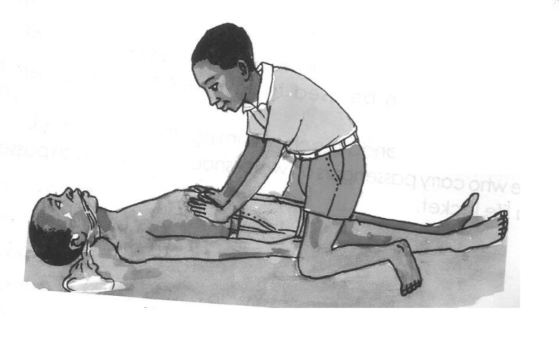

* Repeat this many times so as to push much of the water out of her lungs.
* Apply mouth to mouth breathing.
* This is called **artificial respiration** or **“kiss of life”**

**How to apply mouth to mouth breathing**

* As the victim lies on her back, open the mouth and remove any foreign object stuck there.
* Press the nostrils with your fingers to close them.
* Now bring your mouth to that of the victim.
* Blow strongly into her mouth and then pause to let the air come out. Blow in again.
* Repeat this many times.

**An illustration of mouth to mouth breathing**

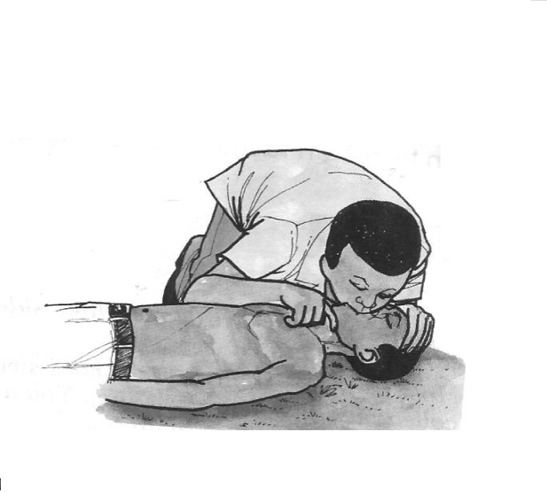

**Note**

* If you do not see the chest rising as you blow, and air coming out as you pause, then air is not getting into the lungs.
* Therefore, you need to expel water from the lungs of the victim.

**Ways of preventing drowning and near drowning.**

* Be careful when crossing flooded places.
* Acquiring the swimming skills.
* Providing life jackets to passengers on sailing boats.
* Careful supervision of children near water bodies.
* Fencing off pits builders use to trap water. Let such pits be filled when building is complete.
* Covering all the sewer and septic tanks.

**FAINTING**

* Fainting is the condition in which a person becomes unconscious for a short time.
* Fainting is a brief loss of consciousness
* The major cause of fainting is lack of enough oxygen supply to the brain

**People who faint are:**

* Unable to balance on their two legs.
* Weak.
* Unable to tell what is around them.
* They become unconscious and lose their sense.

**Conditions that lead to fainting**

* Lack of enough oxygen supply to the brain.
* This is due to lack of enough blood being transported to the brain.
* Staying in crowded places where there is competition for oxygen.
* Staying in a house that is poorly ventilated.
* Doing a very heavy exercise.
* Prolonged hunger.
* Standing up in sunshine for a long time.
* Shocking news.
* Illnesses. Some illnesses cause too much pain that leads to fainting.

**First aid for fainting**

* This is administered depending on the cause of the condition.

**First aid for fainting due to shortage of oxygen in the brain**

* Put the victim in an open place.
* Loosen all tight clothing especially around the neck and chest.
* Avoid crowding around the victim.
* Raise the legs of the victim higher than the head. This helps him to recover faster since blood flows faster to the brain.

**First aid for fainting due to prolonged hunger**

* Lie the victim on the back and fan him.
* On gaining the consciousness, give the victim a sweet and warm drink.
* Thereafter, get the victim soft food to eat. Glucose can also be given if available.

**First aid for fainting due to standing in sunshine**

* Put the person under a shade.
* Place a soaked piece of cloth on the forehead of the victim.
* Fanning and any mild cooling is recommended.

**Note:**

* Any unconscious victim is in danger of suffocation if left lying on his or her back.
* The recovery position is better but check the breathing
* The tongue should not block the air way (ABC – Airway Breathing Circulation)
* If the victim does not recover quickly, one should seek for medical help immediately.

**FOREIGN BODIES IN BODY PASSAGES**

**A foreign body**

This is any external matter that enters the body through a natural opening or a wound in the skin.

**Natural openings on the body include;**

* Eyes
* Ear
* Nose
* Throat
* Mouth
* Vagina
* Rectum
* Anus

**Examples of foreign bodies**

* Insects
* Dust
* Seeds
* Small stones
* Metal objects
* Food particles

**Foreign body in the throat**

* Food is the most common foreign body in the throat.
* Foreign bodies in the throat can cause choking.
* Choking is the blockage of the air passage to the lungs.
* Choking can cause failure to breathe which leads to death.
* This is because food in the throat squeezes and blocks the wind pipe (trachea) used to let air in and out of the lungs.

**Causes of choking**

* Swallowing big chunks of food.
* Talking with the food in the mouth.
* Eating hurriedly.

**First aid for choking**

* Give the victim a number of sharp blows in the back.
* If the choking continues, stand behind him and wrap your arms around his waist.
* Put your fist against his belly just between the navel and ribs.
* Press the belly with a sudden strong upward push. Do this several times.

**An illustration of administering first aid for choking**

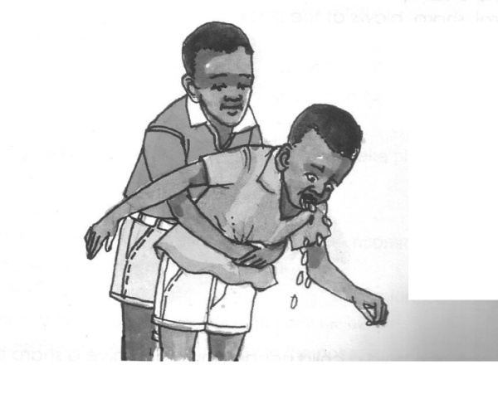

The limp of food in the throat will be forced out by the air.

**For an adult (a big person)**

* Lie the person on his back.
* Place the heels of your hands on the belly and make several sudden pushes on the belly into the chest cavity.
* If the person does not breathe, try the mouth to mouth resuscitation.

**For a baby (smaller victim)**

* Kneel down with one leg and fold the other.
* Put the baby upside down over the folded leg.
* Then give a gentle smack between its shoulder blade at the back

**How to prevent choking**

* Chew the food properly before swallowing.
* Do not talk, laugh or sing while eating.
* Babies should be given well pounded food.
* Avoid running with food in the mouth.

**FOREIGN BODIES IN BODY PASSAGES**

**Foreign bodies in the eye**

* Soil particles (dust) or insects often get into our eyes.
* They cause a lot of discomfort, because the eye is very sensitive to the foreign body.

**First aid for foreign body in the eye**

* Washing the eye with plenty of clean water.
* Gently wipe the foreign body out with a wisp of a clean cotton piece of cloth.

**NB.** If the object is embedded in the eye, do not try to remove it. This requires an expert to do it.

* Avoid using rough objects or one with sharp edges.
* Cover the eye with a clean sterile pad or cloth.
* Fix it with an adhesive bandage.
* Take the victim to a hospital for immediate medical attention.

**Foreign bodies in the ear**

* Foreign bodies in the ear usually include small stones, seeds, insects and beads.
* It is difficult to remove such objects from the ear,
* This is because as one tries to remove it, he/she may end up pushing it deeper.
* The deep pushing of the object may even injure the ear drum. This causes permanent deafness.

**First aid for foreign bodies in the ear**

* Take the victim for medical attention.
* This is a complicated problem which requires the attention of a trained person.
* If the foreign body is an insect, pour clean boiled water in the ear.
* Make the victim lie on that side of the affected ear.
* Do this until the insect comes out.

**Foreign bodies in the nose**

* Tell the victim to breathe through the mouth instead of the nose.
* This prevents the foreign body from being sucked into the wind pipe.
* Do this several times. The foreign body is most likely to be forced out by air.
* If this fails, take the person to a health worker.

**POISONING**

* Poisoning is the act of taking poison in the body
* Poison is any substance (solid, liquid, gas) which when taken into the body will damage the cells and even cause death.

**Common cases of poisoning occur with:**

* Paraffin
* Petrol
* Diesel
* Common drugs like aspirin, chloroquine, panadol
* House hold bleaches like JIK, VIM or other liquid cleaners.
* Rat poisons.
* Insecticides

**Signs of poisoning**

* Loss of body balance.
* Bleeding either externally or internally.
* Vomiting.
* The victim feels thirsty.
* Rapid breathing.
* Fever and sweating.
* Mental confusion and coma leading to death.

**First aid for poisoning**

* For paraffin, petrol or bleach poisoning, give the victim lots of drinks to dilute the poison. Do not make the victim vomit as this can cause damage to the throat.
* For any other type of poison, make the victim vomit by giving him soapy water.

**How to prevent poisoning**

* All drugs should be kept out of reach of children.
* All poisonous chemicals should be clearly labeled and kept in lockable containers.

**Exercise**

1. Briefly explain the term foreign body.
2. Give two examples of foreign bodies in each of the following natural openings on the human body.
3. The eye
4. The ear
5. The nose
6. Suggest one effect of pushing a foreign deep into the ear.
7. What do you understand by the term poisoning?
8. Suggest the first aid for poisoning.

**HUMAN HEALTH**

**SANITATION**

Sanitation is general cleanliness of the environment.

**Ecosan** stands for Ecological sanitation.

**Activities involved in promoting sanitation**:

* Construction of latrines/toilets
* Digging rubbish pits and using them well
* Sweeping rubbish from the compound and houses

**Latrines**

* A latrine is a place where human wastes are deposited.
* A latrine is a place for defecation and urination.

**Types of latrines**

* Ordinary pit latrine.
* Ventilated Improved Pit latrine (VIP)
* Toilet or lavatory.
* Potties.
* Ecosan toilet

**How to build an ordinary pit latrine**

* An ordinary pit latrine can be built from temporary or permanent materials. For temporary; use grass, reeds, poles, clay and banana fibre while for permanent; use bricks, cement, sand, iron sheets, nails, timber and gravels.
* NB: An ordinary pit latrine should have a lid to cover the hole to prevent flies from entering the latrine pit and spread diseases.

**Ventilated Improved Pit (VIP) latrine**

[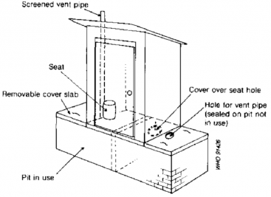](http://www.sswm.info/sites/default/files/toolbox/WHO%201992%20Double%20VIP.png)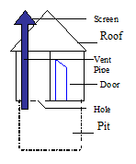

**Functions of the major parts of a VIP latrine**

* **Vent pipe**:

It lets out bad smelling air from the pit.

* **Screen**:

It traps and kills houseflies.

* **The slab (floor):**

To stand/squat on

It should be cemented for easy cleaning.

* The hole should have no lid to cover to allow free air circulation.
* The door should be left open for proper air circulation in the latrine.

It is ventilated because **it has a vent pipe**

It is improved because **it does not produce bad smell**

**Convectional currents** help to drive out bad smell and replace it with cool air

**Site of a pit latrine**

* A pit latrine should be at least 30metres away from any nearest water source to prevent water contamination.
* A pit latrine should be at least 10m away from any house so that the smell does not reach the people & houseflies do not come close to food to spread diseases.
* It should be built on solid ground not in a valley where the water table is near the earth’s surface.
* The pit should be 5 – 10 metres deep.
* A well-built latrine should have a strong roof, floor and doors for privacy of the user.

**How to use & maintain a pit latrine**

* Clear the bush/grass around the pit latrine.
* Sweep/mop the floor of the latrine regularly.
* Smoke the ordinary pit latrine regularly to kill vectors.
* Wash or remove any faeces, insects, cobwebs or dust from the walls and corners of the roof.

**Flush toilet systems (water closet)**

* Toilets are found inside houses and they use water to flush the excreta into septic tanks or sewerage pipes.

**[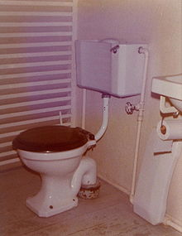](http://en.wikipedia.org/wiki/File:BelizeCity75CityFlushToilet.jpg)Structure of a flush toilet system**

**Functions of the parts of a flush toilet**

**Bowl**:

* It is where faeces and urine are deposited

**Water tank or closet**:

* Holds water for flushing.

**Handle:**

* To pull or push water to flush the faeces & urine down the pipe.

**Pipes:**

* Small pipes bring water into the toilet while big pipes are placed underground to carry excreta to the septic tank.

**Septic tank:**

* **It** is where excreta is stored until it is taken away by cesspool emptier

NB: Bacteria in the septic tank help to reduce on the volume of faeces in the latrine

**How to use a toilet**

* Sit on the toilet when defecating or urinating.
* Wipe your anus with a soft tissue paper (toilet paper) after defecating.
* Flush the toilet after use.
* Wash your hands with clean water and soap after using the toilet.

**How to maintain a toilet**

* Scrub the floor, bowl, seat & walls of the toilet room using a brush, water and a disinfectant.
* Put disinfectants in the bowl to kill germs in the toilet.
* Provide soft tissue paper in the toilet room to avoid people from using hard materials, which can block the pipes

**Problems faced by the flush toilet system and their possible solutions**

* Lack of water for flushing. Pour a basinful of water if flushing fails.
* Blocking due to use of hard materials. Use soft tissues(toilet paper)
* Leakage of the pipes. Repair damaged pipes.

**Importance of using toilets and latrines**

* They prevent houseflies from spreading germs.
* They promote good sanitation,
* They control air pollution.
* They prevent contamination of water sources when properly used.

**HUMAN BODY**

**HUMAN REPRODUCTIVE SYSTEM**

* Reproduction is the process by which a new organism is formed.
* It is the passing of life from one organism to another.

**Importance of reproduction**

* Reproduction helps to increase the number of living organisms in the environment.
* It prevents extinction of living organisms

**Types of reproduction**

**Asexual reproduction**:

* This is the type of reproduction that does not involve the union of the male and female sexual cells (gametes). Only one organism is required for this type of reproduction. It is found in lower organisms like the Amoeba, paramecium, bacteria, yeast, etc., most of which are single celled.

**Sexual reproduction**:

* This is the type of reproduction that involves the fusion of the male and female sexual cells (gametes).
* Higher organisms like man, sheep, goats, cattle, undergo this type of reproduction.
* Mammals, birds, fish, reptiles amphibians, some invertebrates and some plants undergo sexual reproduction

**Structure of the male reproductive organ**

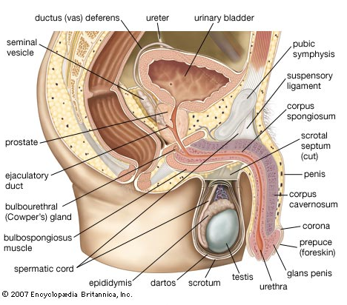

**Functions of the parts**

a) **Testes** (Testicles): Testes produce male sperms.

Testes also produce hormones called testosterone, which are responsible for secondary sex characteristics and increase the desire for sex.

NB. The testes lie outside so that they remain at a temperature lower than that of the body to favour the manufacture of sperms.

b) **Epididymis**: it stores the manufactured sperms. It also connects the testes to the sperm duct.

c) **Sperm ducts**: (Vas deferens): These are tubes, which pass sperms from the testes to the urethra.

d) **Seminal Vesicles**, **Prostate glands** &**Cowpers glands**.

These produce semen (sticky fluid) in which sperms swim up to the vagina.

e) **Urethra**: This is the passage of sperms from the sperm ducts and urine from the bladder but passes only one at a time.

f) **Scrotum**: This is a sac/outer covering of the testes. The scrotum protects the testes from external injury/harm.

It also regulates the temperature around the testes

g) **Penis**: This is a muscle with erectile tissues, which is used to deposit sperms into the vagina during sexual intercourse (coitus/copulation).

It also passes urine out from the body.

**Structure of the female reproductive organs**

[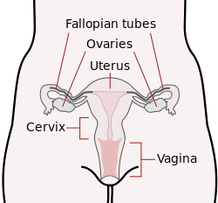](http://en.wikipedia.org/wiki/File:Scheme_female_reproductive_system-en.svg)

**Functions of the parts**

i) **Ovary:**

The two ovaries lie in the lower abdomen and they produce the female sexual cells called ova (Egg cells).

Ovaries also produce hormones called oestrogen, which are responsible for female secondary sex characteristics and also increase the desire for sex.

ii) **Oviduct (Fallopian tubes):**

It is where fertilization takes place.

iii) **Uterus (womb):**

It is where the embryo/foetus grows & develops from during pregnancy.

The uterus also helps to push out the baby during labour/birth.

iv) **Cervix**:

This is a ring of muscle, which closes the lower end of the uterus when the woman is pregnant.

v)**Vagina:**

This is a long elastic muscle tube, where sperms are deposited during sexual intercourse. The vagina (labia minora & labia majora) also produces a fluid that lubricates the vaginal canal/passage to reduce friction during coitus.

The vagina is also a birth canal.

**Growth and Development**

**Growth** is the irreversible increase in the size of an organism.

**Development** is the qualitative increases in functioning and complexity of an organism.

**Differences between growth and development**

* Growth is quantitative while development is qualitative.

**Puberty and Adolescence**

Puberty is the period when a boy or a girl is sexually mature.

This is the period during the course of adolescence when a boy or a girl becomes sexually mature but not yet ready.

**Adolescence** is the transitional stage between childhood and adulthood.

This period normally begins at 12 years in girls and 14 – 16 years in boys and ends at 21 years but can begin earlier or later and end earlier or later depending on hormones.

**Changes that occur during puberty or adolescence**

**a) Primary sex characteristics:**

* These are changes, which involve the development of sexual organs in preparation for their function.

**In Boys:**

* Enlargement of penis and testes.
* Production of sperms (Wet dreams)

**In Girls**:

* Production of ova from ovaries.
* Menstruation starts.

**b**) **Secondary sex characteristics**.

* These are changes in the physical features that distinguish men/women from boys/girls.

**In Boys**:

* Sweat glands become more active.
* Development of hair under the armpits, on the chest, face, beards & pubic hair around the penis/testicles
* Pimples (acnes) grow on the face.
* The voice deepens.
* The body becomes more muscular (masculine)
* All these changes are controlled by a male hormone called testosterone.

**In Girls**:

* Sweat glands become more active.
* Hair grows under armpits and pubic hair around the vulva (vagina)
* Pimples develop on the face.
* Development of breasts
* Enlargement and rounding of the hip girdles
* The voice softens.
* The body becomes smooth (feminine)
* The above changes are controlled by a female hormone called oestrogen.

**c) Psychological and emotional changes**.

* These are changes, which take place in the mind and are not seen or realized by the adolescent.

**Examples of** **Psychological and emotional changes**

* Attraction to the opposite sex.
* Peer group formation.
* Change in temperament

**Out-of-step adolescent growth changes**:

These are changes which occur differently to every individual in the same age group. **Examples of Out-of-step adolescent growth changes**

* A boy who was considered small will suddenly find himself bigger compared to his friends of the same age.
* A girl who was very short may suddenly find herself the tallest compared to her fellow girls of the same age.

NB: An adolescent is a person who is undergoing adolescence.

**Challenges/problems faced by the adolescents**

* They are never satisfied with their demands
* Conflicts among fellow adolescents
* Increased forms of wishes, desires and anxiety.
* Confusion with high expectations and exposure
* Contraction of STDs due to sex offences.
* Abortion

**Sperm production**

* Sperms are produced in the testes in cells called seminiferous tubules.
* The testes begin to produce sperms at puberty.
* In a single ejaculation, there can be around 2 to 3 million sperms out of which only one can fertilize the ovum

**Structure of a sperm cell (spermatozoon)**

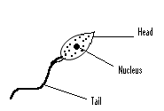

**Ovulation**

Ovulation is the release of the ovum from the ovary.

A baby girl is borne with about 7000 potential eggs out of which 500 become mature and only about 12 can be fertilized.

Structure of the ovum (egg cell)

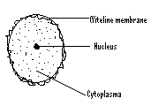

* The two ovaries release eggs in alternation.
* Normally only one egg is released each month.
* Ovulation results in menstruation if fertilization does not take place.
* Menstruation is the monthly slow flow of blood from the uterus through the vagina.
* Menstruation occurs every month in mature females and it lasts for 3 – 7 days.

**Reasons why menstruation may fail**

* Pregnancy
* Stress
* Serious illness

**Fertilization**

* Fertilization is the fusion of the male and female sexual cells to form a zygote.

**Types of fertilization**

a) **External fertilization**:

* This is the type of fertilization, which takes place outside the body of an organism

**Examples of animals that undergo external fertilization**

* Frogs
* Toads
* Fish

b) **Internal fertilization:**

* This is the type of fertilization that takes place inside the body of an organism

**Examples of animals that undergo internal fertilization**

* Humans
* Birds
* Goats

**Fertilization/conception in humans**

* During mating, millions of sperms are released from the penis into the vagina.
* These sperms swim through the uterus up to the oviducts.
* If it is the right time an egg (ovum) has been released from the ovary, only one sperm cell fuses (joins) with the egg cell to form a zygote.
* This is called fertilization/conception and it is the beginning of pregnancy/gestation.
* The fertilized egg (embryo) rolls up to the uterus & attaches itself to the uterine wall, a process we call Implantation.

**Pregnancy and gestation**

Pregnancy is the period of growth and development of the foetus.

Gestation is the period between fertilization/conception and birth.

Gestation in humans is 270 – 280 days or 9 months

**Diagram showing a growing foetus**

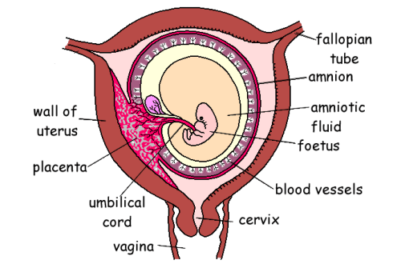

* After Implantation, blood vessels develop between the embryo and the uterus wall and these form what we call Placenta.
* The foetus is joined to the placenta by a cord called Umbilical cord.

**Functions of the parts**

* + 1. **Placenta**:
* This acts as store where food nutrients from the mother are passed on to the foetus.
* The waste products from the foetus are also passed on to the placenta for excretion.
* The placenta also produces hormones, which control pregnancy

b) **Umbilical cord:**

* This is a passage through which food nutrients & oxygen pass from the placenta to the foetus.

NB: Although the foetus gets food & oxygen from the mother, its blood vessels are never connected to the mother’s blood circulation.

* If the mother’s blood circulation was directly connected to that of the mother, the mother’s blood pressure would burst the delicate capillaries of the growing foetus.
* In addition, some substances in the mother’s blood would be poisonous to the foetus.
* That is why the heart and blood vessels of the foetus develop earlier than other organs.

c) **Amniotic fluid**:

* This protects and prevents the foetus from unequal pressure acting on it from all sides.
* The amniotic fluid is a shock absorber.

d) **Amnion/amniotic sac:**

* This is a sac for keeping the amniotic fluid.

**Pregnancy**

**Signs of pregnancy**

* Menstruation periods stop
* The breasts grow bigger
* Frequent urination
* Enlargement of the abdomen by the fourth month
* Some women experience morning sickness in the first three months
* Foetal movement can be felt by the fifth month

**Danger signs during pregnancy**

* Vomiting a lot and often.
* Hard or severe painful abdomen.
* Bleeding or coloured discharge from the vagina
* Severe swelling of legs, hands & face
* Severe headache or difficulty in seeing

**Care of a pregnant woman.**

The following are the requirements of an expectant mother:

* Antenatal care -regular medical checkup.
* Good nutrition.
* Good personal hygiene

**Preparing for the delivery and care of the baby**

* Sterilized delivery equipment like gloves.
* Things for the baby such as clean clothes
* Things for the mother like towel, clothes for delivery, money for transport/emergency

**Sex determination**

* The sex of the baby is determined during fertilization by cells called chromosomes.
* **Chromosomes** are living cells that contain genes.
* **Genes** are living cells that control the characteristics inherited from parents.
* The female’s egg cell has XX type of chromosomes.
* The male’s sperms carry XY type of chromosomes.
* If a sperm carrying X chromosome fertilizes the ovum, then the baby will be a girl and if it is carrying Y-chromosome, the baby will be a boy.

**Twins**

* Twins are two babies born at ago.

**Types of twins**

a**) Fraternal twins (Dizygotic twins)**

* This happens when two ova are released from the two ovaries and are fertilized at the same time by different sperms
* Fraternal twins do not resemble each other closely and may be of different sexes or the same sex.

b) **Identical twins (Monozygotic twins)**

* This is when one fertilized egg (embryo) split into two (during cell division) and each develops separately into a baby.
* Identical twins look alike and are in most cases of the same sex.

**NB**: Two babies borne with some of the body organs joined together are called **Siamese or conjoined twins**

* Three babies born at ago are called **Triplets**.
* Four babies born at ago are called **Quadruplets.**

**Problems of frequent pregnancies**

**Maternal anaemia**

* This is due to loss of too much blood during pregnancy and birth, which is not sufficiently replaced.

**Miscarriage**

* This is when the developing foetus is expelled or rejected by the uterus in its early stages of growth.

**Premature birth**

* This is when a baby is born before it is completely developed.

**Low birth weight**

* This is when a baby born weighs less than the health and normal birth weight, which is between 2.5 – 4 kg.

**Proneness to disease**

* Frequent pregnancies weaken the mother’s body and therefore she can easily get diseases and die.

**Teenage pregnancy/young parents**

* Boys and girls who produce before the age of 18 years are said to be young parents.
* The recommended age for the girl to produce a child is after the age of 21 years.
* This is where by the girl’s pelvis is fully developed.

**Problems of young parents**

* School drop-out.
* Ignorance about child care and handling.
* Lack of enough money since they may not be employed.
* Forced marriage: The young boy may be forced to marry the girl he has impregnated.
* The girl does not get married officially and in most tribes, she is regarded as second woman.

**Family planning**

* Family planning is the use of birth control methods to plan when to have or not to have a child in a family.

**Child spacing** means leaving enough gap/time between the births of children.

**Advantages of family planning and child spacing**

* It helps to allow the mother to build the body and prepare for the next birth.
* The family members are easily provided with enough basic needs.
* It encourages proper planning of the family.

**Why parents produce many children**:

* High infant/child mortality
* Security of family continuity.
* Desire for a certain sex of a child.
* Ignorance about family planning methods.
* A myth about having many children as a sign of male strength

**Problems of having many children**

Besides straining the mother (problems of frequent pregnancies – earlier seen), many children bring other social and economic problems:

* Lack of enough food
* Financial constraints/money problems.

**Method of family planning (birth control)**

**a) Artificial methods:**

* Birth control pills
* Spermicides such as Foams and jellies.
* Use of the Diaphragm
* Use of condoms
* Injector plan
* Tubal ligation
* Vasectomy
* Use of IUDs

Examples of artificial permanent family planning methods

* Tubal ligation
* Vasectomy

**b) Natural family planning methods:**

These are methods, which do not involve the use of chemical, drugs or mechanical devices.

**Examples of natural family planning methods**

* Rhythm method (use of the safe periods).Studying the menstrual cycle
* Abstinence
* Prolonged breast-feeding
* Withdrawal method (coitus interruptus)

**Advantage of natural family planning methods**

* They are cheap
* They do not have side effects

**Disadvantages of natural family planning methods**

* They are not reliable.
* They are not as effective as artificial methods

**Permanent methods of birth control:**

* These involve simple operations for both men and women if the couple no longer wants to get any more children.

**Vasectomy:**

* This is the cutting and blocking of sperm ducts of males.

**Tubal ligation**:

* This is the cutting and tying of the oviducts in females.

**Disorders of the Human reproductive system in females**

1. Ectopic pregnancy

2. Fibroids( Tumours in the uterus)

3. Blocked oviduct

4. Still birth

5. Miscarriage

6. Sterility

7. Cancer of the cervix

8. Pre-Menstrual Syndrome (PMS)

**Disorders of the Human reproductive system in males**

1. Impotence or Erectile dysfunction

2. Low sperm count

3. Enlarged prostate glands

4. Sterility

5. Hydrocele

**Sterility**

* This is the inability to produce children.

**Causes of sterility in men**

* Low sperm, which cannot cause fertilization
* Weak or malformed sperms
* Contracting mumps at an adult stage
* Untreated sexually transmitted diseases
* Failure to get/keep an erection (impotence)

**Note**

**Sterility in women is called barrenness**

**Causes of sterility in women**

* Misplaced uterus or fault in the lining of the uterus
* Too much acidity of the vaginal fluids that may kill sperms
* Failure of the womb to sustain a pregnancy to maturity
* Untreated sexually transmitted diseases such as gonorrhoea

**Pre-Menstrual Syndrome (PMS):**

* This refers to a variety of symptoms that some females experience before their menstruation periods.

**Examples of PMS**

* Nervous tension
* Irritability
* Anxiety
* Fatigue

**Ectopic pregnancy:**

* This is the type of pregnancy that takes place in the oviduct.

**Cancer of the cervix,** prostate cancer, cancer of the penis,

**Diseases of the reproductive system**

**STDs/STIs**

* STDs stands for Sexually Transmitted Diseases.
* STIs stand for Sexually Transmitted Infections.
* STDs or STIs are diseases that are spread through unprotected sexual intercourse with an infected person.

**Common examples of STDs**

* Gonorrhoea
* Syphilis
* HIV/AIDS
* Candidiasis
* Chlamydia
* Chancroid
* Trichomoniasis
* genital herpes
* genital warts

**Gonorrhoea**

Gonorrhoea is caused by a bacterium called gonococcus.

It is spread through unprotected sexual intercourse with an infected person.

**Signs and symptoms of gonorrhoea**

**In men (Usually appear 2 – 5 days after infection)**

* Severe/burning pain when urinating
* Smelly pus discharge from the penis.

**In women (takes long to show up)**

* Smelly pus discharge from the vagina.
* Pain in the lower abdomen.
* Some little pain while passing out urine.
* Menstruation problems like prolonged and severe bleeding.

**Effects/dangers of gonorrhoea**

* Gonorrhoea causes sterility of both men and women who are infected.
* The infected mother can pass on the disease to her unborn baby.
* The disease attacks the baby’s eyes and the baby becomes blind if not treated early.

**Prevention and control of gonorrhoea**

* Abstain from sexual intercourse.
* Be faithful to your sexual partner.
* Proper and consistent use of condoms.
* Get early treatment in case the disease is noticed to avoid spreading it to others. (Both partners should be treated to prevent re-infection)

**Syphilis**

* Syphilis is a more serious STD.
* Syphilis is caused by bacterium called Spirachaete, which lives in blood.

**Ways how syphilis can be spread**

* Through unprotected sexual intercourse with an infected person.
* Through blood transfusion with contaminated blood.
* From infected pregnant mother to the unborn baby.
* Through sharing towels, basins and underwear with an infected person.

**Signs and symptoms of syphilis**

Syphilis progresses in three stages:

1st stage (primary stage) - 2 to 5 weeks.

* A painless sore appears on the genital area. It can also appear on the lips, breasts, fingers, tongue or anus.
* The sore disappears after a few weeks without treatment but the disease still continues.

**2nd stage (secondary stage) – After several weeks or months**

* Painful/itchy rash appears all over the body.
* Some little fever.
* Sores in the mouth, throat, penis, vagina, lips or anus.
* Warts with some cracks (warty lesions)
* These signs may as well disappear without treatment.

**3rd stage (tertiary stage) – Many years later – up to 20 years**

* Heart diseases
* Loss of teeth
* Blindness.
* Paralysis of limbs
* Brain damage leading to insanity.

**Note**: The above are the effects of syphilis

**HIV/AIDS**

AIDS is an abbreviation for

A – Acquired (got from)

I - Immune (protected)

D - Deficiency (lack of)

S - Syndrome (a group of signs & symptoms)

AIDS is caused by a virus known as HIV.

HIV stands for Human Immune-deficiency Virus.

NB AIDS is a group of diseases that come as a result of a weak immune system

HIV is a virus that causes AIDS.

**How HIV is transmitted.**

* Through unprotected sexual intercourse with an infected person.
* Through blood transfusion with infected blood.
* By sharing sharp skin piercing instruments with an infected person.
* From infected mother to the unborn or newly born baby.

**Traditional practices that can lead to the spread of HIV/AIDS**

* Circumcision
* Tattooing
* Ear piercing
* Extraction of teeth
* Gigger extraction
* Wife inheritance

**Signs of HIV/AIDS**

* Chronic diarrhea, which can last for one month.
* Loss of weight (about 10% monthly)
* Prolonged dry cough.
* Oral thrush (white coating in the mouth)
* Herpes zoster (kisipi)
* Wide spread skin rash.

**Symptoms of HIV/AIDS**

* Persistent fever
* General body weakness
* Headache

**Effects of HIV/AIDS**

* Loss of immunity and hence proneness to diseases.
* Loss of income as one tries to treat for the disease.
* Loss of job due to impaired job performance.
* HIV/AIDS causes worries/stigma/stress.
* Restrictions like blood test before: marriage, entering a foreign country, getting some jobs.

**People at the risk of getting HIV/AIDS**

* Prostitutes
* Long distance drivers
* Refugees
* Surgical doctors
* Unborn babies

**HIV/AIDS cannot be spread through the following**

* Sharing beddings, cups and plates with infected people.
* Touching or working with an infected person
* Sitting or playing with an infected victim
* Bathing with an infected person

**Prevention and control of HIV/AIDS**

* Abstinence from sex.
* Being faithful to only one lifelong sexual partner.
* Condoms use
* Avoid sharing unsterilized skin piercing instruments.
* Health education on HIV/AIDS prevention.
* Have an HIV/AIDS test before marriage.
* All donor blood should be screened before marriage.
* Treat for opportunistic signs.

**Write the following in full**

**PMTCT** – Prevention of Mother To Child Transmission.

**ARVs** – Anti Retrovirals

**ART** - Anti Retroviral Therapy.

**TASO** – The AIDS Support Organization

**PIASCY**- Presidential Initiative On AIDS strategy for Communication To the Youths

**Management and care of HIV/AIDS patients**

* AIDS patients need a balanced diet.
* Treatment for secondary infections.
* Keep the patient clean and in a clean environment.
* Show love to the patient.
* Counseling the AIDS patient.

**Candidiasis**

* This is caused by fungi.

**Signs and symptoms:**

* Itchy discharge with bad smell from the vagina, normally like that of a rotten fish
* Burning pain during urination

**Prevention/Control of Candida**

* Wash the vagina warm water or lemon juice in water.
* Avoid douching (washing inside the vaginal canal.

**Trichomoniasis**

**Signs and symptoms**

* Smelly discharge from the vagina
* Itching in the vagina.
* Vaginal discharge containing blood.

**Prevention/control**

* Keep reproductive organs clean.
* Get early treatment.

**Genital herpes**

* A small but very painful blister on the penis, vagina, anus or on the buttocks

**Genital warts**

* A small hard brownish skin growth with a rough surface appears on the penis, scrotum, vagina or at the anus.

**Lymphogranuloma venereus**

* Blisters form on the genitals and when they burst, open sores appear

**Pelvic Inflammatory Diseases (PIDs)**

* Chancroid
* Chlamydia

**Exercise**

1. Mention two diseases that affect the reproductive system.
2. Identify the STD that causes blindness in newly born babies.
3. Name the blood cells affected by the HIV in the human body.
4. What are STDs?
5. State the difference between HIV and AIDS.
6. Identify one disease that may result into the blockage of the oviduct.
7. State the major way a P.6 pupil can apply to prevent the contraction of HIV/AIDS.
8. Identify two ways of caring for our reproductive system.
9. Write the following in full.
10. HIV
11. AIDS
12. STIs
13. STDs
14. Mention two ways how HIV/AIDS is spread among people.
15. Name one STD that is caused by a fungus.